**TRƯỜNG CAO ĐẲNG CÔNG NGHỆ THỦ ĐỨC**

**KHOA CÔNG NGHỆ THÔNG TIN**

--------------------------------



**BÁO CÁO KẾT THÚC MÔN HỌC**

**Chuyên đề phát triển ứng dụng trên di động**

Đề tài : **Selling book**

Giảng viên hướng dẫn:Tiêu Kim Cương

Sinh viên thực hiện:

1. Nguyễn Ngọc Trường - 19211TT1221
2. Trần Ngọc Nam - 19211TT1485
3. Trần Quốc Trị - 19211TT1244
4. Nguyễn Công Đáng - 19211TT1262
5. Lê Hồ - 19211TT0655
6. Nguyễn Phi Trường Vũ - 19211TT4645

Ngành: Công nghệ thông tin Lớp: 21111TNC10713201 Khoá: 19

*Tp. Hồ Chí Minh*, ngày 6 tháng 12 năm 2021

**NHẬT KÝ HOẠT ĐỘNG NHÓM**

|  |  |  |  |  |  |
| --- | --- | --- | --- | --- | --- |
| **STT** | **Họ và tên** | **Công việc đã thực hiện** | **Tự ĐG** | **Nhóm ĐG** | **Chữ ký** |
| 1 | Nguyễn Ngọc Trường | * Write mockups, SRS, test cases for the interface screen of product management * Database design * Write mockups, SRS, test cases for the cashier's interface screen | 16.6% | 16.6% |  |
| 2 | Trần Ngọc Nam | * Write mockups, SRS, test cases for shop owner and invoice handler interface screens * Screens of shop owners, bill handlers | 16.6% | 16.6% |  |
| 3 | Trần Quốc Trị | * Write mockups, SRS, test cases for the user interface screen of purchasing * Client screens * Shopping cart * Purchase * Voucher * Customer information * Status | 16.6% | 16.6% |  |
| 4 | Lê Hồ | * Write mockups, SRS, test cases for the shipper's interface screen * Screens for shippers | 16.6% | 16.6% |  |
| 5 | Nguyễn Công Đáng | * Write mockups, SRS, test cases for the user interface screen of purchasing * Client screens * Login * Sign up * Main interface * Details * Texting | 16.6% | 16.6% |  |
| 6 | Nguyễn Phi Trường Vũ | * Write mockups, SRSs, test cases for the screen editor and manager interface * Managers and packers screens | 16.6% | 16.6% |  |

**MỤC LỤC**

**CHƯƠNG 1: MỞ ĐẦU 24**

**1. Giới Thiệu 24**

**2. Mô Tả Ứng Dụng 25**

**3. Sự Cần Thiết Của Ứng Dụng 25**

**CHƯƠNG 2: PHÂN TÍCH THIẾT KẾ HỆ THỐNG 26**

**1. Phân Tích Hệ Thống 26**

**1.1. Giới Thiệu 26**

**1.1.1. Tổng Quan 26**

**1.1.2. Phạm Vi 26**

**1.2. Yêu Cầu Chức Năng 27**

**1.2.1. Features / Ingredients: Login Screen 27**

**1.2.1.1. User interface 27**

**1.2.1.2. Require function 27**

**1.2.2. Features / Components: Sign up Screen 29**

**1.2.2.1. User interface 29**

**1.2.2.2. Require function 29**

**1.2.3. Features / Components: Forgot Password Screen 31**

**1.2.3.1. User interface 31**

**1.2.3.2. Require function 31**

**1.2.4. Features / Ingredients: Main Screen 33**

**1.2.4.1. User interface 33**

**1.2.4.2. Require function 33**

**1.2.5. Features / Ingredients: Detail Book Screen 34**

**1.2.5.1. User interface 34**

**1.2.5.2. Require function 35**

**1.2.6. Features / Ingredients:Message Screen 37**

**1.2.6.1. User interface 37**

**1.2.6.2. Require function 37**

**1.2.7. Features / Ingredients: Cart Screen 38**

**1.2.7.1. User interface 38**

**1.2.7.2. Require function 39**

**1.2.8. Features / Ingredients: Order Screen 41**

**1.2.8.1. User interface 41**

**1.2.8.2. Require function 41**

**1.2.9. Features / Ingredients: Individual Screen 43**

**1.2.9.1. User interface 43**

**1.2.9.2. Require function 43**

**1.2.10. Features / Ingredients: Order Status Screen 45**

**1.2.10.1. User interface 45**

**1.2.10.2. Require function 45**

**1.2.11. Features / Ingredients: Review Screen 47**

**1.2.11.1. User interface 47**

**1.2.11.2. Require function 47**

**1.2.12. Features / Ingredients: Update Information Individual Screen 48**

**1.2.12.1. User interface 48**

**1.2.12.2. Require function 49**

**Update Information Individual Screen 50**

**Update Information Individual Screen has: 50**

**1.2.13. Features / Ingredients: Change the password Screen 51**

**1.2.13.1. User interface 51**

**1.2.13.2. Require function 51**

**Change the password Screen 52**

**Change the password Screen has: 52**

**1.2.14. Features / Components: Login Screen 52**

**1.2.14.1. User interface 52**

**1.2.14.2. Require function 53**

**1.2.15. Features / Components: Home Screen 55**

**1.2.15.1. User interface 55**

**1.2.15.2. Require function 55**

**1.2.16. Features / Components: Orders to be delivered 56**

**1.2.16.1. User interface 56**

**1.2.16.2. Require function 57**

**1.2.17. Features / Components: Orders Being Delivered Screen 59**

**1.2.17.1. User interface 59**

**1.2.17.2. Require function 59**

**1.2.18. Features / Components: Order Details Screen 60**

**1.2.18.1. User interface 60**

**1.2.18.2. Require function 60**

**1.2.19. Features / Components: Delivered Order Screen 63**

**1.2.19.1. User interface 63**

**1.2.19.2. Require function 63**

**1.2.20. Features / Components: Canceled Order Screen 65**

**1.2.20.1. User interface 65**

**1.2.20.2. Require function 65**

**1.2.21. Features / Components: Profile Screen 67**

**1.2.21.1. User interface 67**

**1.2.21.2. Require function 67**

**1.2.22. Features / Components: Account Management Screen 69**

**1.2.22.1. User interface 69**

**1.2.22.2. Require function 69**

**1.2.23. Features / Components: Edit Profile Screen 71**

**1.2.23.1. User interface 71**

**1.2.23.2. Require function 71**

**1.2.24. Features / Components: Forgot Password Screen 73**

**1.2.24.1. User interface 73**

**1.2.24.2. Require function 73**

**1.2.25. Features / Components: Change Password Screen 75**

**1.2.25.1. User interface 75**

**1.2.25.2. Require function 75**

**1.2.26. Features / Components: Home package 79**

**1.2.26.1. User interface 79**

**1.2.26.2. Require function 79**

**1.2.27. Features / Components: Home package 82**

**1.2.27.1. User interface 82**

**1.2.27.2. Require function 82**

**1.2.28. Features / Components: Home package 84**

**1.2.28.1. User interface 84**

**1.2.28.2. Require function 85**

**1.2.29. Features/Components: Packaged Screen 85**

**1.2.29.1. User interface 85**

**1.2.29.2. Require function 86**

**1.2.30. Features/Components: Delivered Screen 87**

**1.2.30.1. User interface 87**

**1.2.30.2. Require function 88**

**1.2.31. Features/Components: Storehouse Screen 90**

**1.2.31.1. User interface 90**

**1.2.31.2. Require function 90**

**1.2.32. Features/Components: In Transit Screen 92**

**1.2.32.1. User interface 92**

**1.2.32.2. Require function 93**

**1.2.33. Features/Components: Delivered Screen 93**

**1.2.33.1. User interface 93**

**1.2.33.2. Require function 94**

**1.2.34. Features/Components: Unpacked Screen 95**

**1.2.34.1. User interface 95**

**1.2.34.2. Require function 96**

**1.2.35. Features/Components: Unpacked Screen 97**

**1.2.35.1. User interface 97**

**1.2.35.2. Require function 98**

**1.2.36. Features / Ingredients: Main Screen 100**

**1.2.36.1. User interface 100**

**1.2.36.2. Require function 101**

**1.2.37. Features / Ingredients: Product Management Screen 103**

**1.2.37.1. User interface 103**

**1.2.37.2. Require function 104**

**Product Management Screen 105**

**Product Management Screen has: 105**

**1.2.38. Features / Ingredients: Inventory Statistics Screen 106**

**1.2.38.1. User interface 106**

**1.2.38.2. Require function 107**

**1.2.39. Features / Ingredients: Category Management Screen 108**

**1.2.39.1. User interface 108**

**1.2.39.2. Require function 109**

**1.2.40. Features / Ingredients: Export Screen 110**

**1.2.40.1. User interface 110**

**1.2.40.2. Require function 111**

**Export Screen 112**

**Export Screen 112**

**1.2.41. Features / Ingredients: Import Goods Screen 113**

**1.2.41.1. User interface 113**

**1.2.41.2. Require function 114**

**1.2.42. Features / Ingredients: Company Management Screen 115**

**1.2.42.1. User interface 115**

**1.2.42.2. Require function 116**

**Company management Screen 117**

**Company management Screen 117**

**1.2.43. Features / Ingredients: Import history screen 117**

**1.2.43.1. User interface 117**

**1.2.43.2. Require function 118**

**1.2.44. Features / Ingredients: View the exported goods Screen 119**

**1.2.44.1. User interface 119**

**1.2.44.2. Require function 120**

**1.2.45. Features / Ingredients: Detail Import Screen 121**

**1.2.45.1. User interface 121**

**1.2.45.2. Require function 122**

**Detail import Screen 123**

**Detail import Screen 123**

**1.2.46. Features / Ingredients: Add company Screen 123**

**1.2.46.1. User interface 123**

**1.2.46.2. Require function 124**

**Add company Screen 125**

**Add company Screen 125**

**1.2.47. Features / Components: Store Home Screen 126**

**1.2.47.1. User interface 126**

**1.2.47.2. Require function 126**

**1.2.48. Features / Components: Sales Statistics Screen 128**

**1.2.48.1. User interface 128**

**1.2.48.2. Require function 128**

**1.2.49. Features / Components: Order Statistics Screen 130**

**1.2.49.1. User interface 130**

**1.2.49.2. Require function 130**

**1.2.50. Features / Components: Canceled Order Statistics Screen 133**

**1.2.50.1. User interface 133**

**1.2.50.2. Require function 133**

**1.2.51. Features / Components: Statistical screen of the amount payable to the shipping unit 136**

**1.2.51.1. User interface 136**

**1.2.51.2. Require function 136**

**1.2.52. Features / Components: Sales Statistics Screen 140**

**1.2.52.1. User interface 140**

**1.2.52.2. Require function 140**

**1.2.53. Features / Components: Customer Rating Statistics Screen 143**

**1.2.53.1. User interface 143**

**1.2.53.2. Require function 143**

**1.2.54. Features / Components: Good Rating Stats Monitor 145**

**1.2.54.1. User interface 145**

**1.2.54.2. Require function 145**

**1.2.55. Features / Components: Bad Rating Stats Monitor 148**

**1.2.55.1. User interface 148**

**1.2.55.2. Require function 148**

**1.2.56. Features / Components: Inventory Monitor 151**

**1.2.56.1. User interface 151**

**1.2.56.2. Require function 151**

**1.2.57. Features / Components: Handler Monitor 153**

**1.2.57.1. User interface 153**

**1.2.57.2. Require function 153**

**1.2.58. Features / Components: Order Processing Screen 155**

**1.2.58.1. User interface 155**

**1.2.58.2. Require function 155**

**1.2.59. Features / Components: Order Detail Screen 157**

**1.2.59.1. User interface 157**

**1.2.59.2. Require function 157**

**1.2.60. Features / Components: Canceled Order List Screen 160**

**1.2.60.1. User interface 160**

**1.2.60.2. Require function 160**

**1.2.61. Features / Components: Processed Order List Screen 163**

**1.2.61.1. User interface 163**

**1.2.61.2. Require function 163**

**1.2.62. Features/Components: Management Screen 166**

**1.2.62.1. User interface 166**

**1.2.62.2. Require function 166**

**1.2.63. Features/Components: User Management Screen 168**

**1.2.63.1. User interface 168**

**1.2.63.2. Require function 168**

**1.2.64. Features/Components: User Update Screen 170**

**1.2.64.1. User interface 170**

**1.2.64.2. Require function 170**

**1.2.65. Features/Components: Blacklist Screen 172**

**1.2.65.1. User interface 172**

**1.2.65.2. Require function 172**

**1.2.66. Features/Components:Add Blacklist Screen 174**

**1.2.66.1. User interface 174**

**1.2.66.2. Require function 174**

**1.2.67. Features/Components: Main Blacklist Screen 175**

**1.2.67.1. User interface 175**

**1.2.67.2. Require function 175**

**1.2.68. Features/Components: Massage Screen 176**

**1.2.68.1. User interface 176**

**1.2.68.2. Require function 177**

**1.2.69. Features/Components: Chat Screen 178**

**1.2.69.1. User interface 178**

**1.2.69.2. Require function 178**

**1.2.70. Features/Components: Employee Screen 179**

**1.2.70.1. User interface 179**

**1.2.70.2. Require function 179**

**1.2.71. Features/Components:Add Employee Screen 182**

**1.2.71.1. User interface 182**

**1.2.71.2. Require function 182**

**1.2.72. Features/Components:Update Employee Screen 185**

**1.2.72.1. User interface 185**

**1.2.72.2. Require function 185**

**2. Thiết Kế Hệ Thống 188**

**2.1. Giới Thiệu 188**

**2.1.1. Tổng Quan 188**

**2.1.2. Phạm Vi 188**

**2.2. Đặc Tả Hệ Thống 189**

**2.2.1. Mô Tả Kiến Trúc Chung 189**

**2.2.1.1. Tổng Quát 189**

**2.2.1.2. Workflow 190**

**2.2.2. Đặc Tả Chức Năng Hệ Thống 194**

**2.2.2.1. Features / Ingredients: Login Screen 194**

**2.2.2.1.1. User interface 194**

**2.2.2.1.2. Require function 195**

**2.2.2.2. Features / Components: Sign up Screen 197**

**2.2.2.2.1. User interface 197**

**2.2.2.2.2. Require function 197**

**2.2.2.3. Features / Components: Forgot Password Screen 199**

**2.2.2.3.1. User interface 199**

**2.2.2.3.2. Require function 200**

**2.2.2.4. Features / Ingredients: Main Screen 202**

**2.2.2.4.1. User interface 202**

**2.2.2.4.2. Require function 202**

**2.2.2.5. Features / Ingredients: Detail Book Screen 204**

**2.2.2.5.1. User interface 204**

**2.2.2.5.2. Require function 205**

**2.2.2.6. Features / Ingredients:Message Screen 207**

**2.2.2.6.1. User interface 207**

**2.2.2.6.2. Require function 208**

**2.2.2.7. Features / Ingredients: Cart Screen 209**

**2.2.2.7.1. User interface 209**

**2.2.2.7.2. Require function 210**

**2.2.2.8. Features / Ingredients: Order Screen 213**

**2.2.2.8.1. User interface 213**

**2.2.2.8.2. Require function 213**

**2.2.2.9. Features / Ingredients: Individual Screen 215**

**2.2.2.9.1. User interface 215**

**2.2.2.9.2. Require function 216**

**2.2.2.10. Features / Ingredients: Order Status Screen 218**

**2.2.2.10.1. User interface 218**

**2.2.2.10.2. Require function 219**

**2.2.2.11. Features / Ingredients: Review Screen 219**

**2.2.2.11.1. User interface 219**

**2.2.2.11.2. Require function 220**

**2.2.2.12. Features / Ingredients: Update Information Individual Screen 221**

**2.2.2.12.1. User interface 221**

**2.2.2.12.2. Require function 222**

**Update Information Individual Screen 222**

**Update Information Individual Screen has: 222**

**2.2.2.13. Features / Ingredients: Change the password Screen 224**

**2.2.2.13.1. User interface 224**

**2.2.2.13.2. Require function 224**

**Change the password Screen 225**

**Change the password Screen 225**

**has: 225**

**2.2.2.14. Features / Components: Login Screen 225**

**2.2.2.14.1. User interface 225**

**2.2.2.14.2. Require function 226**

**2.2.2.15. Features / Components: Home Screen 229**

**2.2.2.15.1. User interface 229**

**2.2.2.15.2. Require function 229**

**2.2.2.16. Features / Components: Orders to be delivered 230**

**2.2.2.16.1. User interface 230**

**2.2.2.16.2. Require function 231**

**2.2.2.17. Features / Components: Orders Being Delivered Screen 233**

**2.2.2.17.1. User interface 233**

**2.2.2.17.2. Require function 233**

**2.2.2.18. Features / Components: Order Details Screen 235**

**2.2.2.18.1. User interface 235**

**2.2.2.18.2. Require function 235**

**2.2.2.19. Features / Components: Delivered Order Screen 238**

**2.2.2.19.1. User interface 238**

**2.2.2.19.2. Require function 238**

**2.2.2.20. Features / Components: Canceled Order Screen 240**

**2.2.2.20.1. User interface 240**

**2.2.2.20.2. Require function 240**

**2.2.2.21. Features / Components: Profile Screen 242**

**2.2.2.21.1. User interface 242**

**2.2.2.21.2. Require function 242**

**2.2.2.22. Features / Components: Account Management Screen 245**

**2.2.2.22.1. User interface 245**

**2.2.2.22.2. Require function 245**

**2.2.2.23. Features / Components: Edit Profile Screen 247**

**2.2.2.23.1. User interface 247**

**2.2.2.23.2. Require function 247**

**2.2.2.24. Features / Components: Forgot Password Screen 249**

**2.2.2.24.1. User interface 249**

**2.2.2.24.2. Require function 249**

**2.2.2.25. Features / Components: Change Password Screen 252**

**2.2.2.25.1. User interface 252**

**2.2.2.25.2. Require function 252**

**2.2.2.26. Features / Components: Home package 254**

**2.2.2.26.1. User interface 254**

**2.2.2.26.2. Require function 255**

**2.2.2.27. Features / Components: Home package 258**

**2.2.2.27.1. User interface 258**

**2.2.2.27.2. Require function 258**

**2.2.2.28. Features / Components: Home package 260**

**2.2.2.28.1. User interface 260**

**2.2.2.28.2. Require function 261**

**2.2.2.29. Features/Components: Packaged Screen 262**

**2.2.2.29.1. User interface 262**

**2.2.2.29.2. Require function 263**

**2.2.2.30. Features/Components: Delivered Screen 264**

**2.2.2.30.1. User interface 264**

**2.2.2.30.2. Require function 265**

**2.2.2.31. Features/Components: Storehouse Screen 267**

**2.2.2.31.1. User interface 267**

**2.2.2.31.2. Require function 267**

**2.2.2.32. Features/Components: In Transit Screen 268**

**2.2.2.32.1. User interface 268**

**2.2.2.32.2. Require function 269**

**2.2.2.33. Features/Components: Unpacked Screen 270**

**2.2.2.33.1. User interface 270**

**2.2.2.33.2. Require function 271**

**2.2.2.34. Features/Components: Unpacked Screen 272**

**2.2.2.34.1. User interface 272**

**2.2.2.34.2. Require function 273**

**2.2.2.35. Features / Ingredients: Main Screen 274**

**2.2.2.35.1. User interface 274**

**2.2.2.35.2. Require function 275**

**2.2.2.36. Features / Ingredients: Product Management Screen 277**

**2.2.2.36.1. User interface 277**

**2.2.2.36.2. Require function 278**

**Product Management Screen 279**

**Product Management Screen has: 279**

**2.2.2.37. Features / Ingredients: Inventory Statistics Screen 280**

**2.2.2.37.1. User interface 280**

**2.2.2.37.2. Require function 281**

**2.2.2.38. Features / Ingredients: Category Management Screen 282**

**2.2.2.38.1. User interface 282**

**2.2.2.38.2. Require function 283**

**2.2.2.39. Features / Ingredients: Export Screen 285**

**2.2.2.39.1. User interface 285**

**2.2.2.39.2. Require function 286**

**Export Screen 286**

**Export Screen 286**

**2.2.2.40. Features / Ingredients: Import Goods Screen 287**

**2.2.2.40.1. User interface 287**

**2.2.2.40.2. Require function 288**

**2.2.2.41. Features / Ingredients: Company Management Screen 290**

**2.2.2.41.1. User interface 290**

**2.2.2.41.2. Require function 291**

**Company management Screen 292**

**Company management Screen 292**

**2.2.2.42. Features / Ingredients: Import history screen 292**

**2.2.2.42.1. User interface 292**

**2.2.2.42.2. Require function 293**

**2.2.2.43. Features / Ingredients: View the exported goods Screen 294**

**2.2.2.43.1. User interface 294**

**2.2.2.43.2. Require function 295**

**2.2.2.44. Features / Ingredients: Detail Import Screen 296**

**2.2.2.44.1. User interface 296**

**2.2.2.44.2. Require function 297**

**Detail import Screen 298**

**Detail import Screen 298**

**2.2.2.45. Features / Ingredients: Add company Screen 298**

**2.2.2.45.1. User interface 298**

**2.2.2.45.2. Require function 299**

**Add company Screen 300**

**Add company Screen 300**

**2.2.2.46. Features / Components: Store Home Screen 301**

**2.2.2.46.1. User interface 301**

**2.2.2.46.2. Require function 302**

**2.2.2.47. Features / Components: Sales Statistics Screen 303**

**2.2.2.47.1. User interface 303**

**2.2.2.47.2. Require function 303**

**2.2.2.48. Features / Components: Order Statistics Screen 305**

**2.2.2.48.1. User interface 305**

**2.2.2.48.2. Require function 305**

**2.2.2.49. Features / Components: Canceled Order Statistics Screen 309**

**2.2.2.49.1. User interface 309**

**2.2.2.49.2. Require function 309**

**2.2.2.50. Features / Components: Statistical screen of the amount payable to the shipping unit 313**

**2.2.2.50.1. User interface 313**

**2.2.2.50.2. Require function 313**

**2.2.2.51. Features / Components: Sales Statistics Screen 317**

**2.2.2.51.1. User interface 317**

**2.2.2.51.2. Require function 317**

**2.2.2.52. Features / Components: Customer Rating Statistics Screen 321**

**2.2.2.52.1. User interface 321**

**2.2.2.52.2. Require function 321**

**2.2.2.53. Features / Components: Good Rating Stats Monitor 323**

**2.2.2.53.1. User interface 323**

**2.2.2.53.2. Require function 323**

**2.2.2.54. Features / Components: Bad Rating Stats Monitor 327**

**2.2.2.54.1. User interface 327**

**2.2.2.54.2. Require function 327**

**2.2.2.55. Features / Components: Inventory Monitor 331**

**2.2.2.55.1. User interface 331**

**2.2.2.55.2. Require function 331**

**2.2.2.56. Features / Components: Handler Monitor 333**

**2.2.2.56.1. User interface 333**

**2.2.2.56.2. Require function 333**

**2.2.2.57. Features / Components: Order Processing Screen 335**

**2.2.2.57.1. User interface 335**

**2.2.2.57.2. Require function 335**

**2.2.2.58. Features / Components: Order Detail Screen 337**

**2.2.2.58.1. User interface 337**

**2.2.2.58.2. Require function 337**

**2.2.2.59. Features / Components: Canceled Order List Screen 341**

**2.2.2.59.1. User interface 341**

**2.2.2.59.2. Require function 341**

**2.2.2.60. Features / Components: Processed Order List Screen 345**

**2.2.2.60.1. User interface 345**

**2.2.2.60.2. Require function 345**

**2.2.2.61. Features/Components: Management Screen 349**

**2.2.2.61.1. User interface 349**

**2.2.2.61.2. Require function 349**

**2.2.2.62. Features/Components: User Management Screen 351**

**2.2.2.62.1. User interface 351**

**2.2.2.62.2. Require function 352**

**2.2.2.63. Features/Components: User Update Screen 353**

**2.2.2.63.1. User interface 353**

**2.2.2.63.2. Require function 353**

**2.2.2.64. Features/Components: Blacklist Screen 355**

**2.2.2.64.1. User interface 355**

**2.2.2.64.2. Require function 355**

**2.2.2.65. Features/Components:Add Blacklist Screen 357**

**2.2.2.65.1. User interface 357**

**2.2.2.65.2. Require function 357**

**2.2.2.66. Features/Components: Main Blacklist Screen 359**

**2.2.2.66.1. User interface 359**

**2.2.2.66.2. Require function 359**

**2.2.2.67. Features/Components: Massage Screen 361**

**2.2.2.67.1. User interface 361**

**2.2.2.67.2. Require function 361**

**2.2.2.68. Features/Components: Chat Screen 363**

**2.2.2.68.1. User interface 363**

**2.2.2.68.2. Require function 363**

**2.2.2.69. Features/Components: Employee Screen 364**

**2.2.2.69.1. User interface 364**

**2.2.2.69.2. Require function 365**

**2.2.2.70. Features/Components:Add Employee Screen 368**

**2.2.2.70.1. User interface 368**

**2.2.2.70.2. Require function 368**

**2.2.2.71. Features/Components:Update Employee Screen 371**

**2.2.2.71.1. User interface 371**

**2.2.2.71.2. Require function 371**

**CHƯƠNG 3: CÀI ĐẶT VÀ KIỂM THỬ 374**

**1. Cài Đặt 374**

**2. Kiểm Thử 374**

**CHƯƠNG 4: KẾT QUẢ ĐẠT ĐƯỢC 375**

**1. Kết Quả Đạt Được 375**

**1.1. Ứng dụng dành cho khách hàng 375**

**1.1..1. Đăng nhập 375**

**1.1..2. Đăng kí 376**

**1.1..3. Trang chủ 376**

**1.1..4. Giỏ hàng 377**

**1.1..5. Hồ sơ 378**

**1.1..6. Đơn hàng 380**

**1.1..7. Thông tin tài khoản 380**

**1.1..8. Đổi mật khẩu 381**

**1.1..9. Quên mật khẩu 382**

**1.1..10. Chi tiết sản phẩm 383**

**1.1..11. Nhắn tin 384**

**1.2. Chủ cửa hàng 386**

**1.2..1. Đăng nhập 386**

**1.2..2. Trang chủ 387**

**1.2..3. Thống kê đơn hàng 388**

**1.2..4. Thống kê đơn hàng bị huỷ 389**

**1.2..5. Thống kê tiền trả dịch vụ vận chuyển 390**

**1.2..6. Doanh thu 391**

**1.2..7. Thống kê đánh giá tốt 392**

**1.2..8. Thống kê đánh giá xấu 393**

**1.2..9. Thống kê kho 394**

**1.2..10. Đổi mật khẩu 395**

**1.3. Quản lý 396**

**1.3..1. Trang chủ 396**

**1.3..2. Dánh sách khách hàng 396**

**1.3..3. Chỉnh sửa thông tin khách hàng 398**

**1.3..4. Danh sách nhân viên 399**

**1.3..5. Chỉnh sửa thông tin nhân viên 400**

**1.3..6. Xoá thông tin nhân viên 401**

**1.3..7. Thêm nhân viên 402**

**1.3..8. Danh sách đen 403**

**1.3..9. Thêm tài khoản vào danh sách đen 404**

**1.3..10. Đổi mật khẩu 405**

**1.4. Thủ kho 406**

**1.4..1. Trang chủ 406**

**1.4..2. Tổng hợp 407**

**1.4..3. Quản lý loại sách 408**

**1.4..4. Xuất hàng 409**

**1.4..5. Nhập hàng 410**

**1.4..6. Lịch sử nhập hàng 411**

**1.4..7. Quản lý công ty nhập hàng 412**

**1.5. Người xử lý 413**

**1.5..1. Trang chủ 413**

**1.5..2. Danh sách đơn hàng chờ xử lý 414**

**1.5..3. Chi tiết đơn hàng 415**

**1.5..4. Danh sách đơn hàng đã được xử lý 416**

**1.5..5. Dánh sách đơn hàng đã bị huỷ 417**

**1.6. Người soạn đơn 418**

**1.6..1. Trang chủ 418**

**1.6..2. Danh sách đơn hàng chưa đóng gói 419**

**1.6..3. Danh sách đơn hàng đã đóng gói 420**

**1.6..4. Chọn shiper cho đơn hàng đã đóng gói 421**

**1.6..5. Danh sách đơn hàng đang vận chuyển 422**

**1.6..6. Danh sách đơn hàng đã giao 423**

**1.6..7. Danh sách đơn hàng bị huỷ 424**

**1.6..8. Nhận hàng 425**

**1.6..9. Hạng thành viên 426**

**1.7. Shipper 427**

**1.7..1. Đăng nhập 427**

**1.7..2. Trang chủ 428**

**1.7..3. Đơn hàng cần giao 429**

**1.7..4. Đơn hàng đang giao 430**

**1.7..5. Chi tiết đơn hàng 431**

**1.7..6. Đơn hàng đã giao 432**

**1.7..7. Đơn hàng đã huỷ 433**

**1.7..8. Chỉnh sửa thông tin shipper 434**

**1.7..9. Thông tin shipper 435**

**1.7..10. Quên mật khẩu 436**

**1.7..11. Đăng xuất 437**

**2. Các Kết Luận Và Kiến Nghị 438**

**2.1. Những điểm đã làm được: 438**

**2.2. Những điểm chưa làm được: 438**

**2.3. Các chức năng bổ sung nếu có thêm thời gian: 438**

**PHỤ LỤC 439**

**TÀI LIỆU THAM KHẢO 440**

# CHƯƠNG 1: MỞ ĐẦU

1. **Giới Thiệu**
   * + Nền tin học càng phát triển thì con người càng có nhiều những phương pháp mới, công cụ mới để xử lý thông tin và nắm bắt được nhiều thông tin hơn. Tin học được ứng dụng trong mọi ngành nghề, mọi lĩnh vực sản xuất, kinh doanh, du lịch là một xu hướng tất yếu. Kết quả của việc áp dụng tin học trong quản lý là việc hình thành các hệ thống thông tin quản lý nhằm phục vụ cho nhu cầu xử lý dữ liệu và cung cấp thông tin cho các chủ sở hữu hệ thống đó.
     + Chúng tôi đã thực hiện đồ án “Selling book”, một phần mềm giúp người dùng dễ dàng quản lý cửa hàng của mình.
   1. **Môn Học**

Chuyên đề phát triển ứng dụng trên di động

* 1. **Nhóm Thực Hiện**

Nhóm 6 gồm các thành viên:

* Nguyễn Ngọc Trường - 19211TT1221
* Trần Ngọc Nam - 19211TT1485
* Trần Quốc Trị - 19211TT1244
* Nguyễn Công Đáng - 19211TT1262
* Lê Hồ - 19211TT0655
* Nguyễn Phi Trường Vũ - 19211TT4645

1. **Mô Tả Ứng Dụng**

Selling book là ứng dụng cho người dùng thao tác trên điện thoại, có thể dễ dàng đặt mua sách mà người dùng yêu thích mong muốn. Ứng dụng đáp ứng đầy đủ các yếu tố cần thiết của cửa hàngm giúp cho chủ cửa hàng và quản lý dẽ dàng thao tác và theo dõi cửa hàng của mình, sử dụng các shiper giao và nhận hàng, …

1. **Sự Cần Thiết Của Ứng Dụng**

Hiện nay các doanh nghiệp cung cấp các dịch vụ về mua bán sách đang gặp phải một vấn đề chung đó là khó khăn trong quản lí thông tin hàng hóa trong kho cùng với đó là vấn đề đơn giản hóa việc cho phép khách hàng đặt hàng từ xa. Vậy nên chúng em đã họp nhau lên ý tưởng viết ứng dụng quản lí, ứng dụng quản lí shipper và ứng dụng cho phép người dùng đặt mua các sản phẩm sách từ doanh nghiệp.

# CHƯƠNG 2: PHÂN TÍCH THIẾT KẾ HỆ THỐNG

1. **Phân Tích Hệ Thống**
   1. **Giới Thiệu**
      1. **Tổng Quan**

**•**                   This application makes it easy for users to order the books they need. Suitable for those who like fast and convenient.

**•**                   Make it easy for administrators to use and manage.

**•**                   Order quickly and conveniently.

**•**                   Shiper is easy to handle delivery and delivery.

* + 1. **Phạm Vi**

●     Operating System: Android 7.0

●     Test device: Google Pixel 3

●     Display: 1080 X 2160

●     Only supports vertical screen

●     An internet connection is required

* 1. **Yêu Cầu Chức Năng**

## **Features / Ingredients: Login Screen**

### **User interface**

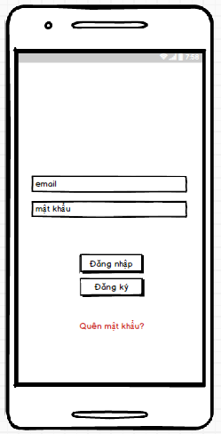

### **Require function**

|  |  |  |  |
| --- | --- | --- | --- |
| **Item** | **description** | **Behavior** | **Response** |
| Login Screen | Login Screen has:   * Image * EditText “Username” * EditText “Password” * Button ”Login” * Button “Sign up” * Forgot password | N/A | N/A |
| Image | Show photos | N/A | N/A |
| EditText “Username” | Used to enter the user’ s email | Tab on and enter | The entered user’ s email will be displayed in the edittext |
| EditText ”Password” | Used to enter the password | Tab on and enter | The entered password will be displayed in the edittext, the password will be formatted “*” |
| Button “login” | After entering the user email and password, tab on the login button to enter the main screen | Tab on | Go to home screen |
| Button “sign up” | Used to register user accounts | Tab on | Go to Sign up screen |
| Forgot password | Used to recover password | Tab on | Go to forgot password screen |

## **Features / Components: Sign up Screen**

### **User interface**

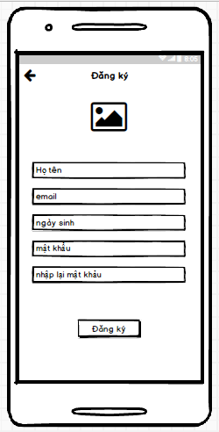

### **Require function**

|  |  |  |  |
| --- | --- | --- | --- |
| **Item** | **Description** | **Behavior** | **Response** |
| Sign up Screen | Sign up Screen has:   * Icon back * Image * EditText “Username” * EditText “email” * EditText “birthday” * EditText “password” * EditText “Repassword” * Button ”sign up” | N/A | N/A |
| Icon Back | Go to login screeen | Tab | Go to login screeen |
| Image | Show logo | Show | N/A |
| EditText “username” | Used to enter the user’ s name | Tab and enter | The entered user’ s name will be displayed in the edittext |
| EditText “email” | Used to enter the user’ s email | Tab on and enter | The entered user’ s email will be displayed in the edittext |
| EditText “birthday” | Used to enter the user’ s birthday | Tab on and enter | The entered user’ s birthday will be displayed in the edittext |
| EditText ”Password” | Used to enter the password | Tab on and enter | The entered password will be displayed in the edittext, the password will be formatted “*” |
| EditText ”Repassword” | Used to enter the password again | Tab on and enter | The entered password will be displayed in the edittext, the password will be formatted “*” |
| Button “Sign up” | After entering all the information, tab on the sign up button to create an account | Tab on | Create an account |

## **Features / Components: Forgot Password Screen**

### **User interface**

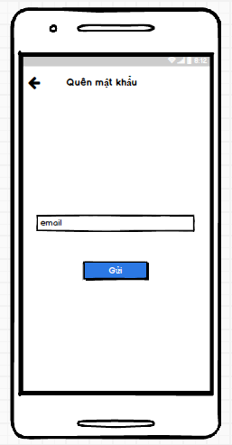

### **Require function**

|  |  |  |  |
| --- | --- | --- | --- |
| **Item** | **Description** | **Behavior** | **Response** |
| Forgot Password Screen | Forgot Password Screen has:   * Icon Back * EditText “Email” * Button “send” | N/A | N/A |
| Icon Back | Go to login screeen | Tab | Go to login screeen |
| EditText “email” | Used to enter the user’ s email | Tab on and enter | The entered user’ s email will be displayed in the edittext |
| Button “send” | Tab on to send the email and to retrieve password | Tab | To retrieve password |

## **Features / Ingredients: Main Screen**

### **User interface**

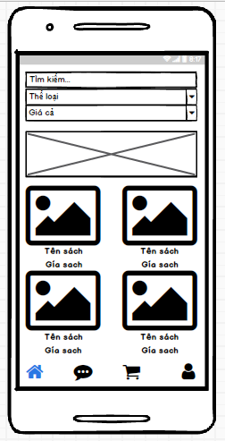

### **Require function**

|  |  |  |  |  |
| --- | --- | --- | --- | --- |
| **Item** | **Description** | | **Behavior** | **Response** |
| Main Screen | Main Screen has;   * Search bar * Spinner “category” * Spinner “price” * Listview * Item book * Icon home * Icon message * Icon cart * Icon individual | | N/A | N/A |
| Search bar | Used to search for books. Search by entering book title | | Tab on and enter | Show the recently searched book |
| Spinner “category” | Used to select the category, the selected category will show the book corresponding to that category | | Tab on and select | Show the book corresponding to that category |
| Spinner “price | Filter by price and filter from reviews | | Tab on and select | Show the book corresponding |
| Icon home | Go to home screen | | Tab on | Go to home screen |
| Icon message | Go to message screen | | Tab on | Go to message screen |
| Icon cart | Go to cart screen | | Tab on | Go to cart screen |
| Icon individual | Go to individual screen | | Tab on | Go to individual screen |
| ListView | Display the list of the books. Tab on the any book, go to detail book screen | Photo of the book | Display | * Display the list of the books * Tab on the any book, go to detail book screen |
| Book title |
| Price of the book |

## **Features / Ingredients: Detail Book Screen**

### **User interface**

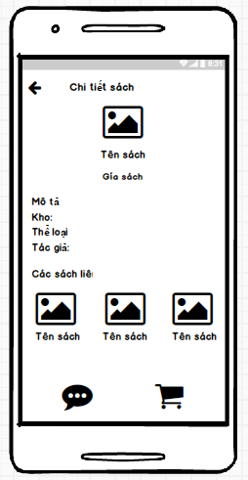

### **1.2.5.2. Require function**

|  |  |  |  |
| --- | --- | --- | --- |
| **Item** | **Description** | **Behavior** | **Response** |
| Detail Book Screen | Detail Book Screen has:   * Icon back * Image * Name title * Price * Description * Stock * Category * Author * Related books * Button”message” * Button “cart” | N/A | N/A |
| Icon back | Go to main screen | Tab on | Go to main screen |
| image | Show photo of the book | Show | Show photo of the book |
| Name title | Show name title of the book | Show | Show name title of the book |
| Price | Show price of the book | Show | Show name title of the book |
| Description | Show description of the book | Show | Show description of the book |
| Stock | Show the number of books in stock | Show | Show the number of books in stock |
| Category | Show category of the book | Show | Show category of the book |
| Author | Show Author of the book | Show | Show Author of the book |
| Related books | Show Related books | Show | Show Related books |
| Button “message” | Tab on to go to messagescreen, Used to exchange information between customers and stores | Tab on | Go to message screen |
| Button”cart” | Add books to cart | Tab on | Add books to cart |

## **Features / Ingredients:Message Screen**

### **User interface**

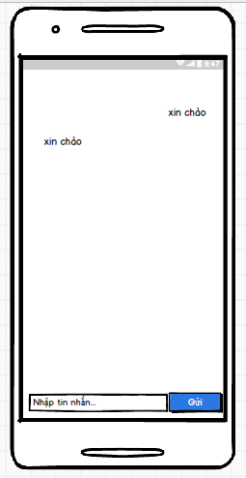

### **Require function**

|  |  |  |  |
| --- | --- | --- | --- |
| **Item** | **Description** | **Behavior** | **Response** |
| Message Screen | Message Screen has:   * Listview * Item left * Item right * Edittext “content” * Button ”send” | N/A | N/A |
| Listview | Contain items | N/A | N/A |
| Item left | Show message received | Show | Show message received |
| Item right | Show message sent | Show | Show message sent |
| Edittext “content” | Used to enter message content | Tab on and enter | Enter message content, show message content |
| Button ”send” | After entering message content, tab on the send button to show on the listview | Tab on | Show the listview |

## **Features / Ingredients: Cart Screen**

### **User interface**

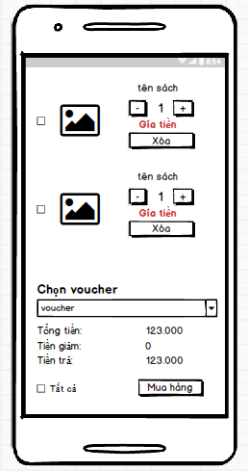

### **Require function**

|  |  |  |  |  |
| --- | --- | --- | --- | --- |
| **Item** | **Description** | | **Behavior** | **Response** |
| Cart Screen | Message Screen has:   * Listview * Spinner “voucher” * Total amount * Reduction amount * Amount to pay * Check box”All” * Purchase | | N/A | N/A |
| Listview | Contain items | Check box: tab on checkbox to select books to buy | N/A | N/A |
| Photo: show photo |
| Name title: show name title of the book |
| * Button “plus”: tab on plus button to increasing the number * Button “minus”: tab on minus button to reduce the number |
| Price: show price of the book |
| Button “delete”: used to remove the book from cart |
| Spinner “voucher” | Used to select the vouchers | | Tab on and select | Select the vouchers |
| Total amount | Show total amount | | Show | Show total amount |
| Reduction  amount | Show reduction  amount | | Show | Show reduction  amount |
| Amount to pay | Show amount to pay | | Show | Show amount to pay |
| Checkbox”all” | Tab on the checkbox “all” to select all the book | | Tab on | Select all the book |
| Button “purchase” | Used to make a purchase, go to the order screen | | Tab on | go to the order screen |

## **Features / Ingredients: Order Screen**

### **User interface**

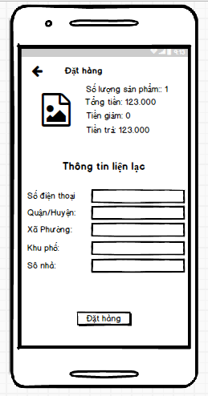

### **Require function**

|  |  |  |  |
| --- | --- | --- | --- |
| **Item** | **Description** | **Behavior** | **Response** |
| Order Screen | Order Screen has:   * Icon back * Total * Total amount * Reducrion amount * Amount to pay * Edittext “number phone” * Edittext “district” * Edittext “wards” * Edittext “quarter” * Edittext “apartment number” * Button “order” | N/A | N/A |
| Icon Back | Back to cart screen | Tab | Back to cart screen |
| Total | Show total number of books | Show | Show total number of books |
| Total amount | Show total amount | Show | Show total amount |
| Reduction  amount | Show reduction  amount | Show | Show reduction  amount |
| Amount to pay | Show amount to pay | Show | Show amount to pay |
| Edittext “number phone” | Used to enter the number phone | Tab on and enter | Show the number phone |
| Edittext “district” | Used to enter the district | Tab on and enter | Show the district |
| Edittext “wards” | Used to enter the wards | Tab on and enter | Show the wards |
| Edittext “quarter” | Used to enter the quarter | Tab on and enter | Show the quarter |
| Edittext “apartment number” | Used to enter the apartment number | Tab on and enter | Show the apartment number |
| Button ”order” | Tab on order button to order | Tab on | Show the message “order successful” |

## **Features / Ingredients: Individual Screen**

### **User interface**

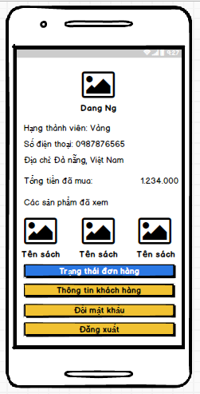

### **Require function**

|  |  |  |  |
| --- | --- | --- | --- |
| **Item** | **Description** | **Behavior** | **Response** |
| Individual Screen | Individual Screen has:   * Image * Username * Ucademy rank * Address * Number phone * Total amount purchased * Books viewed * Button “Order status” * Button “Information Individual” * Button “Change password” * Button “Logout” | N/A | N/A |
| Image | Show photo of the customer | Show | Show photo of the customer |
| Username | Show name of the customer | Show | Show name of the customer |
| Ucademy rank | Show ucademy rank  of the customer | Show | Show ucademy rank of the customer |
| Address | Show Address  of the customer | Show | Show Address  of the customer |
| Number phone | Show number phone of customer | Show | Show number phone of customer |
| Total amount purchased | Show the total amount of books purchased so far | Show | Show total amount purchased |
| Button “Order status” | Go to order status screen | Tab on | Go to order status screen |
| Button “Change password” | Go to Change password screen | Show | Go to Change password screen |
| Button “information individual” | Go to information individual screen | Tab on | Go to information individual screen |
| Button”logout” | Logout from application | Tab on | Go to login screen |

## **Features / Ingredients: Order Status Screen**

### **User interface**

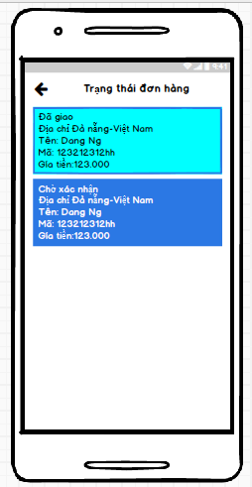

### **Require function**

|  |  |  |  |  |
| --- | --- | --- | --- | --- |
| **Item** | **Description** | | **Behavior** | **Response** |
| Order status Screen | Order status Screen has:   * Icon back * Listview * Item | | N/A | N/A |
| Icon back | Back to Individual screen | | Tab on | Back to Individual screen |
| Listview | Contain items | Order status:   * Need delivery * Delivered * Delivering * Cancelled | N/A | N/A |
| Address |
| Name of the customer |
| Code orders |
| Price |

## **Features / Ingredients: Review Screen**

### **User interface**

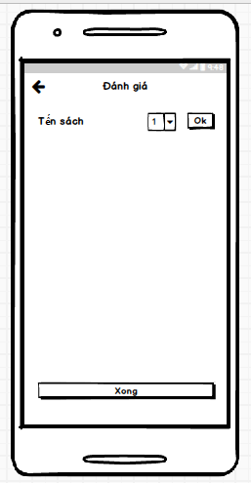

### **Require function**

|  |  |  |  |
| --- | --- | --- | --- |
| **Item** | **Description** | **Behavior** | **Response** |
| Order status Screen | Order status Screen has:   * Icon back * Name title of the book * Spinner “review” * Button “ok” * Button “finish” | N/A | N/A |
| Icon back | Back to order status screen | Tab on | Back to order status screen |
| Name title of the book | Show name title of the book under review | Show | Show name title of the book under review |
| Spinner “review” | Select the number from 1 to 5 respectively to review a book | Select | Select the number from 1 to 5 respectively to review a book |
| Button “ok” | Tab on the ok button | Tab on |  |
| Button “finish” | Tab on finish button to save the result evaluation, then back to order status screen | Tab on | Save the result evaluation, then back to order status screen |

## **Features / Ingredients: Update Information Individual Screen**

### **User interface**

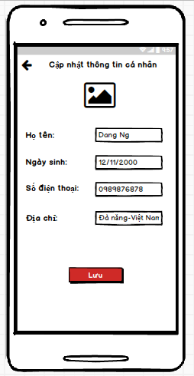

### **Require function**

|  |  |  |  |
| --- | --- | --- | --- |
| **Item** | **Description** | **Behavior** | **Response** |
| Update Information Individual Screen | Update Information Individual Screen has:  * Icon back * Image * Edittext “name” * Edittext “birthday” * Edittext “address” * Edittext “number phone” * Button “save” | N/A | N/A |
| Icon back | Back to individual screen | Tab on | Back to individual screen |
| Image | Show photo of the customer tab on to change photo.   * Change by camera * Change by library | Show | Show name title of the book under review |
| Edittext “name” | Show name of the customer, tab on to enter the new name, if you want to update name | Tab on and enter | update name |
| Edittext “address” | Show address of the customer, tab on to enter the new address, if you want to update address | Tab on and enter | update address |
| Edittext “birthday” | Show birthday of the customer, tab on to enter the new birthday, if you want to update birthday | Tab on and enter | update birthday |
| Edittext “number phone” | Show number phone of the customer, tab on to enter the new number phone, if you want to update number phone | Tab on and enter | update number phone |
| Button “save” | After updating the information, tab on the save button to save information, then back to individual screen | Tab on | save information |

## **Features / Ingredients: Change the password Screen**

### **User interface**

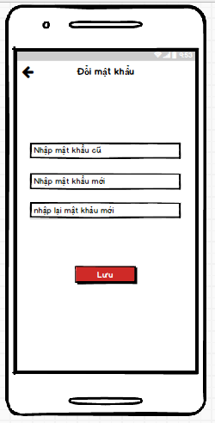

### **Require function**

|  |  |  |  |
| --- | --- | --- | --- |
| **Item** | **Description** | **Behavior** | **Response** |
| Change the password Screen | Change the password Screen has:  * Icon back * Edittext “old password” * Edittext “new password” * Edittext “new password again” * Button “save” | N/A | N/A |
| Icon back | Back to individual screen | Tab on | Back to individual screen |
| Edittext “old password” | Used to enter old password | Tab on and enter | Show password as * |
| Edittext “new password” | Used to enter new password | Tab on and enter | Show password as * |
| Edittext “new password again” | Used to enter new password again | Tab on and enter | Show password as * |
| Button “save” | After updating the password, tab on the save button to save new password | Tab on | Save new password |

1. Shipper:

## **Features / Components: Login Screen**

### **User interface**

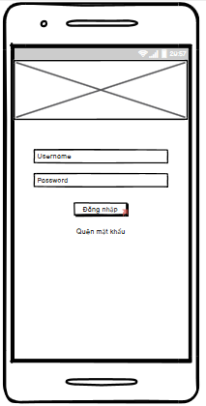

### **Require function**

|  |  |  |  |
| --- | --- | --- | --- |
| **Item** | **Description** | **Behavior** | **Response** |
| **Login Screen** | The login screen includes:  -         “username” edittext  -         “password” edittext  -        “login” button  -          “Forgot password” textview  - “Image” ImageView | N/A | N/A |
| **“Username” edittext** | Enter Username | Tap on | Display the keyboard and the user can input |
| **“Password” edittext** | Enter Password | Tap on | Display the keyboard and the user can input and show password as * |
| **“Forgot password” textview** | If the user forgot the password, tap Forgot Password | Tap on | Go to Forgot Password Screen |
| **“Login” button** | If Username and Password exist correctly in the database, it will go to the Home screen | Tap on | Go to Home Screen |
| If the Username and Password do not exist correctly in the database, a dialog box will be displayed with the content “Invalid Username or Password” and “Close” button. | Tap on | A pop up is showed |
| “Close” button closes a pop up | Tap on | Pop up is closed |
| “Image” ImageView | Show image on the login screen | N/A | N/A |

## **Features / Components: Home Screen**

### **User interface**

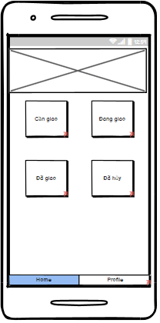

### **Require function**

|  |  |  |  |
| --- | --- | --- | --- |
| **Item** | **Description** | **Behavior** | **Response** |
| **Home Screen** | The Home screen includes:  -        “Need Delivery” button  -        “Delivering” button  -        “Delivered” button  -        “Canceled” button  -        “Home” tab  -        “Profile” tab  -        “Image” ViewFlipper | N/A | N/A |
| **“Need delivery” button** | “Need delivery” button go to the Orders to be delivered screen | Tap on | Go to the Orders to be delivered screen |
| **“Delivering” button** | “Delivering” button go to the Orders being delivered screen | Tap on | Go to the Orders being delivered screen |
| **“Delivered” button** | “Delivered” button go to the Delivered Orders screen | Tap on | Go to the Delivered Orders screen |
| **“Canceled” button** | “Cancelled” button go to Canceled Order screen | Tap on | Go to the Canceled Orders screen |
| **“Profile” tab** | “Profile” tab go to the profile screen | Tap on | Go to the profile screen |
| **“Home” tab** | “Home” tab go to the home screen | Tap on | Go to the home screen |
| **“Image” ViewFlipper** | Used to move images | N/A | N/A |

## **Features / Components: Orders to be delivered**

### **User interface**

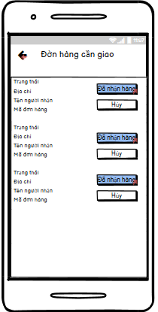

### **Require function**

|  |  |  |  |
| --- | --- | --- | --- |
| **Item** | **Description** | **Behavior** | **Response** |
| **"Order to be delivered" screen** | The "Order to be delivered" screen includes:  -        “icon arrow-left” button  -          Listview | N/A | N/A |
| **“icon arrow-left” button** | Back to the Home screen | Tap on | Back to the Home screen |
| **“Order to be delivered” listview** | Display order information to be delivered including:   * Status * Address * Recipient's name * Code orders * “Cancel” button * “Received” button | Tap on “Received” button | Go to the Orders being delivered screen.  The order will be removed from the list and The order goes to the Orders being delivered screen |
| Tap on “Cancel” button | Confirm that the Shipper is busy and the order will be removed from the list |

## **Features / Components: Orders Being Delivered Screen**

### **User interface**

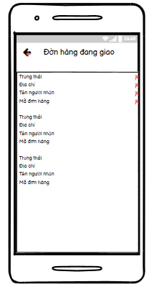

### **Require function**

|  |  |  |  |
| --- | --- | --- | --- |
| **Item** | **Description** | **Behavior** | **Response** |
| **Orders Being Delivered Screen** | The Orders being delivered screen includes:  -        “icon arrow-left” button  -        Listview | N/A | N/A |
| **“icon arrow-left” button** | Back to the Home screen | Tap on “Arrow-left” | Back to the Home screen |
| **'Orders being delivered' listview** | Display information about orders being delivered, including: “  -        Status  -        Address  -        Recipient's name  -        Code orders  " | N/A | N/A |
| Tap on an item will go to the Order Details screen | Tap on | Go to the Order Details screen |

## **Features / Components: Order Details Screen**

### **User interface**

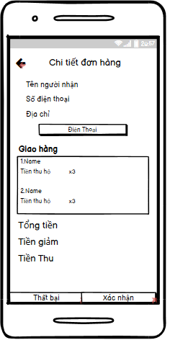

### **Require function**

|  |  |  |  |
| --- | --- | --- | --- |
| **Item** | **Description** | **Behavior** | **Response** |
| **Order Details screen** | The Order Details screen includes:  -        “icon arrow-left” button  -        “Recipient Name” label  -        “Phone number” label  -        “Address” label  -        “Phone” button  -        Listview  -        “Confirm” button  -        “Fail” button  - “Discount” label  - “Proceeds” label  -        “Delivery” textview  -    “Total amount” label | N/A | N/A |
| **“icon arrow-left” button** | Back to the Orders being delivered screen | Tap on | Back to the Orders being delivered screen |
| **“Recipient Name” label** | Display “recipient name” on the screen | N/A | N/A |
| **“Phone number” label** | Display “phone number” on the screen | N/A | N/A |
| **“Address” label** | Display “address” on the screen | N/A | N/A |
| **“Discount” label** | Show discount amount on the screen | N/A | N/A |
| **“Proceeds” label** | Proceeds = Total amount – Discount and show proceeds on screen | N/A | N/A |
| **“Phone” button** | Exit the app and show the phone number on the phone app | Tap on “Phone” | Exit the app and open the phone app |
| **“Delivery” listview** | Display the list of orders of the recipient including:  -        Name Product  -    Proceeds  - Quantity | N/A | N/A |
| **“Total amount” label** | Display the total amount of the orders of each recipient | N/A | N/A |
| **“Confirm” button** | The order is in transit, it has been delivered and it will go to the delivered order screen | Tap on | Go to the Delivered Orders screen |
| **“Fail” button** | Confirm canceled orders and update on database and Go to Canceled Order Screen | Tap on | Go to Canceled Order Screen |
| **“Delivery” textview** | Display “Delivery” textview to the screen | N/A | N/A |

## **Features / Components: Delivered Order Screen**

### **User interface**

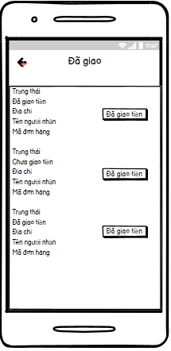

### **Require function**

|  |  |  |  |
| --- | --- | --- | --- |
| **Item** | **Description** | **Behavior** | **Response** |
| **Orders Delivered Screen** | The Delivered Orders screen includes:  -        “icon arrow-left” button  -        Listview | N/A | N/A |
| **“icon arrow-left” button** | Back to the Home screen | Tap on “Arrow-left” | Back to the Home screen |
| **'Order delivered' listview** | Displays information about orders that have been delivered, including the following information:   * Status * Money has/haven't been delivered * Address * Recipient's name * Code orders * Money delivered button | Tap on Money delivered button | Confirm that the Shipper has delivered the money to the store |

## **Features / Components: Canceled Order Screen**

### **User interface**

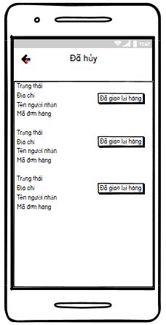s

### **Require function**

|  |  |  |  |
| --- | --- | --- | --- |
| **Item** | **Description** | **Behavior** | **Response** |
| **Canceled Orders screen** | The Canceled Orders screen includes:  -        “icon arrow-left” button  -        Listview | N/A | N/A |
| **“icon arrow-left” button** | Back to the Home screen | Tap on “Arrow-left” | Back to the Home screen |
| **'canceled order ' listview** | Displays information about orders that have been delivered, including the following information:   * Status * Address * Recipient's name * Code orders * redelivered button | Tap on redelivered button | The canceled order confirmation is returned to the store and the order will be deleted upon confirmation |

## **Features / Components: Profile Screen**

### **User interface**

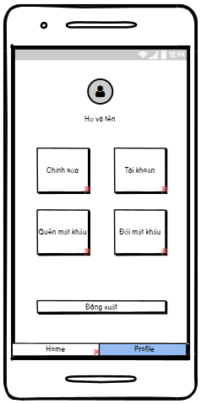

### **Require function**

|  |  |  |  |
| --- | --- | --- | --- |
| **Item** | **Description** | **Behavior** | **Response** |
| **Profile Screen** | The Profile screen includes:  -        “Shipper Name” label  -         “Log Out” button  -        “Edit” button  -        “Avatar” image  -        “Home” tab  -        “Profile” tab  -        “Account” button  -        “ForgotPassword” button  - “ChangePassword” button | N/A | N/A |
| **“Shipper Name” label** | Display “first and last name of shipper” on the screen | N/A | N/A |
| **“Log Out” button** | Tap on“Log Out” the account will exit and go to the Login screen | Tap on | Go to the Login screen |
| **“Avatar” image** | Show Shipper .'s profile photo | N/A | N/A |
| **“Edit” button** | Go to Edit Profile screen | Tap on | Go to Edit Profile screen |
| **“Home” tab** | Go to the Home screen | Tap on | Go to the Home screen |
| **“Profile” tab** | Go to Profile screen | Tap on | Go to Profile screen |
| **“Account” button** | Go to the Account Management screen | Tap on | Go to the Account Management screen |
| **“ForgotPassword” button** | if the email is sent successfully a pop up with message: “email sent successfully” and “Close” button | Tap on | A pop up is showed |
| if the email is sent fail a pop up with message: “Email sent failed” and “Close” button | Tap on | A pop up is showed |
| “Close” button closes a pop up | Tap on | A pop up is close |
| **“ChangePassword” button** | Go to the Change Password screen | Tap on | Go to the Change Password screen |

## **Features / Components: Account Management Screen**

### **User interface**

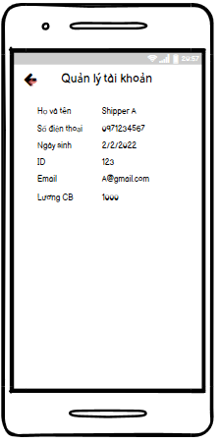

### **Require function**

|  |  |  |  |
| --- | --- | --- | --- |
| **Item** | **Description** | **Behavior** | **Response** |
| **Account Management screen** | The Account Management screen includes:  -        “icon arrow-left” button  -        “Full name” label  -        “Phone number” label  - “ID” label  - “Email” label  - “basic salary” label  -        “Date of Birth” label | N/A | N/A |
| **“Full name” label** | Show first and last name Shipper from database | N/A | N/A |
| **“Phone number” label** | Show Shipper's phone number from database | N/A | N/A |
| **“Date of Birth” label** | Show Shipper's date of birth from database | N/A | N/A |
| **“icon arrow-left” button** | Back to Profile screen | Tap on | Back to Profile screen |
| **“ID” label** | Show ID Shipper from database | N/A | N/A |
| **“Email” label** | Show Email Shipper from database | N/A | N/A |
| **“Basic salary” label** | Show Basic salary Shipper from database | N/A | N/A |

## **Features / Components: Edit Profile Screen**

### **User interface**

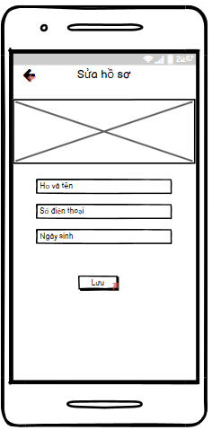

### **Require function**

|  |  |  |  |
| --- | --- | --- | --- |
| **Item** | **Description** | **Behavior** | **Response** |
| **Edit Profile Screen** | The Edit Profile screen includes:  -        “Full name” edittext  -        “Phone number” edittext  -        “Date of Birth” edittext  - “Image” ImageView  -        “Save” button  -        “icon arrow-left” button | N/A | N/A |
| **“Full name” edittext** | Enter Shipper's First and Last Name | Tap on | Display the keyboard and enter the shipper's name |
| **“Phone number” edittext** | Enter Shipper's Phone Number | Tap on | Display the keyboard and enter the shipper's phone number |
| **“Date of Birth” edittext** | Enter Date of Birth | Tap on | Display the keyboard and enter the date of brith |
| **“Save” button** | Used to save the information entered by the user in the edittext, change on database and Go to the Profile screen | Tap on | Go to the Profile screen |
| **“icon arrow-left” button** | Back to Profile screen | Tap on | Back to the Profile screen |
| **“Image” Imageview** | Show image on the Edit screen | N/A | N/A |

## **Features / Components: Forgot Password Screen**

### **User interface**

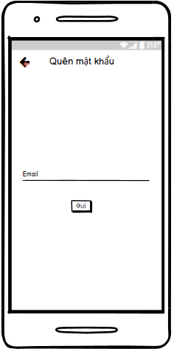

### **Require function**

|  |  |  |  |
| --- | --- | --- | --- |
| **Item** | **Description** | **Behavior** | **Response** |
| **Forgot Password Screen** | The Forgot Password screen includes:  -        “icon arrow-left” button  -         “Send” button  -        “Email” edittext | N/A | N/A |
| **“Send” button** | Used to send to email if email is right, a pop up with a message:" Email sent successfully please check your email" and “Close” button | Tap on | A pop up is showed |
| if email is wrong, a pop up with a message: “Email failed” and “Close” button |
| “Close” button closes pop up | Tap on | A pop up is closed |
| **“Email” edittext** | Enter email of shipper | Tap on | Display the keyboard and enter the email of the shipper |
| **“icon arrow-left” button** | If the user don’t log in then return the Login screen | Tap on | Back to the Login screen |

## **Features / Components: Change Password Screen**

### **User interface**

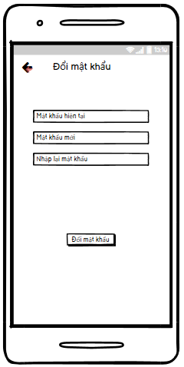

### **Require function**

|  |  |  |  |
| --- | --- | --- | --- |
| **Item** | **Description** | **Behavior** | **Response** |
| **Change Password Screen** | The Change Password screen includes:  -        “icon arrow-left” button  -         “current password” edittext  -        “new password” edittext  - “RePassword” edittext  - “change Password” button | N/A | N/A |
| **“Current Password” edittext** | Enter Current Password | Tap on | Display the keyboard and enter the current password and show CurrentPassword as * |
| **“New Password” edittext** | Enter New Password | Tap on | Display the keyboard and enter the new password and show New Password as * |
| **“RePassword” edittext** | Enter RePassword | Tap on | Display the keyboard and enter the RePassword and show RePassword as * |
| **“ChangePassword” button** | Used to update password | Tap on | A pop up with message: “Change password successfully” and “Close” button |
| **“Icon Arrow-left” button** | Used Back to Profile Screen | Tap on | Back to Profile Screen |

1. Store:

## **Features / Components: Home package**

### **User interface**

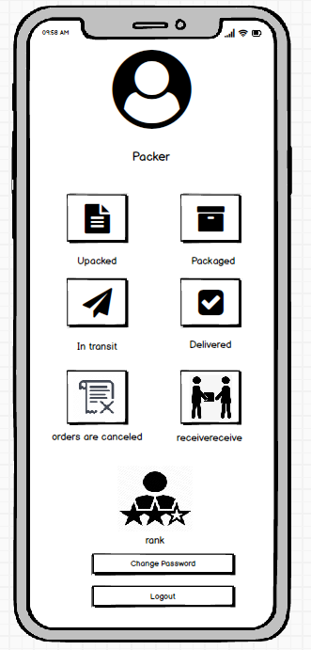

### **Require function**

|  |  |  |  |
| --- | --- | --- | --- |
| **Item** | **Description** | **Behavior** | **Response** |
| **Home package** | Packer's main screen | N/A | N/A |
| ImageView Packer | Logo of the packer | Tap on | Show default image |
| Unpacker | Go to the page using that function | Tap on | Go to the page using that function |
| Packered | Go to the page using that function | Tap on | Go to the page using that function |
| In transit | Go to the page using that function | Tap on | Go to the page using that function |
| Delivered | Go to the page using that function | Tap on | Go to the page using that function |
| Order cancel | Go to the page using that function | Tap on | Go to the page using that function |
| Receive | Go to the page using that function | Tap on | Go to the page using that function |
| Rank | Go to the page using that function | Tap on | Go to the page using that function |
| Change pass | Go to the page using that function | Tap on | Go to the page using that function |
| Logout | Go to the page using that function | Tap on | Go to the page using that function |

## **Features / Components: Home package**

### **User interface**

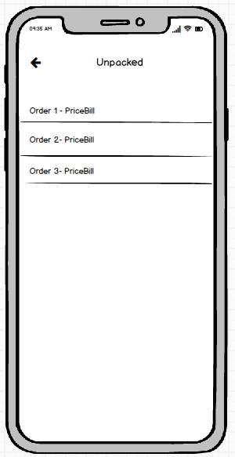

### **Require function**

|  |  |  |  |
| --- | --- | --- | --- |
| **Item** | **Description** | **Behavior** | **Response** |
| Unpacker | Show unpacked orders | N/A | N/A |
| **Order ListView** | Show order list | Tap on View Item | Tap on the order name to go to the order details screen |
| **Delete button** | Delete pending orders | Tap on Delete button | Remove order from listview |
| **Back button** | Back to screen | Tap on Back button | Back to Packer screen |
| **Search Box** | Search for pending orders | Tap on Search Box | Search for orders by name |

## **Features / Components: Home package**

### **User interface**

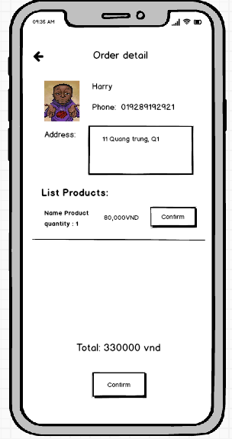

### **Require function**

|  |  |  |  |
| --- | --- | --- | --- |
| **Item** | **description** | **Action** | **Response** |
| **Order Detail screen** | Order details screen has 3 buttons ,1 Data Grid,1 TextView:  ●          Check  ●          Order detail  ●          Total  ●          Back  ●         Storehouse | N/A | N/A |
| **Order detail datagrid** | Show order list | N/A | Show details of products in the order |
| **Check button** | Complete packing | Tap on Check button | Turn your order into a packed state |
| **Back button** | Back to screen | Tap on Back button | Back to Packer screen |
| **Storehouse button** | Check goods in stock | Tap on Storehouse button | The inventory management screen appears |
| **Total TextView** | Show the total amount of the invoice | N/A | Show the total amount of the invoice |

## **Features/Components: Packaged Screen**

### **User interface**

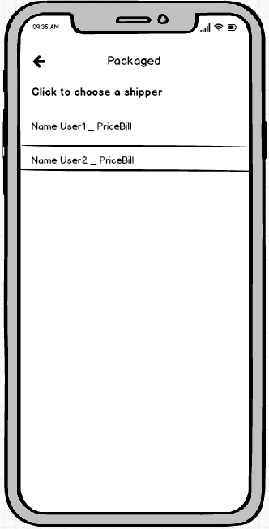

### **Require function**

|  |  |  |  |
| --- | --- | --- | --- |
| **Item** | **description** | **Action** | **Response** |
| **Packaged screen** | The packaged order management screen has 4 buttons, 1 search box, 1 ListView:  ●          Order ListView  ●          Delete  ●          Back  ●          Search Box  ●          Check  ●          Check All | N/A | N/A |
| **Order ListView** | Show the list of packed orders | Tap on View Item | List of packed orders, click on the order wall to see details |
| **Delete button** | Delete order | Tap on Delete button | Remove order from listview |
| **Back button** | Back to screen | Tap on Back button | Back to Packer screen |
| **Search Box** | Order search | Tap on Search Box | Single search by code |
| **Check button** | Delivery of orders | Tap on Check button | Change order to delivery status |
| **Check All button** | Delivery of orders | Tap on Check All button | Move all orders to shipping status |

## **Features/Components: Delivered Screen**

### **User interface**

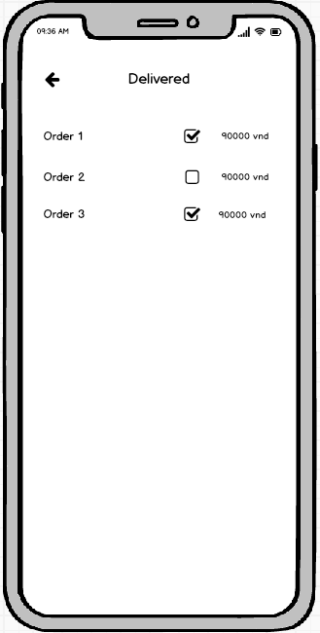

### **Require function**

|  |  |  |  |
| --- | --- | --- | --- |
| **Item** | **description** | **Action** | **Response** |
| **Delivered screen** | Delivered order management screen has 2 buttons, 1 search box, 1 ListView:  ●          Order ListView  ●          Back  ●          Search Box  ●          Checkbox | N/A | N/A |
| **Order ListView** | Delivered order management screen | Tap on View Item | List of delivered orders, tap the check button to confirm that you have received money from the delivery person |
| **Back button** | Back to screen | Tap on Back button | Back to Packer screen |
| **Search Box** | Order search | Tap on Search Box | Single search by code |
| **Check button** | Confirmed successful delivery | Tap on Check button | Confirm the order has been delivered successfully and receive money from the carrier |

## **Features/Components: Storehouse Screen**

### **User interface**

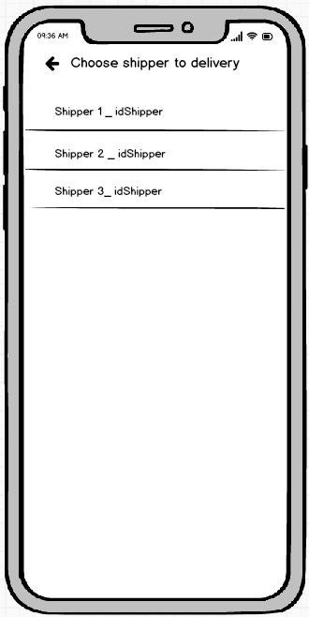

### **Require function**

|  |  |  |  |
| --- | --- | --- | --- |
| **Item** | **Description** | **Action** | **Response** |
| **Screen** | Choose a shipper for the order | N/A | N/A |
| **Listview shipper** | Choose 1 of the shippers | Click | That shipper will have a notice to pick up the order and deliver |
| **Select Button** | Used to choose that shipper | Click | That shipper will become busy |
| **Textinput search** | Used to search shipper by name | Input text | Listview will display the respective shippers |

## **Features/Components: In Transit Screen**

### **User interface**

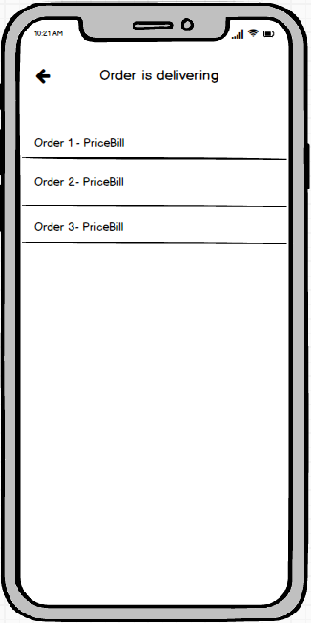

### **Require function**

|  |  |  |  |
| --- | --- | --- | --- |
| **Item** | **description** | **Action** | **Response** |
| **In Transit screen** | The screen of managing orders being delivered has 3 buttons, 1 search box, 1 ListView:  ●          Order ListView  ●          Back  ●          Search Box  ●          Check  ●          Check All | N/A | N/A |
| **Order ListView** | Display the list of orders being delivered | Tap on View Item | List of orders being delivered, click on the order wall to see details |
| **Back button** | Back to screen | Tap on Back button | Back to Packer screen |
| **Search Box** | Order search | Tap on Search Box | Single search by code |
| **Check button** | Confirmed successful delivery | Tap on Check button | The order has been successfully transferred to the delivery status |
| **Check All button** | Confirmed successful delivery | Tap on Check All button | Change all orders to successful delivery |

## **Features/Components: Delivered Screen**

### **User interface**

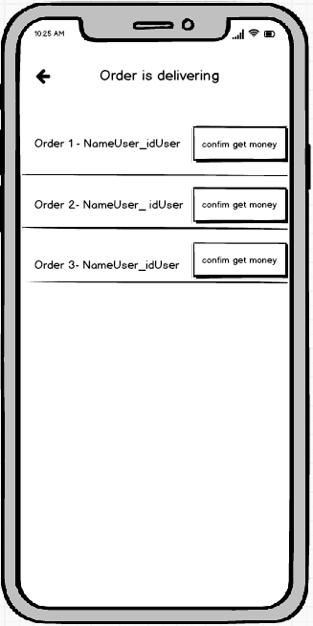

### **Require function**

|  |  |  |  |
| --- | --- | --- | --- |
| **Item** | **description** | **Action** | **Response** |
| **Delivered screen** | Delivered order management screen has 2 buttons, 1 search box, 1 ListView:  ●          Order ListView  ●          Back  ●          Search Box  ●          Checkbox | N/A | N/A |
| **Order ListView** | Delivered order management screen | Tap on View Item | List of delivered orders, tap the check button to confirm that you have received money from the delivery person |
| **Back button** | Back to screen | Tap on Back button | Back to Packer screen |
| **Search Box** | Order search | Tap on Search Box | Single search by code |
| **Check button** | Confirmed successful delivery | Tap on Check button | Confirm the order has been delivered successfully and receive money from the carrier |

## **Features/Components: Unpacked Screen**

### **User interface**

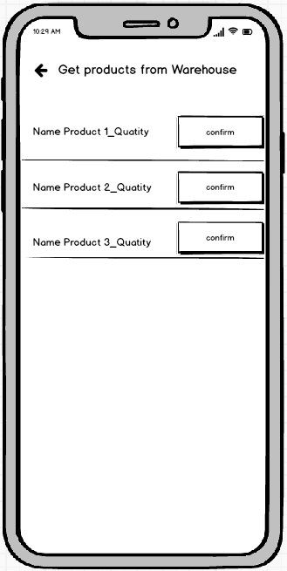

### **Require function**

|  |  |  |  |
| --- | --- | --- | --- |
| **Item** | **description** | **Action** | **Response** |
| **Unpacked screen** | The unpacked screen has 2 buttons, 1 search box, 1 ListView:  ●          Order ListView  ●          Delete  ●          Back  ●          Search Box | N/A | N/A |

## **Features/Components: Unpacked Screen**

### **User interface**

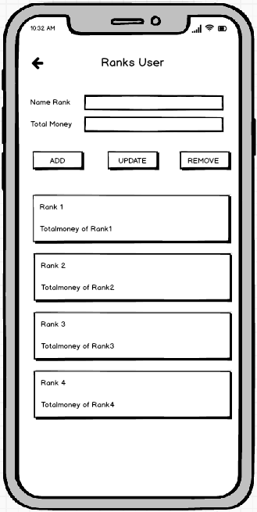

### **Require function**

|  |  |  |  |
| --- | --- | --- | --- |
| **Item** | **description** | **Action** | **Response** |
| **Rank User screen** | You can add and remove member ratings | N/A | N/A |
| **Name Rank** | Enter your membership class name there | Write in | Display the characters you just wrote |
| **Money Rank** | Enter your membership class name there | Write in | Display the characters you just wrote |
| **Button add** | Performs adding ranks to the list and correcting the ranks for users | Tab on button | Performs adding ranks to the list and correcting the ranks for users |
| **Button edit** | Edit the rank that I just clicked | Tab on button | Edit the rank that I just clicked |
| **Button Delete** | Remove that 1 rank from the list | Tab on button | Remove that 1 rank from the list |
| **ListView Rank** | Show all membership classes | See | Show all membership classes |

## **Features / Ingredients: Main Screen**

### **User interface**

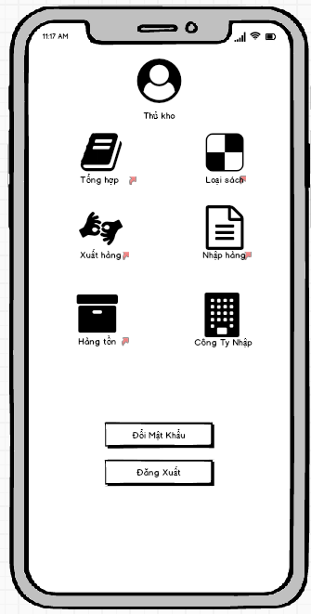

### **Require function**

|  |  |  |  |
| --- | --- | --- | --- |
| Item | Description | Behavior | Response |
| Main screen | Main screen has:   * Image button” Synthesis” * Image button” Inventory” * Image button” Book Type” * Image button” Export” * Image button” Import Goods” * Image button” Company Import” * Button”chang to password” * Button” logout” | N/A | N/A |
| Image button” Synthesis” | The function of the storekeeper. Use to view the books you sell, add new books. | Tab on Image button” Synthesis” | Go to the book management screen, you can add, delete and edit book information. |
| Image button” Inventory” | Used to view inventory statistics currently in stock | Tab on Image button” Inventory” | Go to stock view screen |
| Image button” Book Type” | Use to see how many books are sold in the store and how many books have that type | Tab on Image button” Book Type” | Statistics of books |
| Image button "Export" | Used to ship goods to the order maker to pack the goods. | Tab on Image button "Export" | Go to Export screen |
| Image button "Import goods" | Used to import goods for order writers to pack goods. | Tab on Image button "Import goods" | Go to the import screen. |
| Image button” Company Import” | Used to enter the names of the companies that the store imports books from | Tab on Image button” Company Import” | Go to Company Import screen |
| Button “Change to password” | Used to change password | Tab on Button “Change to password” | Go to change password screen, change password |
| Button “Logout” | Used to logout of the account | Tab on Button “Change to password” | Back to the Login screen |

## **Features / Ingredients: Product Management Screen**

### **User interface**

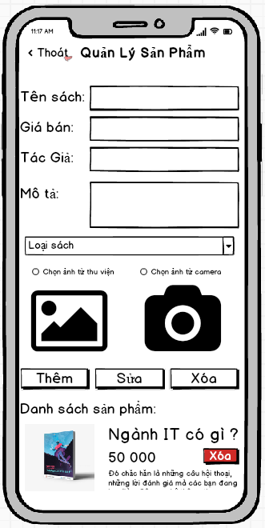

### **Require function**

|  |  |  |  |
| --- | --- | --- | --- |
| Item | Description | Behavior | Response |
| Product Management Screen | Product Management Screen has:  * Button “Exit” * Textinput “Book Title” * Textinput “Selling Price” * Textinput “Description” * Compobox “Book Type” * Radiobox “Camera” * Radiobox “Library” * Button “Edit” * ListView “Product List” * Button “Delete” | N/A | N/A |
| Button “Exit” | Used to return to the previous page | Click on | Back to previous page |
| Textinput “Book Title” | Enter the title of the book here | Input | Will display the information the user entered |
| Textinput “Selling Price” | Enter the selling price of the book | Input | Will display the information the user entered |
| Textinput “Description” | Enter a description | Input | Will display the information the user entered |
| Compobox “Book Type” | Select type of book | Click on | Users can choose the appropriate type of book. |
| Radiobox “Camera” | Used to take a photo of the book by camera | Select Radiobox “Camera” | Take a photo of the book by camera |
| Radiobox “Library” | Used to select photo of the book from library | Select Radiobox “Library” | Select photo of the book from library |
| Button “Edit” | Edit available book information | Click on | When the user clicks on each book, the book's information will be displayed on the textinput, then it is possible to edit the book information and click the edit button, the book information will be corrected. |
| ListView “Product List” | See the list of books and can click on it to edit the information. | Click on | You can click to update the content. |
| Button “Delete” | Delete the book from the system | Click on | The application will remove the book from the store and will update the list of existing books. |

## **Features / Ingredients: Inventory Statistics Screen**

### **User interface**

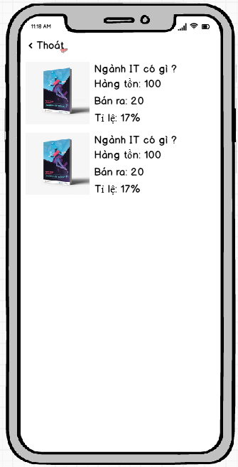

### **Require function**

|  |  |  |  |
| --- | --- | --- | --- |
| **Item** | **Description** | **Behavior** | **Response** |
| **Screen** | Show list of products and sales rate | N/A | N/A |

## **Features / Ingredients: Category Management Screen**

### **User interface**

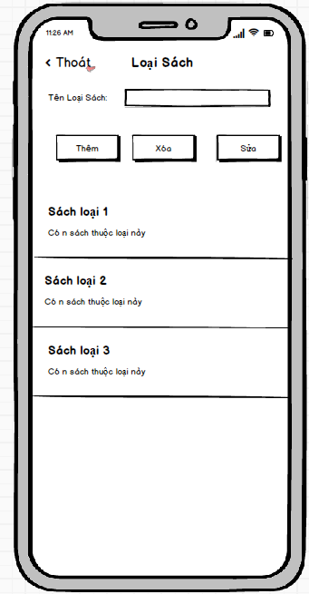

### **Require function**

|  |  |  |  |
| --- | --- | --- | --- |
| **Item** | **Description** | **Behavior** | **Response** |
| Category management Screen | Category management Screen has:   * Button “back” * EditText “Name Category” * Button ”Add” * Button “Delete” * Button ”Edit” * ListView | N/A | N/A |
| Button “back” | Back to main screen | Tab on Button “back” | Back to main screen |
| EditText “category” | Used to enter the type of book | Input | The entered the type of book will be displayed in the edittext |
| Button “Add” | Used to add the type of book | Tab on Button “Add” | Show on the listview |
| Button “Delete” | Used to delete the type of book | Tab on Button “Delete” | Delete from listview |
| Button “Edit” | Used to update the type of book | Tab on Button “Edit” | Update category |
| ListView | Display the category | Display | Display the category |

## **Features / Ingredients: Export Screen**

### **User interface**

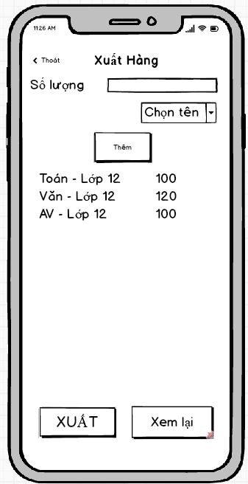

### **Require function**

|  |  |  |  |
| --- | --- | --- | --- |
| Item | Description | Behavior | Response |
| Export Screen | Export Screen Has:   * Button “back” * Edittext “quantity” * Combobox “name of the book” * Button “Add” * Listview * Button “export” * Button “View again” | N/A | N/A |
| Button “back” | Back to main screen | Tab on Button “back” | Back to main screen |
| Edittext “quantity” | Used to enter the quantity to be exported | Input | The quantity entered will be displayed on the edittext |
| Combobox “name of the book” | Used to select the name of the book to be exported | Select | The name of the book selected will be displayed on the combobox |
| Button “Add” | Used to add the book to be exported on the listview | Tab on Button “Add” | Show on the listview |
| Listview | Used to contain the added books | N/A | Contain the added books |
| Button “Export” | Used to |  |  |
| Button “View again” | Used to view again the books exported | Tab on Button “View again” | Go to the View the exported books screen, view again the books exported |

## **Features / Ingredients: Import Goods Screen**

### **User interface**

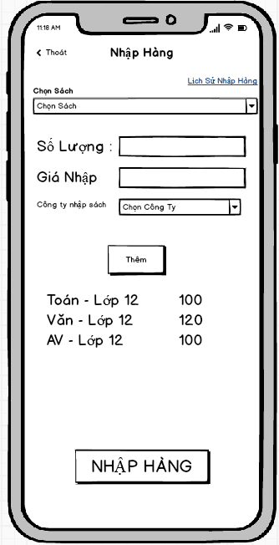

### **Require function**

|  |  |  |  |
| --- | --- | --- | --- |
| Item | Description | Behavior | Response |
| Import Goods screen | Import Goods screen has:   * Button “back” * Link “Import history” * Combobox “name of the book” * Edittext “Quantity” * Edittext “price” * Button “Company” * Button “Add” * Button “Import” | N/A | N/A |
| Button “back” | Back to main screen | Tab on Button “back” | Back to main screen |
| Combobox “name of book” | Used for importers to choose the name of the book they need to import | Tab on Combobox “name of book” and select | The screen will display the titles of the corresponding book type combobox above |
| Link “Import history” | Used to view imported orders | Tab on the Link “Import history” | Go to the Import history screen, view imported orders |
| Edittext “Quantity” | Used to enter the quantity to be entered | Tab on Edittext “Quantity” | Will display on the numeric keypad for users to input |
| Edittext “price” | Used to enter the price to be entered | Tab on Edittext “price” | Will display on the numeric keypad for users to input |
| Button “Company” | Go to select company screen, to select company | Tab on Button “Company” | Go to select company screen, to select company |
| Button “Add” | Used to add books to import to listview | Tab on Button “Add” | Add books to import to listview |
| Listview | Show recently added books | Show | Show recently added books |
| Button “Import” | Used to import books from listview to stock | Tab on Button “Import” | import books from listview to stock |

## **Features / Ingredients: Company Management Screen**

### **User interface**

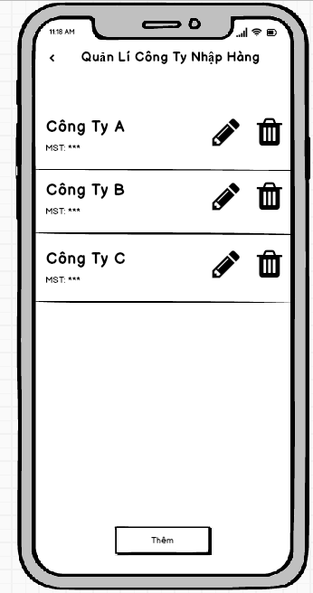

### **Require function**

|  |  |  |  |
| --- | --- | --- | --- |
| Item | Description | Behavior | Response |
| Company management Screen | Company management Screen has:   * Button “back” * Listview * Items * Icon “edit” * Icon “delete” * Button “Add” | N/A | N/A |
| Button “back” | Back to main screen | Tab on Button “back” | Back to main screen |
| ListView | Show list of companies | Show | N/A |
| Items | Name of company | N/A | N/A |
| Company code |
| Icon “edit”: Update company | Tab on Icon “edit” | Go to the update company |
| Icon “delete”: delete company from list | Tab on Icon “delete” | Delete company from list |
| Button “Add” | Used to add company | Tab on Button “Add” | Go to the add company screen to add company |

## **Features / Ingredients: Import history screen**

### **User interface**

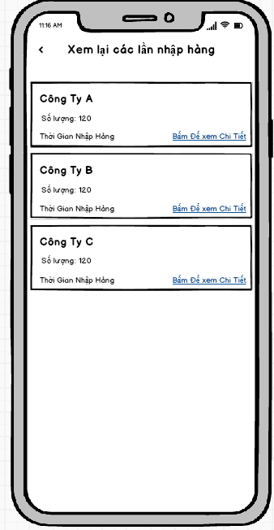

### **Require function**

|  |  |  |  |
| --- | --- | --- | --- |
| Item | Description | Behavior | Response |
| Import history screen | Import history screen has:   * Button “back” * Listview * Items | N/A | N/A |
| Button “back” | Back to Import screen | Tab on Button “back” | Back to Import screen |
| Listview | Show imported orders | N/A | N/A |
| Items | Company: Show company | N/A | N/A |
| Quantity: Show quantity | N/A | N/A |
| Time: Show time import goods | N/A | N/A |
| Link “view detail”:Used to view detail orders | Tab on the link “View detail” | Go to the detail import sceen, view detail. |

## **Features / Ingredients: View the exported goods Screen**

### **User interface**

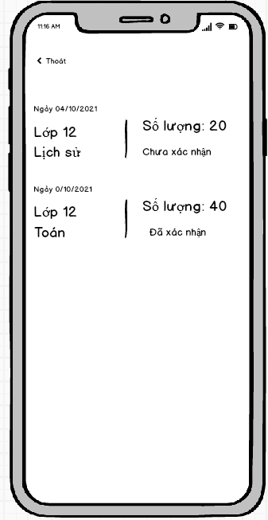

### **Require function**

|  |  |  |  |
| --- | --- | --- | --- |
| Item | Description | Behavior | Response |
| Playback screen | Used to let the storekeeper review the goods that have been shipped | N/A | N/A |
| Listview | View information about that day's delivery | N/A | Display information about each date and each type of book published |
| Unconfimred | The person who prepares the application has not yet entered the form and has received the goods from the exporter | N/A | Show the storekeeper that he or she has not confirmed receipt of goods from you |
| Confirmed | The order maker has ticked the button received goods from the storekeeper. | N/A | Show the storekeeper that the order maker has confirmed receipt of the goods from the storekeeper |

## **Features / Ingredients: Detail Import Screen**

### **User interface**

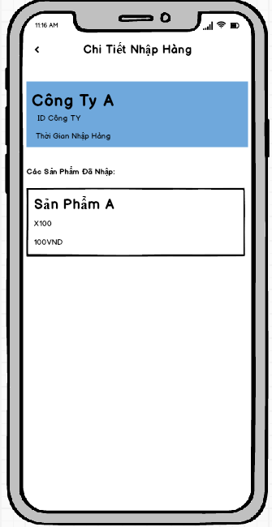

### **Require function**

|  |  |  |  |
| --- | --- | --- | --- |
| Item | Description | Behavior | Response |
| Detail import Screen | Detail import Screen has:   * Button “back” * Item 1 * Item 2 | N/A | N/A |
| Button “back” | Back to Import history screen | Tab on Button “back” | Back to Import history screen |
| Item 1 | Show name of the company | N/A | N/A |
| Show address of the company |
| Show time |
| Item 2 | Show name of the book | N/A | N/A |
| Show quantity imported |
| Show price of the book |

## **Features / Ingredients: Add company Screen**

### **User interface**

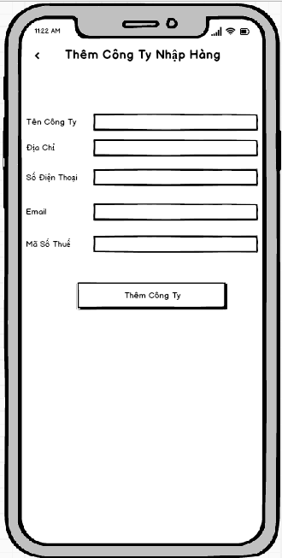

### **Require function**

|  |  |  |  |
| --- | --- | --- | --- |
| Item | Description | Behavior | Response |
| Add company Screen | Add company Screen has:   * Button “back” * Edittext “name company” * Edittext “address” * Edittext “number phone” * Edittext “email” * Edittext “tax id” * Button “Add” | N/A | N/A |
| Button “back” | Back to Company Management screen | Tab on Button “back” | Back to Company Management screen |
| Edittext “name company” | Used to enter the name of the company | Input | Display company name just entered in edittext |
| Edittext “address” | Used to enter the address of the company | Input | Display company address just entered in edittext |
| Edittext “number phone” | Used to enter the number phone of the company | Input | Display company number phone just entered in edittext |
| Edittext “email” | Used to enter the email of the company | Input | Display company email just entered in edittext |
| Edittext “tax id” | Used to enter the tax id of the company | Input | Display company number tax id just entered in edittext |
| Button “Add” | Used to add company | Tab on Button “Add” | Add company to list company management |

## **Features / Components: Store Home Screen**

### **User interface**

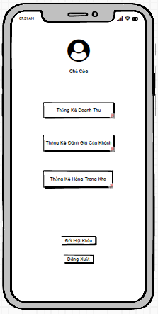

### **Require function**

|  |  |  |  |
| --- | --- | --- | --- |
| **Item** | **Description** | **Behavior** | **Response** |
| **Screen** | Inside the screen include the Administrator's Photo, the administrator's title, the Sales Statistics Button, the Customer Rating Statistics Button, the Inventory Statistics Button and the Log Out Button, Change Password Button. | N/A | N/A |
| **Sales Statistics Button** | Click this Button to go to the App's revenue statistics interface. | Tap on Sales Statistics Button | Go to the revenue statistics interface |
| **Review Statistics Button** | Click this Button to go to the App's evaluation statistics interface. | Tap on Review Statistics Button | Go to the evaluation statistics interface |
| **In-stock Statistics Button** | Click this Button to go to the App's inventory statistics interface. | Tap on In-stock Statistics Button | Go to the stock statistics interface |
| **Log Out Button** | Click this Button to log out of the account and switch to the App's login interface. | Tap on Log Out Button | Log out of your account and return to the login interface |
| **Change Password Button** | Click this Button to change password of the account and switch to the App's change password interface. | Tap on Change Password Button | Change password of your account, a pop up change password screen. |

## **Features / Components: Sales Statistics Screen**

### **User interface**

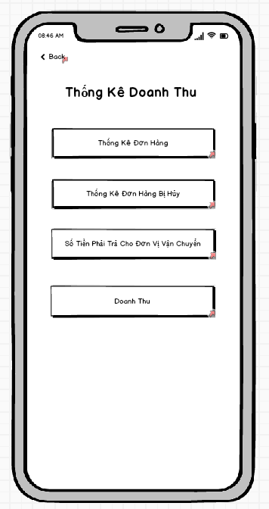

### **Require function**

|  |  |  |  |
| --- | --- | --- | --- |
| **Item** | **Description** | **Behavior** | **Response** |
| **Screen** | Inside the screen include Button Back ,Button Order Statistics, Button Statistics Canceled Orders, Button Amount To Pay For Shipping Units And Button Turnover | N/A | N/A |
| **Order Statistics Button** | Click this Button to go to the App's order statistics interface. | Tap On | Go to the order statistics interface |
| **Canceled Order Statistics Button** | Click this Button to go to the App's canceled order statistics interface. | Tap On | Go to canceled order statistics interface |
| **Button Amount To Pay For Shipping Unit** | Click this Button to go to the App's billing statistics interface. | Tap On | Go to the payment statistics interface for the shipping unit |
| **Revenue Button** | Click this Button to switch to App revenue interface. | Tap On | Go to the revenue interface |
| **Button Back** | Click to return to the Revenue Statistics interface | Tap On | Go to the store owner interface |

## **Features / Components: Order Statistics Screen**

### **User interface**

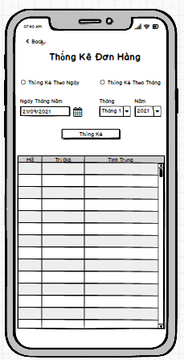

### **Require function**

|  |  |  |  |
| --- | --- | --- | --- |
| **Item** | **Description** | **Behavior** | **Response** |
| **Screen** | Inside the screen include Button Back , TextView Order Statistics, RadioButton Statistics By Date, RadioButton Statistics By Month, DateTime Date May, ComboBox Month, ComboBox Year, Button Statistics,  TextView Date May, TextView Month, TextView Year, Table Statistical Data. Objects such as DateTime Date May, ComboBox Month, ComboBox Year will be locked if one of the two Radio Buttons is not selected for daily statistics and monthly statistics. | N/A | N/A |
| **TextView Order Statistics** | Show the title of the interface | Display | Show the title |
| **Text View Date May** | Display title for DateTime object Date May | Display | Show the title |
| **Text View Month** | Display title for ComboBox object Month | Display | Show the title |
| **Text View Year** | Display title for ComboBox object Year | Display | Show the title |
| **RadioButton Statistics By Day** | Tick ​​it to tell the application to list orders by date and to allow the DateTime object to be unlocked. | Check | Set a date-based statistical requirement and unlock the ability to interact with the DateTime object May Day. |
| **RadioButton Monthly Statistics** | Tick ​​to ask the application to list orders by month and allow to unlock the ComboBox Month and ComboBox Year objects . | Check | Set a monthly statistical requirement and unlock the ability to interact with the ComboBox Month and ComboBox Year objects .. |
| **DateTime Date May** | Click on select a specific date to ask the application to order statistics for the selected day. | Tap On | Displays the date the user has just selected to request order statistics by date |
| **ComboBox Monthly** | Click to select the month in which the user wants to record orders according to the previously selected month | Tap On | Display the month the user has just selected to request order statistics for the previously selected month |
| **ComboBox Five** | Click to select the Year in which the user wants order statistics according to the previously selected month | Tap On | Displays the location that the user has just selected to request order statistics for the previously selected month |
| **Stats Button** | Click to start sending the request that the user has set to get the data and fill in the statistical data table | Tap On | The data is compiled according to the previously set requirements |
| **Statistical Data Table** | This table is used to display the statistical data requested by the user. The table includes columns of information such as, Order ID, Orderer, Address, Value, Status | Display | The data will be displayed inside the table in rows and columns |
| **Button Back** | Click to return to the Revenue Statistics interface | Tap On | Go to the revenue statistics interface |

## **Features / Components: Canceled Order Statistics Screen**

### **User interface**

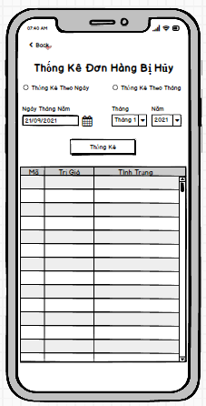

### **Require function**

|  |  |  |  |
| --- | --- | --- | --- |
| **Item** | **Description** | **Behavior** | **Response** |
| **Screen** | Inside the screen include Button Back , TextView Canceled Order Statistics, RadioButton Statistics By Date, RadioButton Statistics By Month, DateTime Date May, ComboBox Month, ComboBox Year, Button Statistics,  TextView Date May, TextView Month, TextView Year, Table Statistical Data. Objects such as DateTime Date May, ComboBox Month, ComboBox Year will be locked if one of the two Radio Buttons is not selected for daily statistics and monthly statistics. | N/A | N/A |
| **TextView Canceled Order Statistics** | Show the title of the interface | Display | Show the title |
| **Text View Date May** | Display title for DateTime object Date May | Display | Show the title |
| **Text View Month** | Display title for ComboBox object Month | Display | Show the title |
| **Text View Year** | Display title for ComboBox object Year | Display | Show the title |
| **RadioButton Statistics By Day** | Tick ​​it to tell the application to count canceled orders by date and allow the DateTime object to be unlocked. | Check | Set a date-based statistical requirement and unlock the ability to interact with the DateTime object May Day. |
| **RadioButton Monthly Statistics** | Tick ​​to request the application to list canceled orders by month and allow to unlock the ComboBox Month and ComboBox objects . | Check | Set a monthly statistical requirement and unlock the ability to interact with the ComboBox Month and ComboBox Year objects.. |
| **DateTime Date May** | Click on select a specific date to request the application to list the canceled orders on the selected date. | Tap On | Displays the date the user has just selected to request statistics of canceled orders by date |
| **ComboBox Monthly** | Click to select the month in which the user wants to record canceled orders according to the previously selected month | Tap On | Display the month that the user has just selected to request statistics of canceled orders according to the previously selected month |
| **ComboBox Five** | Click to select the Year in which the user wants to record canceled orders according to the previously selected month | Tap On | Displays the location that the user has just selected to request the statistics of canceled orders according to the previously selected month |
| **Stats Button** | Click to start sending the request that the user has set to get the data and fill in the statistical data table | Tap On | The data is compiled according to the previously set requirements |
| **Statistical Data Table** | This table is used to display the statistical data requested by the user. The table includes columns of information such as, Order ID, Orderer, Address, Value, Status | Display | The data will be displayed inside the table in rows and columns |
| **Button Back** | Click to return to the Revenue Statistics interface | Tap On | Go to the revenue statistics interface |

## **Features / Components: Statistical screen of the amount payable to the shipping unit**

### **User interface**

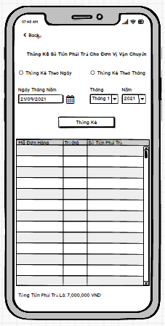

### **Require function**

|  |  |  |  |
| --- | --- | --- | --- |
| **Item** | **Description** | **Behavior** | **Response** |
| **Screen** | Inside the screen include Button Back , TextView Statistics Payable for Shipping Units, RadioButton Statistics By Day, RadioButton Statistics By Month, DateTime May Day, ComboBox Month, ComboBox Year, Button Statistics,  TextView Date May, TextView Month, TextView Year,  TextView Amount To Pay For Shipping, Table Of Statistical Data. Objects such as DateTime Date May, ComboBox Month, ComboBox Year will be locked if one of the two Radio Buttons is not selected for daily statistics and monthly statistics. | N/A | N/A |
| **TextView Statistics Payable for Shipping Units** | Show the title of the interface | Display | Show the title |
| **Text View Date May** | Display title for DateTime object Date May | Display | Show the title |
| **Text View Month** | Display title for ComboBox object Month | Display | Show the title |
| **Text View Year** | Display title for ComboBox object Year | Display | Show the title |
| **RadioButton Statistics By Day** | Tick ​​to ask the application to calculate the amount to be transferred to the carrier by date and to allow the DateTime object to be unlocked. | Check | Set a date-based statistical requirement and unlock the ability to interact with the DateTime object May Day. |
| **RadioButton Monthly Statistics** | Tick ​​to ask the application to calculate the amount to be transferred to the shipping unit by month and allows unlocking the ComboBox Month and ComboBox Year objects . | Check | Set a monthly statistical requirement and unlock the ability to interact with the ComboBox Month and ComboBox Year objects.. |
| **DateTime Date May** | Click on select a specific date to ask the application to calculate the amount to be transferred to the shipping unit on the selected date. | Tap On | Displays the date the user has just selected to request statistics of the amount to be transferred to the carrier according to the selected date |
| **ComboBox Monthly** | Click to select the month in which the user wants to calculate the amount to be transferred to the shipping unit according to the previously selected month | Tap On | Displays the month that the user has just selected to request statistics of the amount to be transferred to the shipping unit according to the previously selected month |
| **ComboBox Five** | Click to select the Year in which the user wants to calculate the amount to be transferred to the shipping unit according to the previously selected month | Tap On | Displays the location that the user has just selected to request the statistics of the amount to be transferred to the shipping unit according to the previously selected month |
| **Stats Button** | Click to start sending the request that the user has set to get the data and fill in the statistical data table | Tap On | The data is compiled according to the previously set requirements |
| **Statistical Data Table** | This table is used to display the statistical data requested by the user. The table includes columns of information such as, Order ID, Value, Amount Payable | Display | The data will be displayed inside the table in rows and columns |
| **Button Back** | Click to return to the Revenue Statistics interface | Tap On | Go to the revenue statistics interface |
| **TextView Amount To Pay For Shipping** | Display the total payable by day or by month | Display | Show total payable |

## **Features / Components: Sales Statistics Screen**

### **User interface**

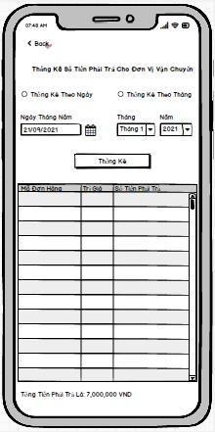

### **Require function**

|  |  |  |  |
| --- | --- | --- | --- |
| **Item** | **Description** | **Behavior** | **Response** |
| **Screen** | Inside the screen include Button Back , TextView Sales Statistics, RadioButton Statistics By Date, RadioButton Statistics By Month, DateTime Date May, ComboBox Month, ComboBox Year, Button Statistics,  TextView Date May, TextView Month, TextView Year,  TextView Total Revenue, Table of Statistical Data. Objects such as DateTime Date May, ComboBox Month, ComboBox Year will be locked if one of the two Radio Buttons is not selected for daily statistics and monthly statistics. | N/A | N/A |
| **TextView Revenue** | Show the title of the interface | Display | Show the title |
| **Text View Date May** | Display title for DateTime object Date May | Display | Show the title |
| **Text View Month** | Display title for ComboBox object Month | Display | Show the title |
| **Text View Year** | Display title for ComboBox object Year | Display | Show the title |
| **RadioButton Statistics By Day** | Tick ​​it to ask the application to calculate the revenue by date and allow the DateTime object to be unlocked. | Check | Set a date-based statistical requirement and unlock the ability to interact with the DateTime object May Day. |
| **RadioButton Monthly Statistics** | Tick ​​to request the application to calculate the monthly revenue and allow the ComboBox Month and ComboBox Year objects to be unlocked . | Check | Set a monthly statistical requirement and unlock the ability to interact with the ComboBox Month and ComboBox Year objects.. |
| **DateTime Date May** | Click on select a specific date to ask the application for revenue statistics for the selected day. | Tap On | Display the date selected by the user to request sales statistics for the selected date |
| **ComboBox Monthly** | Click to select the month in which the user wants the revenue statistics for the previously selected month | Tap On | Displays the month the user has just selected to request revenue statistics for the previously selected month |
| **ComboBox Five** | Click to select the Year in which the user wants the revenue statistics for the previously selected month | Tap On | Displays the location that the user has just selected to request revenue statistics for the previously selected month |
| **Stats Button** | Click to start sending the request that the user has set to get the data and fill in the statistical data table | Tap On | The data is compiled according to the previously set requirements |
| **Statistical Data Table** | This table is used to display the statistical data requested by the user. The table includes columns of information such as, Order ID, Value, Amount Payable | Display | The data will be displayed inside the table in rows and columns |
| **Button Back** | Click to return to the Revenue Statistics interface | Tap On | Go to the revenue statistics interface |
| **TextView Total Revenue** | Display total sales by day or by month | Display | Show total revenue |

## **Features / Components: Customer Rating Statistics Screen**

### **User interface**

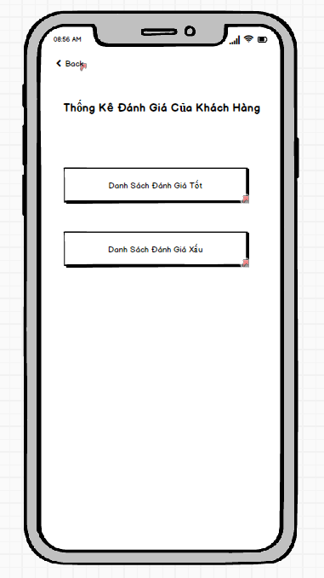

### **Require function**

|  |  |  |  |
| --- | --- | --- | --- |
| **Item** | **Description** | **Behavior** | **Response** |
| **Screen** | Inside the screen include Button Back , TextView Customer Review Statistics, Button, Good Review Button, Bad Review Button | N/A | N/A |
| **Good Review Button** | Click this Button to go to the statistics interface of good customer reviews. | Tap On | Go to the good reviews statistics interface |
| **Bad Rating Statistics Button** | Click this Button to go to the statistics interface of bad customer reviews. | Tap On | Go to the bad reviews statistics interface |
| **Text View Customer Rating Statistics** | Show the title of the interface | Tap On | Show interface title |
| **Button Back** | Click to return to the main interface of the store owner authorization | Tap On | Go to the main interface of the store owner decentralization |

## **Features / Components: Good Rating Stats Monitor**

### **User interface**

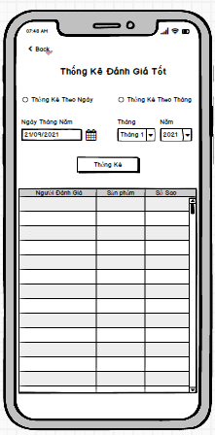

### **Require function**

|  |  |  |  |
| --- | --- | --- | --- |
| **Item** | **Description** | **Behavior** | **Response** |
| **Screen** | Inside the screen include Button Back , TextView Stats Good Rating, RadioButton Statistics By Date, RadioButton Statistics By Month, DateTime Date May, ComboBox Month, ComboBox Year, Button Statistics,  TextView Date May, TextView Month, TextView Year,  TextView Total Revenue, Table of Statistical Data. Objects such as DateTime Date May, ComboBox Month, ComboBox Year will be locked if one of the two Radio Buttons is not selected for daily statistics and monthly statistics. | N/A | N/A |
| **TextView Statistics Good Review** | Show the title of the interface | Display | Show the title |
| **Text View Date May** | Display title for DateTime object Date May | Display | Show the title |
| **Text View Month** | Display title for ComboBox object Month | Display | Show the title |
| **Text View Year** | Display title for ComboBox object Year | Display | Show the title |
| **RadioButton Statistics By Day** | Tick ​​it to tell the statistical application to rate well by date and to allow the DateTime object to be unlocked. | Check | Set a date-based statistical requirement and unlock the ability to interact with the DateTime object May Day. |
| **RadioButton Monthly Statistics** | Tick ​​to ask the application to calculate the good rating by month and allow to unlock the ComboBox Month and ComboBox Year objects . | Check | Set a monthly statistical requirement and unlock the ability to interact with the ComboBox Month and ComboBox Year objects.. |
| **DateTime Date May** | Click to select a specific date to ask the application for good evaluation statistics according to the selected date. | Tap On | Display the date the user has just selected to request good rating statistics according to the selected date |
| **ComboBox Monthly** | Click to select the month in which the user wants good statistics according to the previously selected month | Tap On | Display the month that the user has just selected to request good review statistics according to the previously selected month |
| **ComboBox Five** | Click to select the Year in which the user wants good review statistics according to the previously selected month | Tap On | Displays the location that the user has just selected to ask for good rating statistics according to the previously selected month |
| **Stats Button** | Click to start sending the request that the user has set to get the data and fill in the statistical data table | Tap On | The data is compiled according to the previously set requirements |
| **Statistical Data Table** | This table is used to display the statistical data requested by the user. The table includes columns of information such as, Reviewer, Product Name, Number of Stars, Review Content | Display | The data will be displayed inside the table in rows and columns |
| **Button Back** | Click to return to the Customer Rating Statistics interface | Tap On | Go to the customer rating statistics interface |

## **Features / Components: Bad Rating Stats Monitor**

### **User interface**

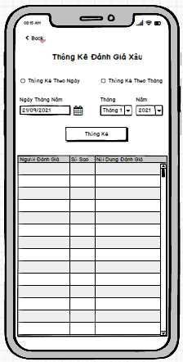

### **Require function**

|  |  |  |  |
| --- | --- | --- | --- |
| **Item** | **Description** | **Behavior** | **Response** |
| **Screen** | Inside the screen include Button Back , TextView Bad Rating Statistics, RadioButton Statistics By Date, RadioButton Statistics By Month, DateTime Date May, ComboBox Month, ComboBox Year, Button Statistics,  TextView Date May, TextView Month, TextView Year,  TextView Total Revenue, Table of Statistical Data. Objects such as DateTime Date May, ComboBox Month, ComboBox Year will be locked if one of the two Radio Buttons is not selected for daily statistics and monthly statistics. | N/A | N/A |
| **TextView Bad Rating Stats** | Show the title of the interface | Display | Show the title |
| **Text View Date May** | Display title for DateTime object Date May | Display | Show the title |
| **Text View Month** | Display title for ComboBox object Month | Display | Show the title |
| **Text View Year** | Display title for ComboBox object Year | Display | Show the title |
| **RadioButton Statistics By Day** | Tick ​​it to tell the application to report bad rating by date and to allow the DateTime object to be unlocked. | Tap On | Set a date-based statistical requirement and unlock the ability to interact with the DateTime object May Day. |
| **RadioButton Monthly Statistics** | Tick ​​to ask the application to calculate the bad rating by month and allow to unlock the ComboBox Month and ComboBox Year objects . | Tap On | Set a monthly statistical requirement and unlock the ability to interact with the ComboBox Month and ComboBox Year objects.. |
| **DateTime Date May** | Click to select a specific date to ask the application to report bad reviews according to the selected date. | Tap On | Displays the date the user has just selected to request bad review statistics according to the selected date |
| **ComboBox Monthly** | Click to select the month in which the user wants the bad rating statistics according to the previously selected month | Tap On | Displays the month the user has just selected to request bad review statistics according to the previously selected month |
| **ComboBox Five** | Click to select the Year in which the user wants bad rating statistics according to the previously selected month | Tap On | Display the location that the user has just selected to ask for bad review statistics according to the previously selected month |
| **Stats Button** | Click to start sending the request that the user has set to get the data and fill in the statistical data table | Tap On | The data is compiled according to the previously set requirements |
| **Statistical Data Table** | This table is used to display the statistical data requested by the user. The table includes columns of information such as, Reviewer, Product Name, Number of Stars, Review Content | Display | The data will be displayed inside the table in rows and columns |
| **Button Back** | Click to return to the Customer Rating Statistics interface | Tap On | Go to the customer rating statistics interface |

## **Features / Components: Inventory Monitor**

### **User interface**

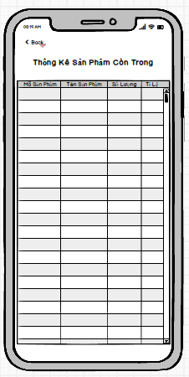

### **Require function**

|  |  |  |  |
| --- | --- | --- | --- |
| **Item** | **Description** | **Behavior** | **Response** |
| **Screen** | Inside the screen include Button Back , TextView Inventory Statistics, Table of Statistical Data | N/A | N/A |
| **Statistical Data Table** | This table is used to display statistical data as soon as you enter the interface. The table includes columns of information such as Product Code, Product Name, Remaining Quantity | Display | The data will be displayed inside the table in rows and columns |
| **Text View Statistics** | Show the title of the interface | Tap On | Show interface title |
| **Button Back** | Click to return to the Shop Owner interface | Tap On | Go to inventory statistics interface |

## **Features / Components: Handler Monitor**

### **User interface**

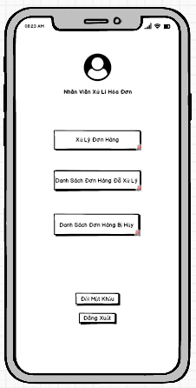

### **Require function**

|  |  |  |  |
| --- | --- | --- | --- |
| **Item** | **Description** | **Behavior** | **Response** |
| **Screen** | Inside the screen include the Administrator's Photo, the administrator's title, the Order Processing Button, the Processed Order List Button, the Canceled Order List Button and the Log Out Button. | N/A | N/A |
| **Order Processing Button** | Click this Button to go to the App's order processing interface. | Tap On | Go to the order processing interface |
| **Processed Order List Button** | Click this Button to go to the App's processed orders interface. | Tap On | Go to the processed orders interface |
| **Canceled Order List Button** | Click this Button to go to the App's canceled order list interface. | Tap On | Go to the canceled order list interface |
| **Log Out Button** | Click this Button to log out of the account and switch to the App's login interface. | Tap On | Log out of your account and return to the login interface |

## **Features / Components: Order Processing Screen**

### **User interface**

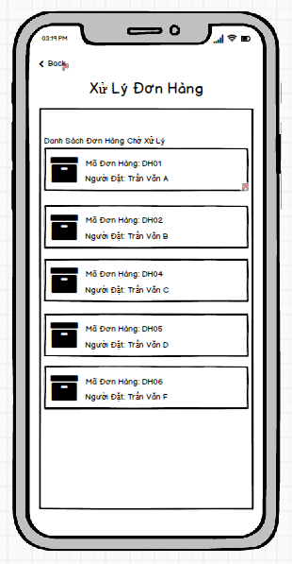

### **Require function**

|  |  |  |  |
| --- | --- | --- | --- |
| **Item** | **Description** | **Behavior** | **Response** |
| **Screen** | Inside the screen includes Button Back, TextView Order Processing, TextView List of Pending Orders and ViewGroups with information of pending orders. | N/A | N/A |
| **TextView Order Processing** | Show title for interface | Display | Show interface title |
| **TextView List of Pending Orders** | Display title for pending order ViewGroup objects | Display | Show title for list of pending orders |
| **Log Out Button** | Click this Button to log out of the account and switch to the App's login interface. | Tap On | Log out of your account and return to the login interface |
| **ViewGroup Pending Orders** | Inside View Group includes order icon, Order ID TextView, Orderer TextView. With each ViewGroup representing a pending order, clicking on one of the ViewGroups will take you to the order details page that the ViewGroup displays. | Tap On | Go to order details page |
| **Button Back** | Click to return to the handler interface | Tap On | Go to handler interface |

## **Features / Components: Order Detail Screen**

### **User interface**

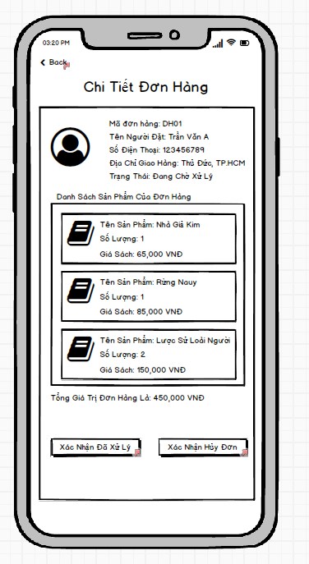

### **Require function**

|  |  |  |  |
| --- | --- | --- | --- |
| **Item** | **Description** | **Behavior** | **Response** |
| **Screen** | Inside the screen include the Back Button, Order Detail TextView, Order Details ViewGroup, Order Product Information ViewGroups, Product List TextView, Order Total Value TextView, Processed Confirmation Button Reason, Confirm Order Cancellation | N/A | N/A |
| **TextView Order Details** | Show title for interface | Display | Show interface title |
| **TextView Product List** | Display the title for the product ViewGroup objects of the order | Display | Display title for ViewGroup objects |
| **Text View Total Order Value** | Display the total value of the order | Display | Display the total value of the order |
| **ViewGroup Booking Information** | Inside the View Group includes the person's account avatar, Order ID TextView, Orderer Name TextView, Phone Number TextView, Address TextView, Order Status TextView. This ViewGroup is used to display information of the person placing the order. | Display | Display information of the person placing the order |
| **ViewGroup product information of the order** | Inside the View Group include the product's photo, TextView Product Name, TextView Number of User Sets, TextView Price Of Product. This ViewGroup is used to display detailed information of each product inside the order | Display | Display product information inside the order |
| **Confirmation Processed Button** | Click to send confirmation that this order has been processed | Tap On | Show processing confirmation message, this message allows to choose yes or no. If you select yes, a confirmation message of successful order processing will be displayed and a Close Button will close the message. If you choose not, it will close the notification and do nothing |
| **Cancellation Confirmation Button** | Click to send confirmation that this order will be cancelled | Tap On | Show a confirmation message to cancel the order, this message allows you to choose yes or no. If you choose yes, a confirmation message will be displayed to confirm the successful order cancellation and a Close Button to close the notification. If you choose not, it will close the notification and do nothing |
| **Button Back** | Click to return to the order processing interface | Tap On | Go to the order processing interface |

## **Features / Components: Canceled Order List Screen**

### **User interface**

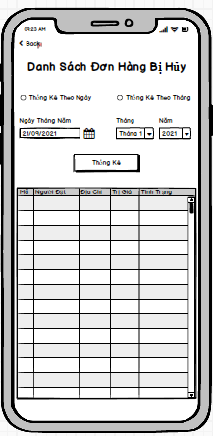

### **Require function**

|  |  |  |  |
| --- | --- | --- | --- |
| **Item** | **Description** | **Behavior** | **Response** |
| **Screen** | Inside the screen include Button Back , TextView Statistics Canceled Order List, RadioButton Statistics By Date, RadioButton Statistics By Month, DateTime Date May, ComboBox Month, ComboBox Year, Button Statistics,  TextView Date May, TextView Month, TextView Year, Table Statistical Data. Objects such as DateTime Date May, ComboBox Month, ComboBox Year will be locked if one of the two Radio Buttons is not selected for daily statistics and monthly statistics. | N/A | N/A |
| **TextView List of Canceled Orders** | Show the title of the interface | Display | Show the title |
| **Text View Date May** | Display title for DateTime object Date May | Display | Show the title |
| **Text View Month** | Display title for ComboBox object Month | Display | Show the title |
| **Text View Year** | Display title for ComboBox object Year | Display | Show the title |
| **RadioButton Statistics By Day** | Tick ​​it to tell the application to count canceled orders by date and allow the DateTime object to be unlocked. | Check | Set a date-based statistical requirement and unlock the ability to interact with the DateTime object May Day. |
| **RadioButton Monthly Statistics** | Tick ​​to request the application to list canceled orders by month and allow to unlock the ComboBox Month and ComboBox objects . | Check | Set a monthly statistical requirement and unlock the ability to interact with the ComboBox Month and ComboBox Year objects.. |
| **DateTime Date May** | Click on select a specific date to request the application to list the canceled orders on the selected date. | Click | Displays the date the user has just selected to request statistics of canceled orders by date |
| **ComboBox Monthly** | Click to select the month in which the user wants to record canceled orders according to the previously selected month | Tap On | Display the month that the user has just selected to request statistics of canceled orders according to the previously selected month |
| **ComboBox Five** | Click to select the Year in which the user wants to record canceled orders according to the previously selected month | Tap On | Displays the location that the user has just selected to request the statistics of canceled orders according to the previously selected month |
| **Stats Button** | Click to start sending the request that the user has set to get the data and fill in the statistical data table | Tap On | The data is compiled according to the previously set requirements |
| **Statistical Data Table** | This table is used to display the statistical data requested by the user. The table includes columns of information such as, Order ID, Orderer, Address, Value, Status | Display | The data will be displayed inside the table in rows and columns |
| **Button Back** | Click to return to the handler interface | Tap On | Go to handler interface |

## **Features / Components: Processed Order List Screen**

### **User interface**

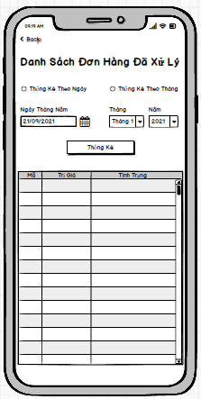

### **Require function**

|  |  |  |  |
| --- | --- | --- | --- |
| **Item** | **Description** | **Behavior** | **Response** |
| **Screen** | Inside the screen include Button Back , TextView List of Processed Orders, RadioButton Statistics By Date, RadioButton Statistics By Month, DateTime Date May, ComboBox Month, ComboBox Year, Button Statistics,  TextView Date May, TextView Month, TextView Year, Table Statistical Data. Objects such as DateTime Date May, ComboBox Month, ComboBox Year will be locked if one of the two Radio Buttons is not selected for daily statistics and monthly statistics. | N/A | N/A |
| **TextView List of Processed Orders** | Show the title of the interface | Display | Show the title |
| **Text View Date May** | Display title for DateTime object Date May | Display | Show the title |
| **Text View Month** | Display title for ComboBox object Month | Display | Show the title |
| **Text View Year** | Display title for ComboBox object Year | Display | Show the title |
| **RadioButton Statistics By Day** | Tick ​​it to ask the application to list processed orders by date and to allow the DateTime object to be unlocked. | Check | Set a date-based statistical requirement and unlock the ability to interact with the DateTime object May Day. |
| **RadioButton Monthly Statistics** | Tick ​​to ask the application to list the processed orders by month and allow the ComboBox Month and ComboBox Year objects to be unlocked . | Check | Set a monthly statistical requirement and unlock the ability to interact with the ComboBox Month and ComboBox Year objects.. |
| **DateTime Date May** | Click on select a specific date to ask the application to list the orders processed in the selected day. | Tap On | Display the date the user has just selected to request the processed order statistics by date |
| **ComboBox Monthly** | Click to select the month in which the user wants the processed order statistics according to the previously selected month | Tap On | Displays the month the user has just selected to request the processed order statistics according to the previously selected month |
| **ComboBox Five** | Click to select the Year in which the user wants to record the processed orders according to the previously selected month | Tap On | Displays the location that the user has just selected to ask for the processed order statistics according to the previously selected month |
| **Stats Button** | Click to start sending the request that the user has set to get the data and fill in the statistical data table | Tap On | The data is compiled according to the previously set requirements |
| **Statistical Data Table** | This table is used to display the statistical data requested by the user. The table includes columns of information such as, Order ID, Orderer, Address, Value, Status | Display | The data will be displayed inside the table in rows and columns |
| **Button Back** | Click to return to the handler interface | Tap On | Go to handler interface |

## **Features/Components: Management Screen**

### **User interface**

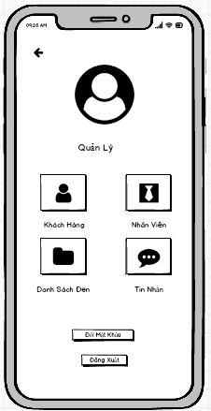

### **Require function**

|  |  |  |  |
| --- | --- | --- | --- |
| **Item** | **Description** | **Action** | **Response** |
| **Management screen** | Management screen with 6 buttons, 1 TextView:  ●          User  ●          Employee  ●          Blacklist  ●          Message  ●         Manage  ●         Change password  ●         Logout | N/A | N/A |
| **User button** | Go to the user account management screen | Tap on User button | The user management screen appears |
| **Block button** | Go to the user account management screen | Tap on Block button | The user blocking management screen appears |
| **Employee button** | Go to employee account management screen | Tap on Employee button | Employee management screen appears |
| **Blacklist button** | Go to the blacklist account management screen | Tap on Blacklist button | Blacklist management screen appears |
| **Message button** | Go to the message management screen | Tap on Message button | The message management screen appears |
| **Manage TextView** | Display the name of the screen | N/A | N/A |
| **Change Password button** | Go to the change password screen | Tap on Change Password button | The change password screen appears |
| **Logout button** | Sign out account | Tap on Logout button | The login screen appears |

## **Features/Components: User Management Screen**

### **User interface**

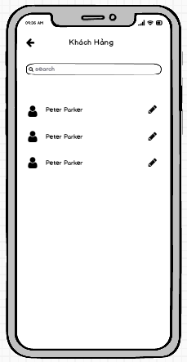

### **Require function**

|  |  |  |  |
| --- | --- | --- | --- |
| **Item** | **description** | **Action** | **Response** |
| **User management screen** | The user management screen has 2 buttons, 1 search box:  ●          Update  ●          Back  ●          Search Box | N/A | N/A |
| **Update button** | Update user information | Tap on Update button | Go to user account update screen |
| **Back button** | Back to screen | Tap on Back button | Back to Management screen |
| **Search Box** | Search for users | Tap on Search Box | Search for users |

## **Features/Components: User Update Screen**

### **User interface**

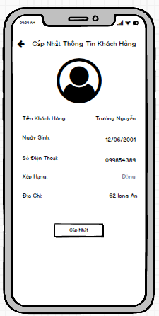

### **Require function**

|  |  |  |  |
| --- | --- | --- | --- |
| **Item** | **Description** | **Action** | **Response** |
| **User Update Screen** | Update user screen has 1 buttons ,5 Edit Text:  ●         Update  ●          Back  ●          Name  ●        Birthday  ●        Phone  ●         Rank  ●         Address | N/A | N/A |
| **Update button** | Update customer information | Tap on Update button | Save the information customer, return to the user management screen |
| **Name edittext** | Enter user account | Tap on Name edittext | Enter the fullname for customer |
| **Birthday edittext** | Enter user password | Tap on Birthday edittext | Enter the birthday for customer |
| **Phone edittext** | Enter the number phone | Tap on Phone edittext | Enter the number phone for customer |
| **Rank edittext** | Display rank | Tap on Rank edittext | Display rank for customer |
| **Address edittext** | Enter the password | Tap on Address edittext | Enter the addres for customer |

## **Features/Components: Blacklist Screen**

### **User interface**

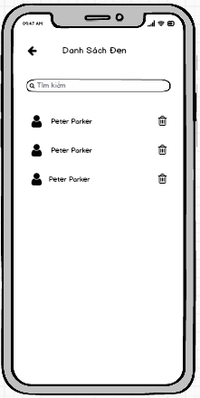

### **Require function**

|  |  |  |  |
| --- | --- | --- | --- |
| **Item** | **Description** | **Action** | **Response** |
| **Blacklist screen** | The  blacklist screen has 2 buttons, 1 search box:  ●          Delete  ●          Back  ●          Search Box | N/A | N/A |
| **Delete button** | Delete user account | Tap on Delete button | Remove user account from blacklist |
| **Back button** | Back to screen | Tap on Back button | Back to Management screen |
| **Search Box** | Search for users | Tap on Search Box | Search for users |

## **Features/Components:Add Blacklist Screen**

### **User interface**

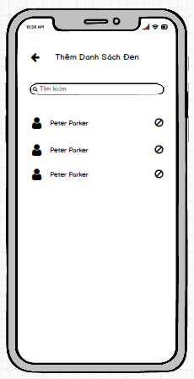

### **Require function**

|  |  |  |  |
| --- | --- | --- | --- |
| **Item** | **description** | **Action** | **Response** |
| **Add Blacklist screen** | Add blacklist has 2 buttons ,1 search box:  ●          Check  ●          Back  ●          Search Box | N/A | N/A |
| **Block button** | Add a user account to the blacklist | Tap on Block button | Add a user account to the blacklist |
| **Back button** | Back to screen | Tap on Back button | Back to Blacklist screen |
| **Search Box** | Search for users | Tap on Search Box | Search for users |

## **Features/Components: Main Blacklist Screen**

### **User interface**

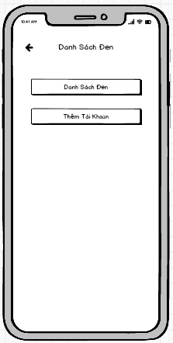

### **Require function**

|  |  |  |  |
| --- | --- | --- | --- |
| **Item** | **description** | **Action** | **Response** |
| **Block screen** | Block screen has 3 buttons :  ●          Blacklist  ●          Back  ●          Add blacklist | N/A | N/A |
| **Blacklist button** | Switch interface blacklist screen | Tap on Blacklist button | A popup Blacklist screen |
| **Back button** | Back to screen | Tap on Back button | Back to Management screen |
| **Add blacklist button** | Switch interface add blacklist screens | Tap on Add blacklist button | A popup Add Blacklist screen |

## **Features/Components: Massage Screen**

### **User interface**

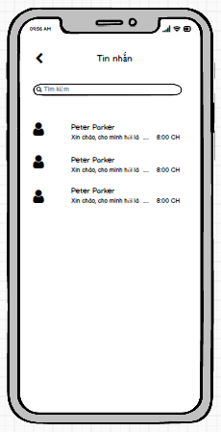

### **Require function**

|  |  |  |  |
| --- | --- | --- | --- |
| **Item** | **description** | **Action** | **Response** |
| **Massage screen** | Message screen has 2 buttons ,1 search box,1 Listview:  ●          Message Listview  ●          Back  ●          Search Box | N/A | N/A |
| **Message listview** | Show list of chats | Tap on Add button | Tap on the chat to go to the chat screen |
| **Back button** | Back to screen | Tap on Back button | Back to Management screen |
| **Search Box** | Search for users | Tap on Search Box | Search chat |

## **Features/Components: Chat Screen**

### **User interface**

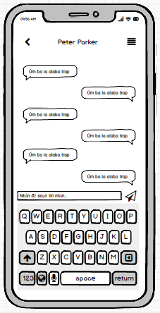

### **Require function**

|  |  |  |  |
| --- | --- | --- | --- |
| **Item** | **description** | **Action** | **Response** |
| **Employee screen** | Employee screen has 2 buttons ,1 Edit text:  ●          Back  ●          Edit Text  ●          Send | N/A | N/A |
| **Chat EditText** | Enter the message you want to send in the chat | Tap on Update button | Go to employee information update screen |
| **Send button** | Send a message you're composing | Tap on Delete button | Delete employee information |
| **Back button** | Back to screen | Tap on Back button | Back to Massage screen |

## **Features/Components: Employee Screen**

### **User interface**

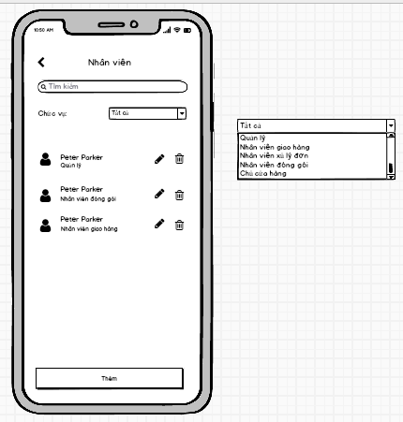

### **Require function**

|  |  |  |  |
| --- | --- | --- | --- |
| **Item** | **description** | **Action** | **Response** |
| **Employee screen** | Employee screen has 4 buttons ,1 Search Box,1 Combo Box,1 TextView:  ●          Add  ●          Delete  ●          Update  ●          Back  ●          Search Box  ●          Position  ●          Position Combo Box | N/A | N/A |
| **Add button** | Add to employee | Tap on Add button | Add a new employee |
| **Update button** | Update employee information | Tap on Update button | Go to employee information update screen |
| **Delete button** | Delete employee | Tap on Delete button | Delete employee information |
| **Back button** | Back to screen | Tap on Back button | Back to Management screen |
| **Search Box** | Looking for employees | Tap on Search Box | Looking for employees |
| **Roles TextView** | Show name of combo box | N/A | N/A |
| **Roles Combo Box** | Filter the list of employees by role | Select roles All | Show All roles on the Combo Box |
| Select roles Management | Show Management roles on the Combo Box |
| Select roles Shipper | Show Shipper roles on the Combo Box |
| Select roles Order handled | Show Order handle roles on the Combo Box |
| Select roles Packer | Show Packer roles on the Combo Box |
| Select roles Shop Owner | Show Shop Owner roles on the Combo Box |

## **Features/Components:Add Employee Screen**

### **User interface**

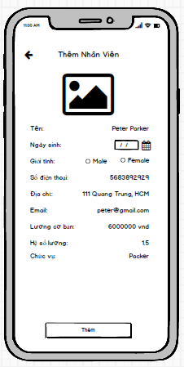

### **Require function**

|  |  |  |  |
| --- | --- | --- | --- |
| **Item** | **description** | **Action** | **Response** |
| **Add Employee screen** | Add Employee screen has 2 Button,2 Radio Button ,8 Edit Text,1 Date Chooser,1 Combo Box:  ●          Add  ●          Username  ●          Password  ●          Back  ●          Name  ●          Birth of day  ●          Gender  ●          Phone  ●          Address  ●          Email  ●          Basic salary  ●          Coefficient  ●          Roles | N/A | N/A |
| **Name edittext** | Enter employee name | Tap on Name edittext | Save information |
| **Birth of day edittext** | Enter date of birth | Tap on Birth of day date chooser | Back to Employee screen |
| **Gender radio button** | Choose your gender | Tap on Male radio button or Female radio button | Gender selection |
| **Phone edittext** | Enter your phone number | Tap on Phone edittext | Enter your phone number |
| **Address edittext** | Enter address | Tap on Address edittext | Enter address |
| **Email edittext** | Enter your email address | Tap on Email edittext | Enter your email address |
| **Basic salary edittext** | Enter basic salary | Tap on Basic salary edittext | Enter basic salary |
| **Coefficient edittext** | Enter salary coefficient | Tap on Coefficient edittext | Enter salary coefficient |
| **Roles edittext** | Enter the position for the employee | Tap on Position **e**text | Enter the position for the employee |
| **Username Edit Text** | Enter account | Tap on Username EditText | Enter the employee's account name |
| **Password Edit Text** | Enter password | Tap on Password EditText | Enter the employee's password |
| **Add Button** | Save the newly created account | Tap on Save Button | Save the newly created account and return to the staff management screen |

## **Features/Components:Update Employee Screen**

### **User interface**

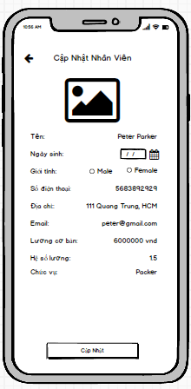

### **Require function**

|  |  |  |  |
| --- | --- | --- | --- |
| **Item** | **description** | **Action** | **Response** |
| **Update Employee screen** | Update Employee screen has 2 Button,2 Radio Button ,8 Edit Text,1 Date Chooser, 1 Combo Box:  ●          Update  ●          Back  ●          Username  ●          Password  ●          Name  ●          Birth of day  ●          Gender  ●          Phone  ●          Address  ●          Email  ●          Basic salary  ●          Coefficient  ●          Roles | N/A | N/A |
| **Name edittext** | Enter employee name | Tap on Name edittext | Save information |
| **Birth of day edittext** | Enter date of birth | Tap on Birth of day date chooser | Back to Employee screen |
| **Gender radio button** | Choose your gender | Tap on Male radio button or Female radio button | Gender selection |
| **Phone edittext** | Enter your phone number | Tap on Phone edittext | Enter your phone number |
| **Address edittext** | Enter address | Tap on Address edittext | Enter address |
| **Email edittext** | Enter your email address | Tap on Email edittext | Enter your email address |
| **Basic salary edittext** | Enter basic salary | Tap on Basic salary edittext | Enter basic salary |
| **Coefficient edittext** | Enter salary coefficient | Tap on Coefficient edittext | Enter salary coefficient |
| **Roles Combo Box** | Choose a role for an employee | Select roles on the Combo Box | Choose a role for an employee |
| **Username Edit Text** | Enter account | Tap on Username EditText | Enter the employee's account name |
| **Password Edit Text** | Enter password | Tap on Password EditText | Enter the employee's password |
| **Update Button** | Save the updated information | Tap on Save Button | Save the updated information and return to the employee management screen |

1. **Thiết Kế Hệ Thống**
   1. **Giới Thiệu**
      1. **Tổng Quan**

* This application makes it easy for users to order the books they need. Suitable for those who like fast and convenient.
* Make it easy for administrators to use and manage.
* Order quickly and conveniently.
* Shiper is easy to handle delivery and delivery.
  + 1. **Phạm Vi**

●     Operating System: Android 7.0

●     Test device: Google Pixel 3

●     Display: 1080 X 2160

●     Only supports vertical screen

●     An internet connection is required

* 1. **Đặc Tả Hệ Thống**
     1. **Mô Tả Kiến Trúc Chung**
        1. **Tổng Quát**

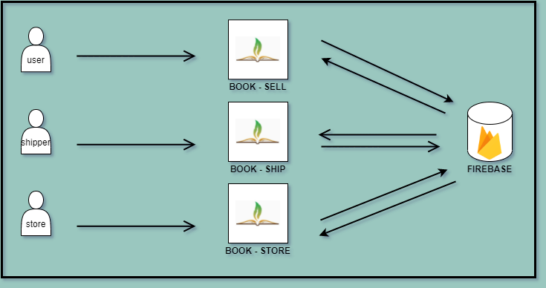

* + - 1. **Workflow**
* **Store**

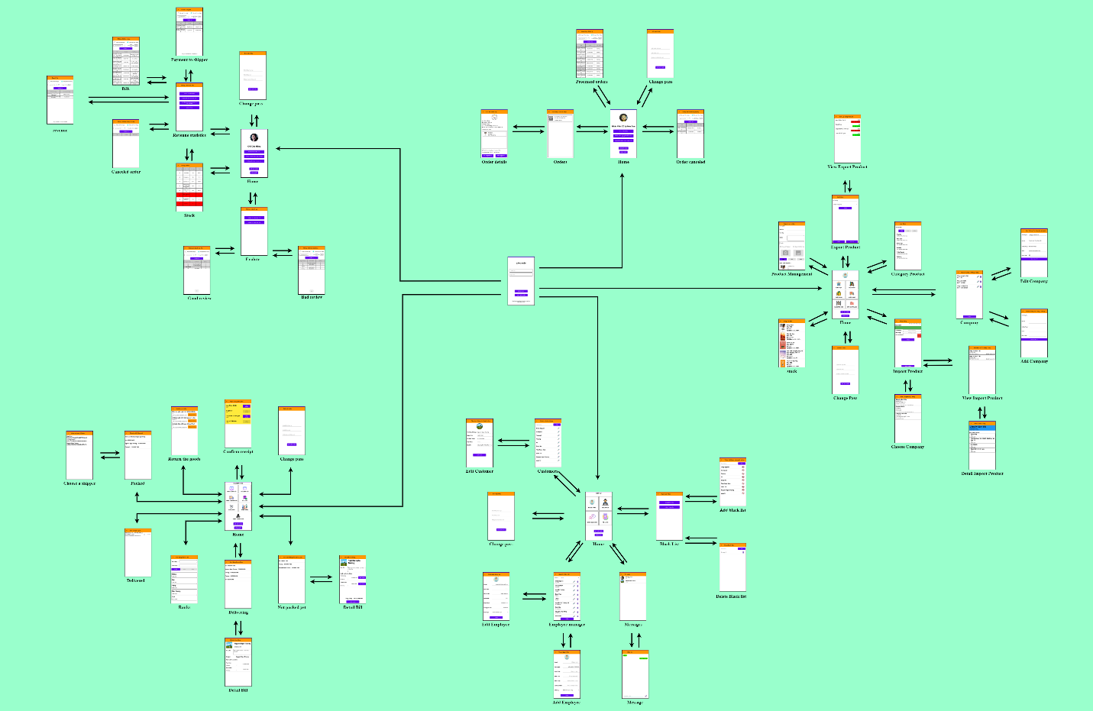

* **Customer**

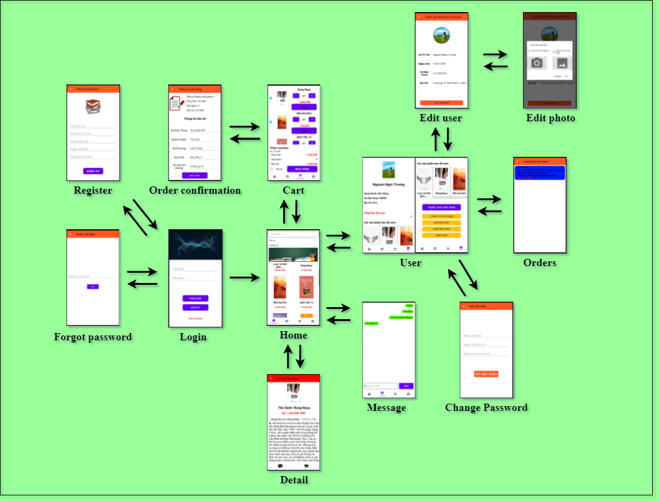

* **Shipper**

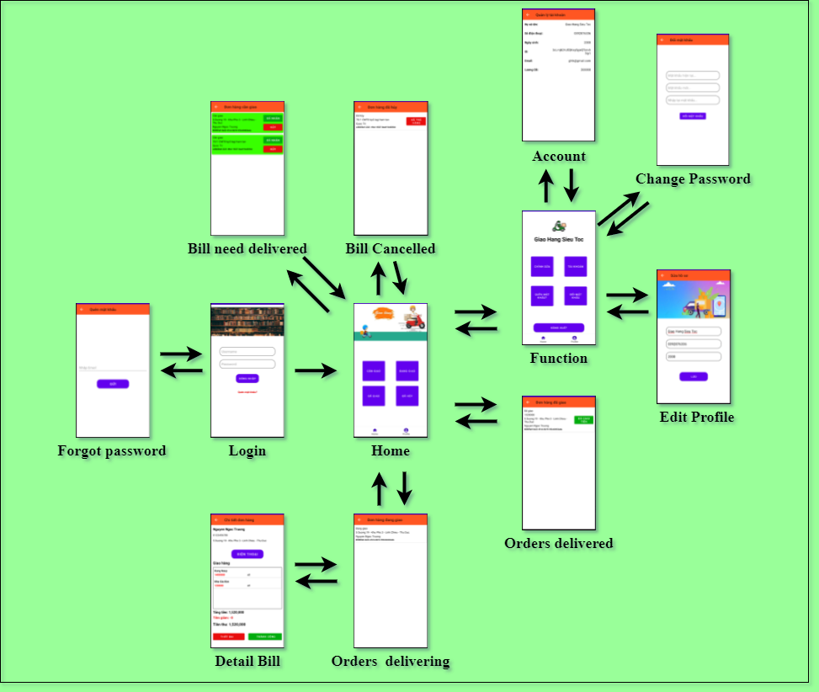

* **Database**

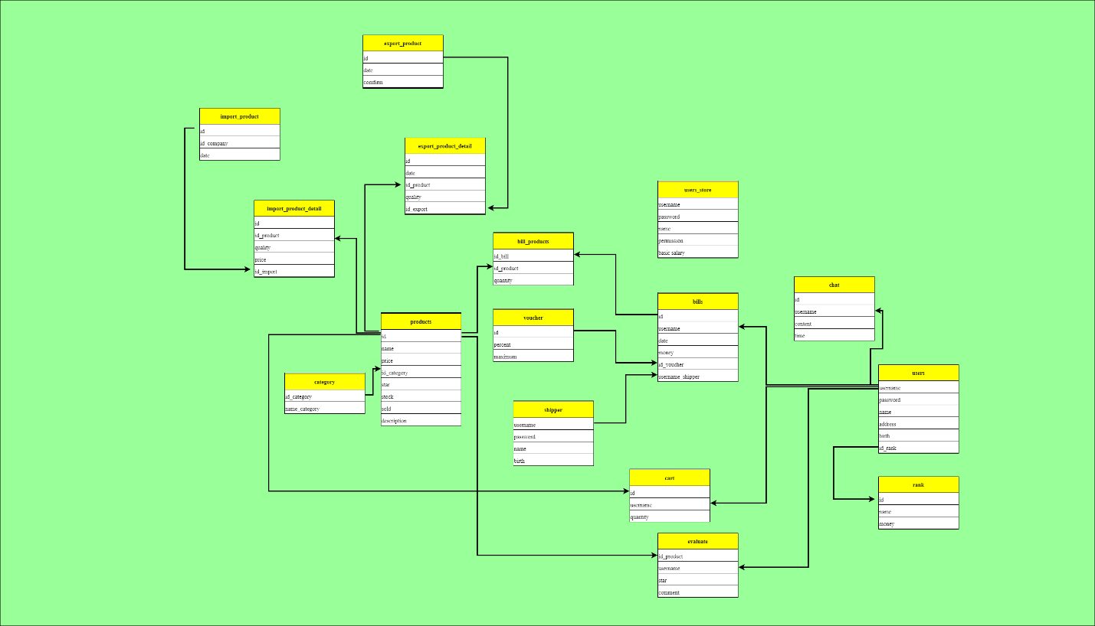

* + 1. **Đặc Tả Chức Năng Hệ Thống**

## **Features / Ingredients: Login Screen**

### **User interface**

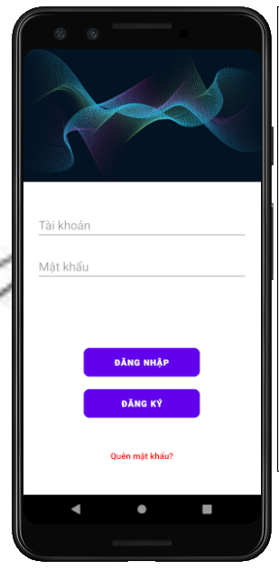

### **Require function**

|  |  |  |  |
| --- | --- | --- | --- |
| **Item** | **description** | **Behavior** | **Response** |
| Login Screen | Login Screen has:   * Image * EditText “Username” * EditText “Password” * Button ”Login” * Button “Sign up” * Forgot password * Icon facebook * Icon google | N/A | N/A |
| Image | Show photos | N/A | N/A |
| EditText “Username” | Used to enter the user’ s email | Tab on and enter | The entered user’ s email will be displayed in the edittext |
| EditText ”Password” | Used to enter the password | Tab on and enter | The entered password will be displayed in the edittext, the password will be formatted “*” |
| Button “login” | After entering the user’s email and password, tab on the login button to go to main screen | Tab on | Go to home screen |
| If the email and password do not exist correctly in the database, a dialog box will be displayed with the content “Invalid email or password” and tab on “close” button to close a dialog box | Tab on | A dialog box will be displayed with the content “Invalid email or password” |
| Button “sign up” | Used to register user accounts, tab on sign up button to go to sign up screen | Tab on | Go to Sign up screen |
| Forgot password | Used to recover password, tab on forgot password to go to forgot password screen. | Tab on | Go to forgot password screen |

## **Features / Components: Sign up Screen**

### **User interface**

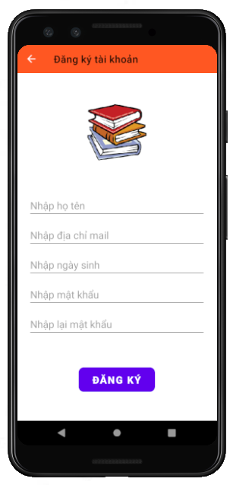

### **Require function**

|  |  |  |  |
| --- | --- | --- | --- |
| **Item** | **Description** | **Behavior** | **Response** |
| Sign up Screen | Sign up Screen has:   * Arrow-left * Image * EditText “Username” * EditText “email” * EditText “birthday” * EditText “password” * EditText “Repassword” * Button ”sign up” | N/A | N/A |
| Arrow-left | Back to login screeen | Tab | Back to login screeen |
| Image | Show logo | Show | N/A |
| EditText “username” | Used to enter the user’ s name | Tab and enter | The entered user’ s name will be displayed in the edittext |
| EditText “email” | Used to enter the user’ s email | Tab on and enter | The entered user’ s email will be displayed in the edittext |
| EditText “birthday” | Used to enter the user’ s birthday | Tab on and enter | The entered user’ s birthday will be displayed in the edittext |
| EditText ”Password” | Used to enter the password | Tab on and enter | The entered password will be displayed in the edittext, the password will be formatted “*” |
| EditText ”Repassword” | Used to enter the password again | Tab on and enter | The entered password will be displayed in the edittext, the password will be formatted “*” |
| Button “Sign up” | After entering all the information, tab on the sign up button to create an account | Tab on | Create an account |
| If you empty any field blank, , a dialog box will be displayed with the content "please enter all information" | Tab on | A dialog box will be displayed with the content "please enter all information" |
| After successful registration the data will be uploaded to firebase | N/A | Uploaded to firebase |

## **Features / Components: Forgot Password Screen**

### **User interface**

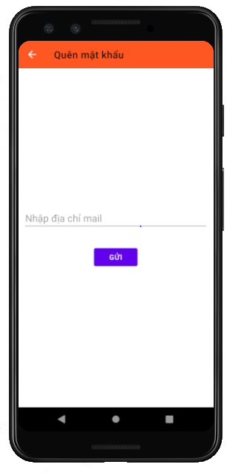

### **Require function**

|  |  |  |  |
| --- | --- | --- | --- |
| **Item** | **Description** | **Behavior** | **Response** |
| Forgot Password Screen | Forgot Password Screen has:   * Arrow-left * EditText “Email” * Button “send” | N/A | N/A |
| Arrow-left | Back to login screeen | Tab on | Back to login screeen |
| EditText “email” | Used to enter the user’ s email | Tab on and enter | The entered user’ s email will be displayed in the edittext |
| Button “send” | Tab on to send the email and to retrieve password | Tab | To retrieve password |

## **Features / Ingredients: Main Screen**

### **User interface**

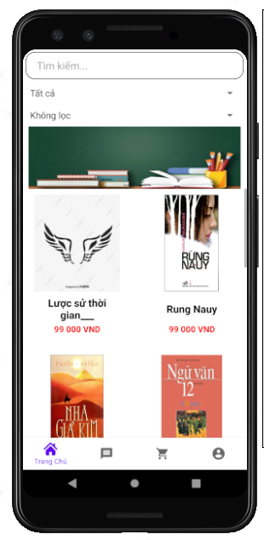

### **Require function**

|  |  |  |  |  |
| --- | --- | --- | --- | --- |
| **Item** | **Description** | | **Behavior** | **Response** |
| Main Screen | Main Screen has;   * Search bar * Spinner “category” * Spinner “price” * Listview * Item book * Icon home * Icon message * Icon cart * Icon individual | | N/A | N/A |
| Search bar | Used to search for books. Search by entering book title | | Tab on and enter | Show the recently searched book |
| Spinner “category” | Used to select the category, the selected category will show the book corresponding to that category | | Tab on and select | Show the book corresponding to that category |
| Spinner “price | Filter by price and filter from reviews | | Tab on and select | Show the book corresponding |
| Icon home | Go to home screen | | Tab on | Go to home screen |
| Icon message | Go to message screen | | Tab on | Go to message screen |
| Icon cart | Go to cart screen | | Tab on | Go to cart screen |
| Icon individual | Go to individual screen | | Tab on | Go to individual screen |
| ListView | Display the list of the books. Tab on the any book, go to detail book screen. Data is taken from firebase | Photo of the book | Display | * Display the list of the books * Tab on the any book, go to detail book screen |
| Book title |
| Price of the book |

## **Features / Ingredients: Detail Book Screen**

### **User interface**

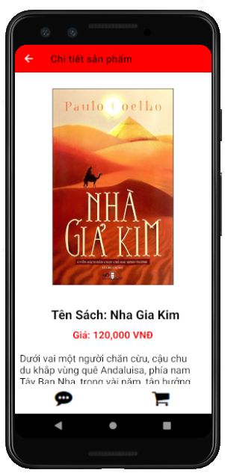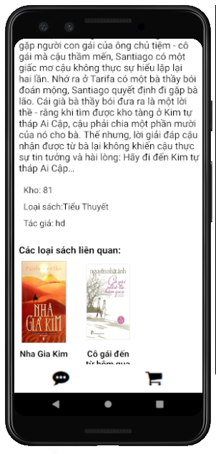

### **Require function**

|  |  |  |  |
| --- | --- | --- | --- |
| **Item** | **Description** | **Behavior** | **Response** |
| Detail Book Screen | Detail Book Screen has:   * Arrow-left * Image * Name title * Price * Description * Stock * Category * Author * Related books * Button”message” * Button “cart” | N/A | N/A |
| Arrow-left | Back to main screen | Tab on | Back to main screen |
| image | Show photo of the book | Show | Show photo of the book |
| Name title | Show name title of the book | Show | Show name title of the book |
| Price | Show price of the book | Show | Show name title of the book |
| Description | Show description of the book | Show | Show description of the book |
| Stock | Show the number of books in stock | Show | Show the number of books in stock |
| Category | Show category of the book | Show | Show category of the book |
| Author | Show Author of the book | Show | Show Author of the book |
| Related books | Show Related books | Show | Show Related books |
| Button “message” | Tab on to go to messagescreen, Used to exchange information between customers and stores | Tab on | Go to message screen |
| Button”cart” | Add books to cart | Tab on | Add books to cart |

## **Features / Ingredients:Message Screen**

### **User interface**

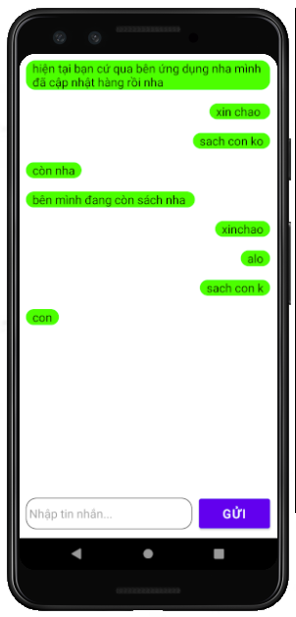

### **Require function**

|  |  |  |  |
| --- | --- | --- | --- |
| **Item** | **Description** | **Behavior** | **Response** |
| Message Screen | Message Screen has:   * Listview * Item left * Item right * Edittext “content” * Button ”send” | N/A | N/A |
| Listview | Contain items | N/A | N/A |
| Item left | Show message received | Show | Show message received |
| Item right | Show message sent | Show | Show message sent |
| Edittext “content” | Used to enter message content | Tab on and enter | Enter message content, show message content |
| Button ”send” | After entering message content, tab on the send button to show on the listview | Tab on | Show the listview |
| After entering message content, The message content will be uploaded to firebase. | N/A | The message content will be uploaded to firebase |

## **Features / Ingredients: Cart Screen**

### **User interface**

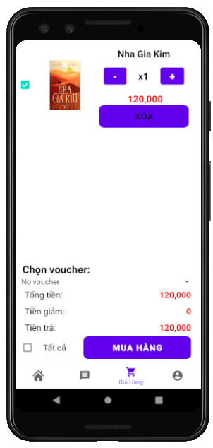

### **Require function**

|  |  |  |  |  |
| --- | --- | --- | --- | --- |
| **Item** | **Description** | | **Behavior** | **Response** |
| Cart Screen | Message Screen has:   * Listview * Spinner “voucher” * Total amount * Reduction amount * Amount to pay * Check box”All” * Purchase | | N/A | N/A |
| Listview | Contain items | Check box: tab on checkbox to select books to buy | N/A | N/A |
| Photo: show photo |
| Name title: show name title of the book |
| * Button “plus”: tab on plus button to increasing the number * Button “minus”: tab on minus button to reduce the number |
| Price: show price of the book |
| Button “delete”: used to remove the book from cart |
| Spinner “voucher” | Used to select the vouchers | | Tab on and select | Select the vouchers |
| Total amount | Show the total amount of that book excluding the reduction amount | | Show | Show total amount |
| Reduction  amount | Show reduction amount on voucher if any | | Show | Show reduction  amount |
| Amount to pay | Show amount to pay | | Show | Show amount to pay |
| Checkbox”all” | Tab on the checkbox “all” to select all the book | | Tab on | Select all the book |
| Button “purchase” | Used to make a purchase, go to the order screen | | Tab on | go to the order screen |

## **Features / Ingredients: Order Screen**

### **User interface**

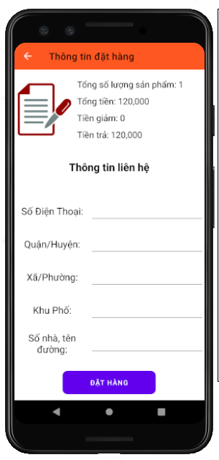

### **Require function**

|  |  |  |  |
| --- | --- | --- | --- |
| **Item** | **Description** | **Behavior** | **Response** |
| Order Screen | Order Screen has:   * Icon back * Total * Total amount * Reducrion amount * Amount to pay * Edittext “number phone” * Edittext “district” * Edittext “wards” * Edittext “quarter” * Edittext “apartment number” * Button “order” | N/A | N/A |
| Icon Back | Back to cart screen | Tab | Back to cart screen |
| Total | Show total number of books | Show | Show total number of books |
| Total amount | Show total amount | Show | Show total amount |
| Reduction  amount | Show reduction  amount | Show | Show reduction  amount |
| Amount to pay | Show amount to pay | Show | Show amount to pay |
| Edittext “number phone” | Used to enter the number phone | Tab on and enter | Show the number phone |
| Edittext “district” | Used to enter the district | Tab on and enter | Show the district |
| Edittext “wards” | Used to enter the wards | Tab on and enter | Show the wards |
| Edittext “quarter” | Used to enter the quarter | Tab on and enter | Show the quarter |
| Edittext “apartment number” | Used to enter the apartment number | Tab on and enter | Show the apartment number |
| Button ”order” | Tab on order button to order, After tab on the order button, the address information and phone number will be updated and will park the data to Firebase | Tab on | Show the message “order successful” |

## **Features / Ingredients: Individual Screen**

### **User interface**

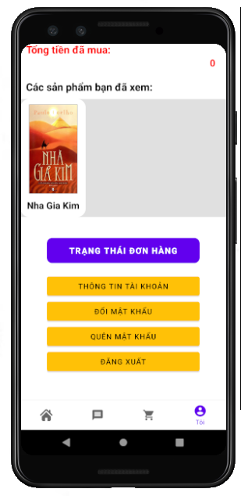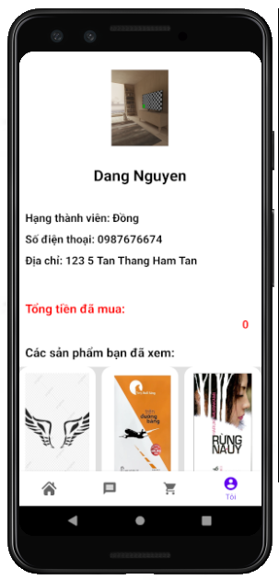

### **Require function**

|  |  |  |  |
| --- | --- | --- | --- |
| **Item** | **Description** | **Behavior** | **Response** |
| Individual Screen | Individual Screen has:   * Image * Username * Ucademy rank * Address * Number phone * Total amount purchased * Books viewed * Button “Order status” * Button “Information Individual” * Button “Change password” * Button “Logout” | N/A | N/A |
| Image | Show photo of the customer | Show | Show photo of the customer |
| Username | Show name of the customer | Show | Show name of the customer |
| Ucademy rank | Show ucademy rank  of the customer | Show | Show ucademy rank of the customer |
| Address | Show Address  of the customer | Show | Show Address  of the customer |
| Number phone | Show number phone of customer | Show | Show number phone of customer |
| Total amount purchased | Show the total amount of books purchased so far | Show | Show total amount purchased |
| Button “Order status” | Go to order status screen | Tab on | Go to order status screen |
| Button “Change password” | Go to Change password screen | Show | Go to Change password screen |
| Button “information individual” | Go to information individual screen | Tab on | Go to information individual screen |
| Button”logout” | Logout from application | Tab on | Go to login screen |

## **Features / Ingredients: Order Status Screen**

### **User interface**

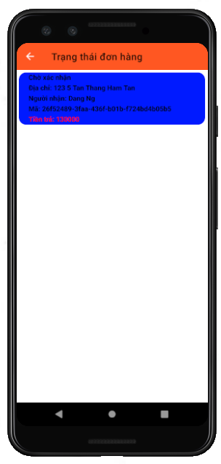

### **Require function**

|  |  |  |  |
| --- | --- | --- | --- |
| **Item** | **Description** | **Behavior** | **Response** |
| Order status Screen | Order status Screen has:   * Arrow-left * Listview * Item | N/A | N/A |
| Arrow-left | Back to Individual screen | Tab on | Back to Individual screen |
| Listview | Order status:   * Wait for confirmation:Orders waiting for confirmation will be displayed in blue * Delivered: Orders delivered will be displayed in grey. For delivered orders, customers can review them * Delivering: Orders delivering will be displayed in green * Cancelled: Orders delivering will be displayed in yellow   Address: show address of the customer  Name of the customer: show name of the customer  Code orders  Price: show amount to pay | N/A | N/A |

## **Features / Ingredients: Review Screen**

### **User interface**

### **Require function**

|  |  |  |  |
| --- | --- | --- | --- |
| **Item** | **Description** | **Behavior** | **Response** |
| Order status Screen | Order status Screen has:   * Arrow-left * Name title of the book * Spinner “review” * Button “ok” * Button “finish” | N/A | N/A |
| Arrow-left | Back to order status screen | Tab on | Back to order status screen |
| Name title of the book | Show name title of the book under review | Show | Show name title of the book under review |
| Spinner “review” | Select the number from 1 to 5 respectively to review a book | Select | Select the number from 1 to 5 respectively to review a book |
| Button “ok” | Tab on the ok button | Tab on |  |
| Button “finish” | Tab on finish button to save the result evaluation, then back to order status screen | Tab on | Save the result evaluation, then back to order status screen |

## **Features / Ingredients: Update Information Individual Screen**

### **User interface**

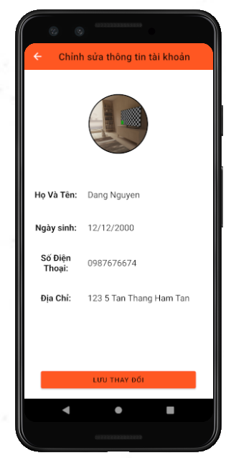

### **Require function**

|  |  |  |  |
| --- | --- | --- | --- |
| **Item** | **Description** | **Behavior** | **Response** |
| Update Information Individual Screen | Update Information Individual Screen has:  * Arrow-left * Image * Edittext “name” * Edittext “birthday” * Edittext “address” * Edittext “number phone” * Button “save” | N/A | N/A |
| Arrow-left | Back to individual screen | Tab on | Back to individual screen |
| Image | Show photo of the customer tab on to change photo.   * Change by camera * Change by library | Show | Show name title of the book under review |
| Edittext “name” | Show name of the customer, tab on to enter the new name, if you want to update name | Tab on and enter | Update name |
| Edittext “address” | Show address of the customer, tab on to enter the new address, if you want to update address | Tab on and enter | Update address |
| Edittext “birthday” | Show birthday of the customer, tab on to enter the new birthday, if you want to update birthday | Tab on and enter | Update birthday |
| Edittext “number phone” | Show number phone of the customer, tab on to enter the new number phone, if you want to update number phone | Tab on and enter | Update number phone |
| Button “save” | * After updating the information, tab on the save button to save information, then back to individual screen. * Information will be uploaded to firebase. | Tab on | Save information |

## **Features / Ingredients: Change the password Screen**

### **User interface**

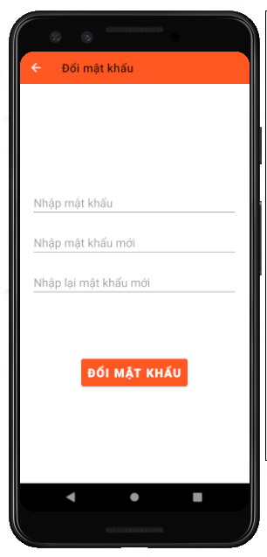

### **Require function**

|  |  |  |  |
| --- | --- | --- | --- |
| **Item** | **Description** | **Behavior** | **Response** |
| Change the password Screen | Change the password Screenhas:  * Arrow-left * Edittext “old password” * Edittext “new password” * Edittext “new password again” * Button “save” | N/A | N/A |
| Arrow-left | Back to individual screen | Tab on | Back to individual screen |
| Edittext “old password” | Used to enter old password | Tab on and enter | Show password as * |
| Edittext “new password” | Used to enter new password | Tab on and enter | Show password as * |
| Edittext “new password again” | Used to enter new password again | Tab on and enter | Show password as * |
| Button “save” | After updating the password, tab on the save button to save new password | Tab on | Save new password |

## **Features / Components: Login Screen**

### **User interface**

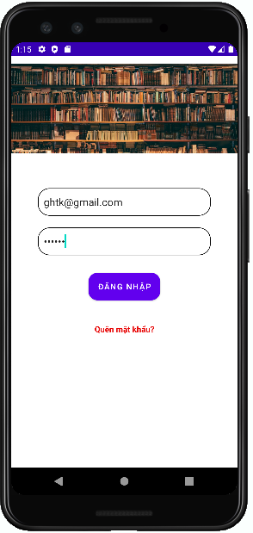

### **Require function**

|  |  |  |  |
| --- | --- | --- | --- |
| **Item** | **Description** | **Behavior** | **Response** |
| **Login Screen** | The login screen includes:  -         “username” edittext  -         “password” edittext  -        “login” button  -          “Forgot password” textview  - “Image” ImageView | N/A | N/A |
| **“Username” edittext** | Enter Username | Tap on | Display the keyboard and the user can input |
| **“Password” edittext** | Enter Password | Tap on | Display the keyboard and the user can input and show password as * |
| **“Forgot password” textview** | If the user forgot the password, tap Forgot Password | Tap on | Go to Forgot Password Screen |
| **“Login” button** | If Username and Password exist correctly in the database, it will go to the Home screen | Tap on | Go to Home Screen |
| If the Username and Password do not exist correctly in the database, a dialog box will be displayed with the content “Invalid Username or Password” and “Close” button. | Tap on | A pop up is showed |
| “Close” button closes a pop up | Tap on | Pop up is closed |
| “Image” ImageView | Show image on the login screen | N/A | N/A |

## **Features / Components: Home Screen**

### **User interface**

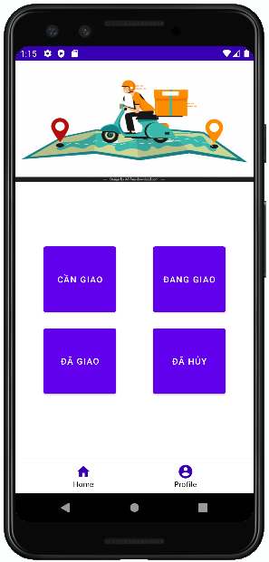

### **Require function**

|  |  |  |  |
| --- | --- | --- | --- |
| **Item** | **Description** | **Behavior** | **Response** |
| **Home Screen** | The Home screen includes:  -        “Need Delivery” button  -        “Delivering” button  -        “Delivered” button  -        “Canceled” button  -        “Home” tab  -        “Profile” tab  -        “Image” ViewFlipper | N/A | N/A |
| **“Need delivery” button** | “Need delivery” button go to the Orders to be delivered screen | Tap on | Go to the Orders to be delivered screen |
| **“Delivering” button** | “Delivering” button go to the Orders being delivered screen | Tap on | Go to the Orders being delivered screen |
| **“Delivered” button** | “Delivered” button go to the Delivered Orders screen | Tap on | Go to the Delivered Orders screen |
| **“Canceled” button** | “Cancelled” button go to Canceled Order screen | Tap on | Go to the Canceled Orders screen |
| **“Profile” tab** | “Profile” tab go to the profile screen | Tap on | Go to the profile screen |
| **“Home” tab** | “Home” tab go to the home screen | Tap on | Go to the home screen |
| **“Image” ViewFlipper** | Used to move images | N/A | N/A |

## **Features / Components: Orders to be delivered**

### **User interface**

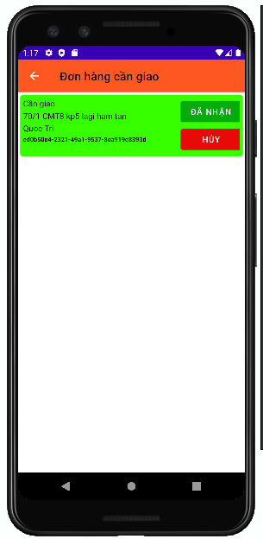

### **Require function**

|  |  |  |  |
| --- | --- | --- | --- |
| **Item** | **Description** | **Behavior** | **Response** |
| **"Order to be delivered" screen** | The "Order to be delivered" screen includes:  -        “icon arrow-left” button  -          Listview | N/A | N/A |
| **“icon arrow-left” button** | Back to the Home screen | Tap on | Back to the Home screen |
| **“Order to be delivered” listview** | Display order information to be delivered including:   * Status * Address * Recipient's name * Code orders * “Cancel” button * “Received” button | Tap on “Received” button | Go to the Orders being delivered screen.  The order will be removed from the list and The order goes to the Orders being delivered screen |
| Tap on “Cancel” button | Confirm that the Shipper is busy and the order will be removed from the list |

## **Features / Components: Orders Being Delivered Screen**

### **User interface**

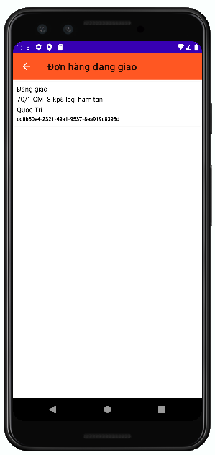

### **Require function**

|  |  |  |  |
| --- | --- | --- | --- |
| **Item** | **Description** | **Behavior** | **Response** |
| **Orders Being Delivered Screen** | The Orders being delivered screen includes:  -        “icon arrow-left” button  -        Listview | N/A | N/A |
| **“icon arrow-left” button** | Back to the Home screen | Tap on “Arrow-left” | Back to the Home screen |
| **'Orders being delivered' listview** | Display information about orders being delivered, including: “  -        Status  -        Address  -        Recipient's name  -        Code orders  " | N/A | N/A |
| Tap on an item will go to the Order Details screen | Tap on | Go to the Order Details screen |

## **Features / Components: Order Details Screen**

### **User interface**

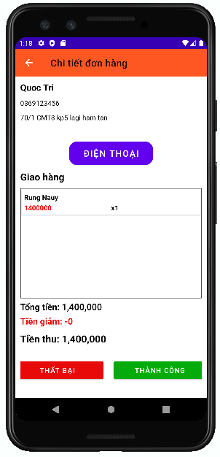

### **Require function**

|  |  |  |  |
| --- | --- | --- | --- |
| **Item** | **Description** | **Behavior** | **Response** |
| **Order Details screen** | The Order Details screen includes:  -        “icon arrow-left” button  -        “Recipient Name” label  -        “Phone number” label  -        “Address” label  -        “Phone” button  -        Listview  -        “Confirm” button  -        “Fail” button  - “Discount” label  - “Proceeds” label  -        “Delivery” textview  -    “Total amount” label | N/A | N/A |
| **“icon arrow-left” button** | Back to the Orders being delivered screen | Tap on | Back to the Orders being delivered screen |
| **“Recipient Name” label** | Display “recipient name” on the screen | N/A | N/A |
| **“Phone number” label** | Display “phone number” on the screen | N/A | N/A |
| **“Address” label** | Display “address” on the screen | N/A | N/A |
| **“Discount” label** | Show discount amount on the screen | N/A | N/A |
| **“Proceeds” label** | Proceeds = Total amount – Discount and show proceeds on screen | N/A | N/A |
| **“Phone” button** | Exit the app and show the phone number on the phone app | Tap on “Phone” | Exit the app and open the phone app |
| **“Delivery” listview** | Display the list of orders of the recipient including:  -        Name Product  -    Proceeds  - Quantity | N/A | N/A |
| **“Total amount” label** | Display the total amount of the orders of each recipient | N/A | N/A |
| **“Confirm” button** | The order is in transit, it has been delivered and it will go to the delivered order screen | Tap on | Go to the Delivered Orders screen |
| **“Fail” button** | Confirm canceled orders and update on database and Go to Canceled Order Screen | Tap on | Go to Canceled Order Screen |
| **“Delivery” textview** | Display “Delivery” textview to the screen | N/A | N/A |

## **Features / Components: Delivered Order Screen**

### **User interface**

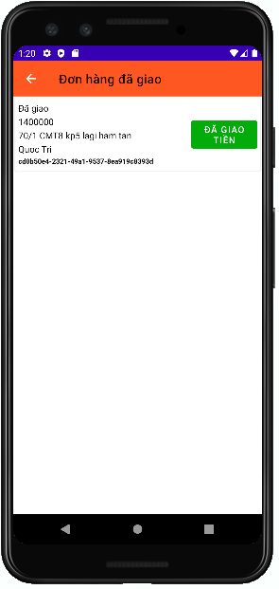

### **Require function**

|  |  |  |  |
| --- | --- | --- | --- |
| **Item** | **Description** | **Behavior** | **Response** |
| **Orders Delivered Screen** | The Delivered Orders screen includes:  -        “icon arrow-left” button  -        Listview | N/A | N/A |
| **“icon arrow-left” button** | Back to the Home screen | Tap on “Arrow-left” | Back to the Home screen |
| **'Order delivered' listview** | Displays information about orders that have been delivered, including the following information:   * Status * Money has/haven't been delivered * Address * Recipient's name * Code orders * Money delivered button | Tap on Money delivered button | Confirm that the Shipper has delivered the money to the store |

## **Features / Components: Canceled Order Screen**

### **User interface**

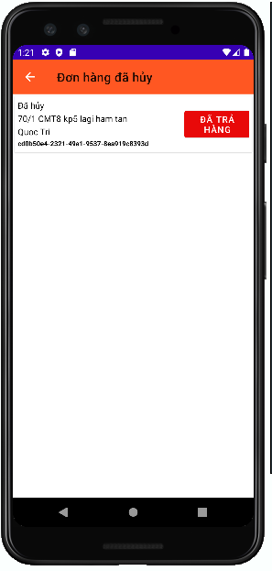 s

### **Require function**

|  |  |  |  |
| --- | --- | --- | --- |
| **Item** | **Description** | **Behavior** | **Response** |
| **Canceled Orders screen** | The Canceled Orders screen includes:  -        “icon arrow-left” button  -        Listview | N/A | N/A |
| **“icon arrow-left” button** | Back to the Home screen | Tap on “Arrow-left” | Back to the Home screen |
| **'canceled order ' listview** | Displays information about orders that have been delivered, including the following information:   * Status * Address * Recipient's name * Code orders * redelivered button | Tap on redelivered button | The canceled order confirmation is returned to the store and the order will be deleted upon confirmation |

## **Features / Components: Profile Screen**

### **User interface**

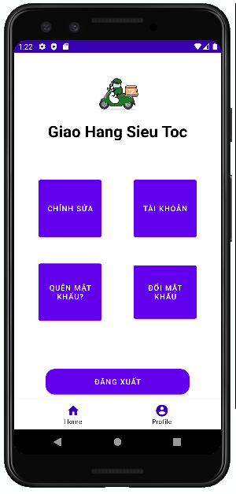

### **Require function**

|  |  |  |  |
| --- | --- | --- | --- |
| **Item** | **Description** | **Behavior** | **Response** |
| **Profile Screen** | The Profile screen includes:  -        “Shipper Name” label  -         “Log Out” button  -        “Edit” button  -        “Avatar” image  -        “Home” tab  -        “Profile” tab  -        “Account” button  -        “ForgotPassword” button  - “ChangePassword” button | N/A | N/A |
| **“Shipper Name” label** | Display “first and last name of shipper” on the screen | N/A | N/A |
| **“Log Out” button** | Tap on“Log Out” the account will exit and go to the Login screen | Tap on | Go to the Login screen |
| **“Avatar” image** | Show Shipper .'s profile photo | N/A | N/A |
| **“Edit” button** | Go to Edit Profile screen | Tap on | Go to Edit Profile screen |
| **“Home” tab** | Go to the Home screen | Tap on | Go to the Home screen |
| **“Profile” tab** | Go to Profile screen | Tap on | Go to Profile screen |
| **“Account” button** | Go to the Account Management screen | Tap on | Go to the Account Management screen |
| **“ForgotPassword” button** | if the email is sent successfully a pop up with message: “email sent successfully” and “Close” button | Tap on | A pop up is showed |
|  | if the email is sent fail a pop up with message: “Email sent failed” and “Close” button | Tap on | A pop up is showed |
|  | “Close” button closes a pop up | Tap on | A pop up is close |
| **“ChangePassword” button** | Go to the Change Password screen | Tap on | Go to the Change Password screen |

## **Features / Components: Account Management Screen**

### **User interface**

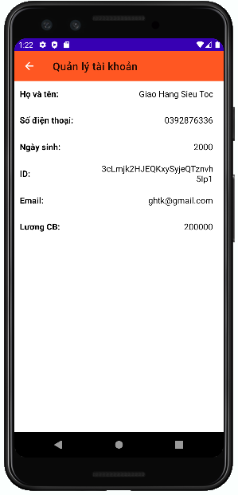

### **Require function**

|  |  |  |  |
| --- | --- | --- | --- |
| **Item** | **Description** | **Behavior** | **Response** |
| **Account Management screen** | The Account Management screen includes:  -        “icon arrow-left” button  -        “Full name” label  -        “Phone number” label  - “ID” label  - “Email” label  - “basic salary” label  -        “Date of Birth” label | N/A | N/A |
| **“Full name” label** | Show first and last name Shipper from database | N/A | N/A |
| **“Phone number” label** | Show Shipper's phone number from database | N/A | N/A |
| **“Date of Birth” label** | Show Shipper's date of birth from database | N/A | N/A |
| **“icon arrow-left” button** | Back to Profile screen | Tap on | Back to Profile screen |
| **“ID” label** | Show ID Shipper from database | N/A | N/A |
| **“Email” label** | Show Email Shipper from database | N/A | N/A |
| **“Basic salary” label** | Show Basic salary Shipper from database | N/A | N/A |

## **Features / Components: Edit Profile Screen**

### **User interface**

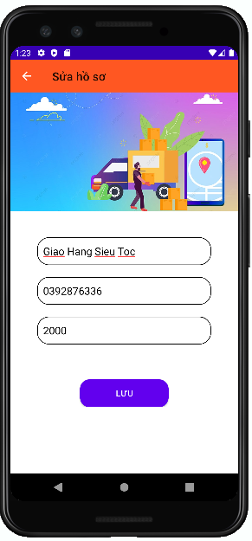

### **Require function**

|  |  |  |  |
| --- | --- | --- | --- |
| **Item** | **Description** | **Behavior** | **Response** |
| **Edit Profile Screen** | The Edit Profile screen includes:  -        “Full name” edittext  -        “Phone number” edittext  -        “Date of Birth” edittext  - “Image” ImageView  -        “Save” button  -        “icon arrow-left” button | N/A | N/A |
| **“Full name” edittext** | Enter Shipper's First and Last Name | Tap on | Display the keyboard and enter the shipper's name |
| **“Phone number” edittext** | Enter Shipper's Phone Number | Tap on | Display the keyboard and enter the shipper's phone number |
| **“Date of Birth” edittext** | Enter Date of Birth | Tap on | Display the keyboard and enter the date of brith |
| **“Save” button** | Used to save the information entered by the user in the edittext, change on database and Go to the Profile screen | Tap on | Go to the Profile screen |
| **“icon arrow-left” button** | Back to Profile screen | Tap on | Back to the Profile screen |
| **“Image” Imageview** | Show image on the Edit screen | N/A | N/A |

## **Features / Components: Forgot Password Screen**

### **User interface**

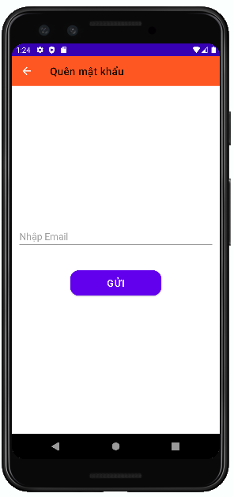

### **Require function**

|  |  |  |  |
| --- | --- | --- | --- |
| **Item** | **Description** | **Behavior** | **Response** |
| **Forgot Password Screen** | The Forgot Password screen includes:  -        “icon arrow-left” button  -         “Send” button  -        “Email” edittext | N/A | N/A |
| **“Send” button** | Used to send to email if email is right, a pop up with a message:" Email sent successfully please check your email" and “Close” button | Tap on | A pop up is showed |
| if email is wrong, a pop up with a message: “Email failed” and “Close” button |
| “Close” button closes pop up | Tap on | A pop up is closed |
| **“Email” edittext** | Enter email of shipper | Tap on | Display the keyboard and enter the email of the shipper |
| **“icon arrow-left” button** | If the user don’t log in then return the Login screen | Tap on | Back to the Login screen |

## **Features / Components: Change Password Screen**

### **User interface**

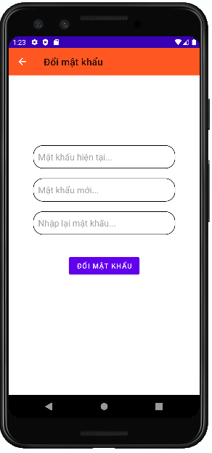

### **Require function**

|  |  |  |  |
| --- | --- | --- | --- |
| **Item** | **Description** | **Behavior** | **Response** |
| **Change Password Screen** | The Change Password screen includes:  -        “icon arrow-left” button  -         “current password” edittext  -        “new password” edittext  - “RePassword” edittext  - “change Password” button | N/A | N/A |
| **“Current Password” edittext** | Enter Current Password | Tap on | Display the keyboard and enter the current password and show CurrentPassword as * |
| **“New Password” edittext** | Enter New Password | Tap on | Display the keyboard and enter the new password and show New Password as * |
| **“RePassword” edittext** | Enter RePassword | Tap on | Display the keyboard and enter the RePassword and show RePassword as * |
| **“ChangePassword” button** | Used to update password | Tap on | A pop up with message: “Change password successfully” and “Close” button |
| **“Icon Arrow-left” button** | Used Back to Profile Screen | Tap on | Back to Profile Screen |

## **Features / Components: Home package**

### **User interface**

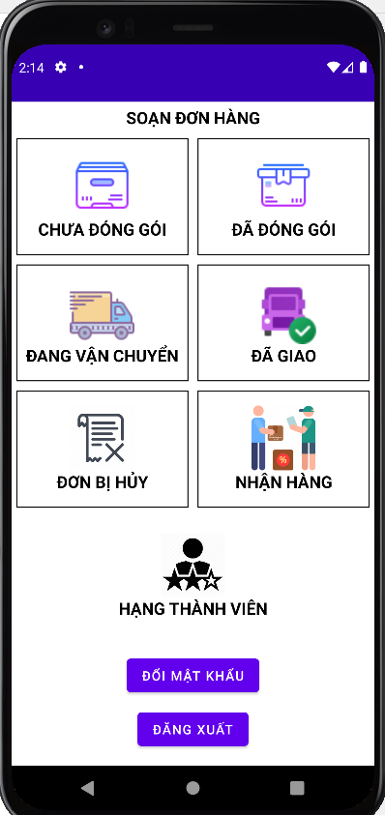

### **Require function**

|  |  |  |  |
| --- | --- | --- | --- |
| **Item** | **Description** | **Behavior** | **Response** |
| **Home package** | Packer's main screen | N/A | N/A |
| ImageView Packer | Logo of the packer | Tap on | Show default image |
| Unpacker | Go to the page using that function | Tap on | Go to the page using that function |
| Packered | Go to the page using that function | Tap on | Go to the page using that function |
| In transit | Go to the page using that function | Tap on | Go to the page using that function |
| Delivered | Go to the page using that function | Tap on | Go to the page using that function |
| Order cancel | Go to the page using that function | Tap on | Go to the page using that function |
| Receive | Go to the page using that function | Tap on | Go to the page using that function |
| Rank | Go to the page using that function | Tap on | Go to the page using that function |
| Change pass | Go to the page using that function | Tap on | Go to the page using that function |
| Logout | Go to the page using that function | Tap on | Go to the page using that function |

## **Features / Components: Home package**

### **User interface**

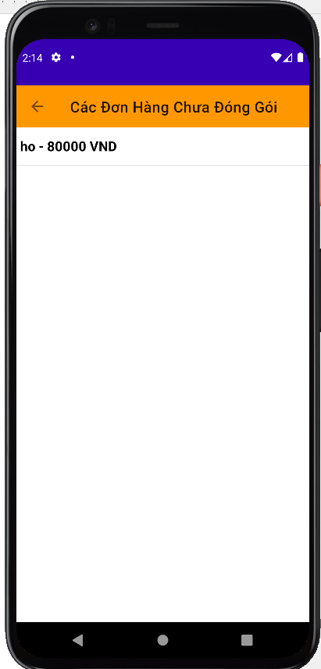

### **Require function**

|  |  |  |  |
| --- | --- | --- | --- |
| **Item** | **Description** | **Behavior** | **Response** |
| Unpacker | Show unpacked orders | N/A | N/A |
| **Order ListView** | Show order list | Tap on View Item | Tap on the order name to go to the order details screen |
| **Delete button** | Delete pending orders | Tap on Delete button | Remove order from listview |
| **Back button** | Back to screen | Tap on Back button | Back to Packer screen |
| **Search Box** | Search for pending orders | Tap on Search Box | Search for orders by name |

## **Features / Components: Home package**

### **User interface**

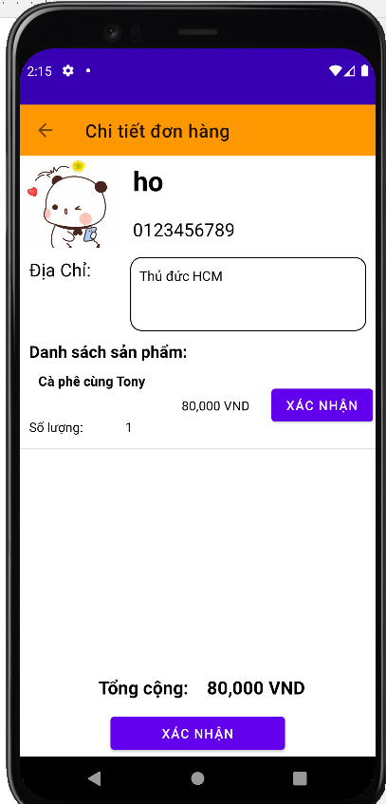

### **Require function**

|  |  |  |  |
| --- | --- | --- | --- |
| **Item** | **description** | **Action** | **Response** |
| **Order Detail screen** | Order details screen has 3 buttons ,1 Data Grid,1 TextView:  ●          Check  ●          Order detail  ●          Total  ●          Back  ●         Storehouse | N/A | N/A |
| **Order detail datagrid** | Show order list | N/A | Show details of products in the order |
| **Check button** | Complete packing | Tap on Check button | Turn your order into a packed state |
| **Back button** | Back to screen | Tap on Back button | Back to Packer screen |
| **Storehouse button** | Check goods in stock | Tap on Storehouse button | The inventory management screen appears |
| **Total TextView** | Show the total amount of the invoice | N/A | Show the total amount of the invoice |

## **Features/Components: Packaged Screen**

### **User interface**

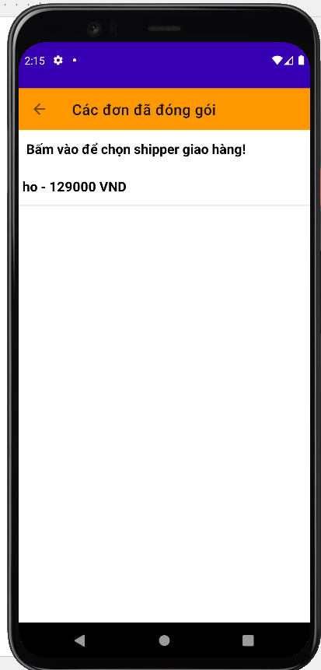

### **Require function**

|  |  |  |  |
| --- | --- | --- | --- |
| **Item** | **description** | **Action** | **Response** |
| **Packaged screen** | The packaged order management screen has 4 buttons, 1 search box, 1 ListView:  ●          Order ListView  ●          Delete  ●          Back  ●          Search Box  ●          Check  ●          Check All | N/A | N/A |
| **Order ListView** | Show the list of packed orders | Tap on View Item | List of packed orders, click on the order wall to see details |
| **Delete button** | Delete order | Tap on Delete button | Remove order from listview |
| **Back button** | Back to screen | Tap on Back button | Back to Packer screen |
| **Search Box** | Order search | Tap on Search Box | Single search by code |
| **Check button** | Delivery of orders | Tap on Check button | Change order to delivery status |
| **Check All button** | Delivery of orders | Tap on Check All button | Move all orders to shipping status |

## **Features/Components: Delivered Screen**

### **User interface**

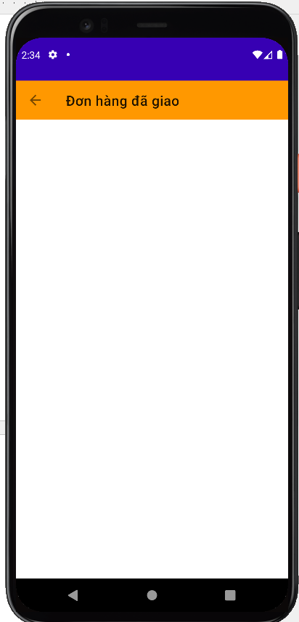

### **Require function**

|  |  |  |  |
| --- | --- | --- | --- |
| **Item** | **description** | **Action** | **Response** |
| **Delivered screen** | Delivered order management screen has 2 buttons, 1 search box, 1 ListView:  ●          Order ListView  ●          Back  ●          Search Box  ●          Checkbox | N/A | N/A |
| **Order ListView** | Delivered order management screen | Tap on View Item | List of delivered orders, tap the check button to confirm that you have received money from the delivery person |
| **Back button** | Back to screen | Tap on Back button | Back to Packer screen |
| **Search Box** | Order search | Tap on Search Box | Single search by code |
| **Check button** | Confirmed successful delivery | Tap on Check button | Confirm the order has been delivered successfully and receive money from the carrier |

## **Features/Components: Storehouse Screen**

### **User interface**

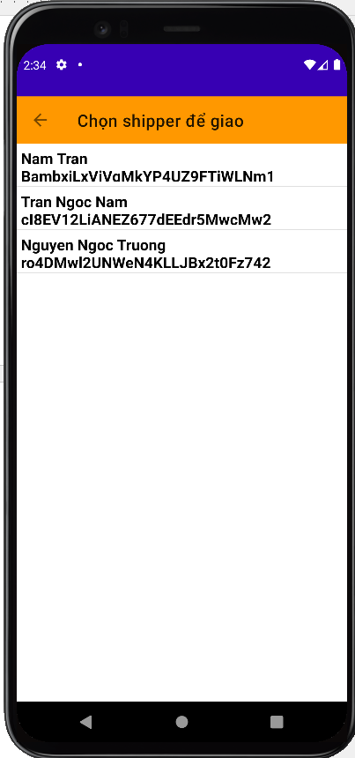

### **Require function**

|  |  |  |  |
| --- | --- | --- | --- |
| **Item** | **Description** | **Action** | **Response** |
| **Screen** | Choose a shipper for the order | N/A | N/A |
| **Listview shipper** | Choose 1 of the shippers | Click | That shipper will have a notice to pick up the order and deliver |
| **Select Button** | Used to choose that shipper | Click | That shipper will become busy |
| **Textinput search** | Used to search shipper by name | Input text | Listview will display the respective shippers |

## **Features/Components: In Transit Screen**

### **User interface**

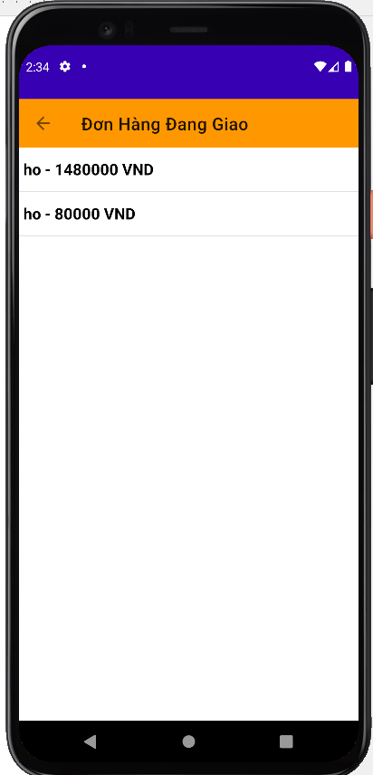

### **Require function**

|  |  |  |  |
| --- | --- | --- | --- |
| **Item** | **description** | **Action** | **Response** |
| **In Transit screen** | The screen of managing orders being delivered has 3 buttons, 1 search box, 1 ListView:  ●          Order ListView  ●          Back  ●          Search Box  ●          Check  ●          Check All | N/A | N/A |
| **Order ListView** | Display the list of orders being delivered | Tap on View Item | List of orders being delivered, click on the order wall to see details |
| **Back button** | Back to screen | Tap on Back button | Back to Packer screen |
| **Search Box** | Order search | Tap on Search Box | Single search by code |
| **Check button** | Confirmed successful delivery | Tap on Check button | The order has been successfully transferred to the delivery status |
| **Check All button** | Confirmed successful delivery | Tap on Check All button | Change all orders to successful delivery |

## **Features/Components: Unpacked Screen**

### **User interface**

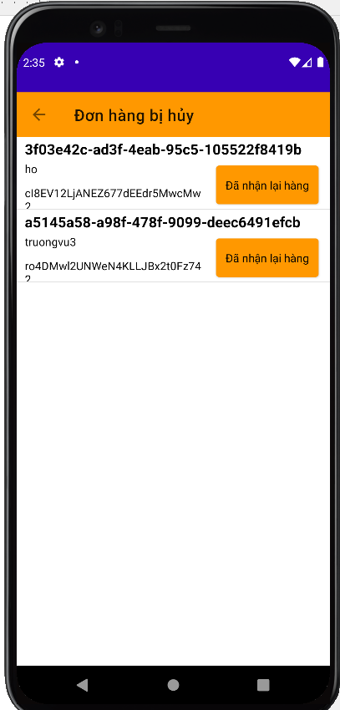

### **Require function**

|  |  |  |  |
| --- | --- | --- | --- |
| **Item** | **description** | **Action** | **Response** |
| **Unpacked screen** | The unpacked screen has 2 buttons, 1 search box, 1 ListView:  ●          Order ListView  ●          Delete  ●          Back  ●          Search Box | N/A | N/A |

## **Features/Components: Unpacked Screen**

### **User interface**

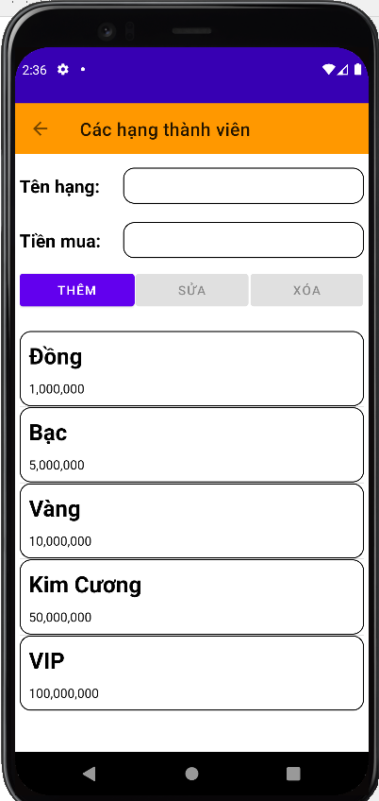

### **Require function**

|  |  |  |  |
| --- | --- | --- | --- |
| **Item** | **description** | **Action** | **Response** |
| **Rank User screen** | You can add and remove member ratings | N/A | N/A |
| **Name Rank** | Enter your membership class name there | Write in | Display the characters you just wrote |
| **Money Rank** | Enter your membership class name there | Write in | Display the characters you just wrote |
| **Button add** | Performs adding ranks to the list and correcting the ranks for users | Tab on button | Performs adding ranks to the list and correcting the ranks for users |
| **Button edit** | Edit the rank that I just clicked | Tab on button | Edit the rank that I just clicked |
| **Button Delete** | Remove that 1 rank from the list | Tab on button | Remove that 1 rank from the list |
| **ListView Rank** | Show all membership classes | See | Show all membership classes |

## **Features / Ingredients: Main Screen**

### **User interface**

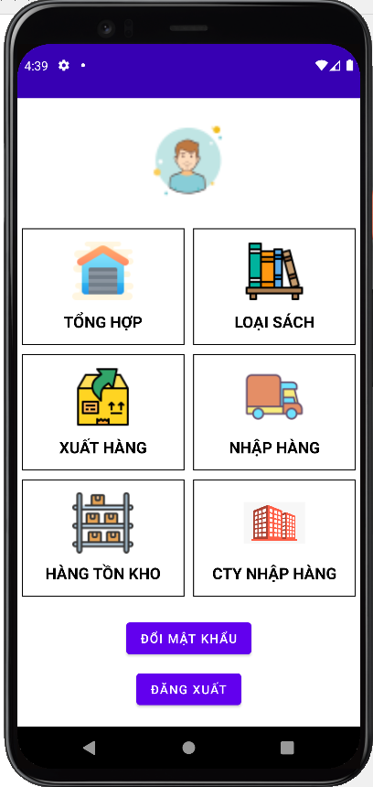

### **Require function**

|  |  |  |  |
| --- | --- | --- | --- |
| Item | Description | Behavior | Response |
| Main screen | Main screen has:   * Image button” Synthesis” * Image button” Inventory” * Image button” Book Type” * Image button” Export” * Image button” Import Goods” * Image button” Company Import” * Button”chang to password” * Button” logout” | N/A | N/A |
| Image button” Synthesis” | The function of the storekeeper. Use to view the books you sell, add new books. | Tab on Image button” Synthesis” | Go to the book management screen, you can add, delete and edit book information. |
| Image button” Inventory” | Used to view inventory statistics currently in stock | Tab on Image button” Inventory” | Go to stock view screen |
| Image button” Book Type” | Use to see how many books are sold in the store and how many books have that type | Tab on Image button” Book Type” | Statistics of books |
| Image button "Export" | Used to ship goods to the order maker to pack the goods. | Tab on Image button "Export" | Go to Export screen |
| Image button "Import goods" | Used to import goods for order writers to pack goods. | Tab on Image button "Import goods" | Go to the import screen. |
| Image button” Company Import” | Used to enter the names of the companies that the store imports books from | Tab on Image button” Company Import” | Go to Company Import screen |
| Button “Change to password” | Used to change password | Tab on Button “Change to password” | Go to change password screen, change password |
| Button “Logout” | Used to logout of the account | Tab on Button “Change to password” | Back to the Login screen |

## **Features / Ingredients: Product Management Screen**

### **User interface**

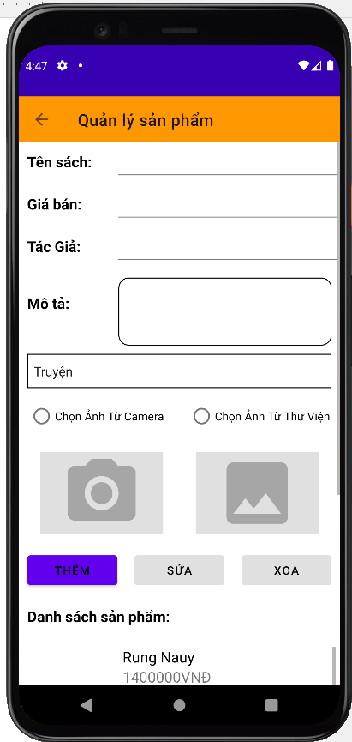

### **Require function**

|  |  |  |  |
| --- | --- | --- | --- |
| Item | Description | Behavior | Response |
| Product Management Screen | Product Management Screen has:  * Button “Exit” * Textinput “Book Title” * Textinput “Selling Price” * Textinput “Description” * Compobox “Book Type” * Radiobox “Camera” * Radiobox “Library” * Button “Edit” * ListView “Product List” * Button “Delete” | N/A | N/A |
| Button “Exit” | Used to return to the previous page | Click on | Back to previous page |
| Textinput “Book Title” | Enter the title of the book here | Input | Will display the information the user entered |
| Textinput “Selling Price” | Enter the selling price of the book | Input | Will display the information the user entered |
| Textinput “Description” | Enter a description | Input | Will display the information the user entered |
| Compobox “Book Type” | Select type of book | Click on | Users can choose the appropriate type of book. |
| Radiobox “Camera” | Used to take a photo of the book by camera | Select Radiobox “Camera” | Take a photo of the book by camera |
| Radiobox “Library” | Used to select photo of the book from library | Select Radiobox “Library” | Select photo of the book from library |
| Button “Edit” | Edit available book information | Click on | When the user clicks on each book, the book's information will be displayed on the textinput, then it is possible to edit the book information and click the edit button, the book information will be corrected. |
| ListView “Product List” | See the list of books and can click on it to edit the information. | Click on | You can click to update the content. |
| Button “Delete” | Delete the book from the system | Click on | The application will remove the book from the store and will update the list of existing books. |

## **Features / Ingredients: Inventory Statistics Screen**

### **User interface**

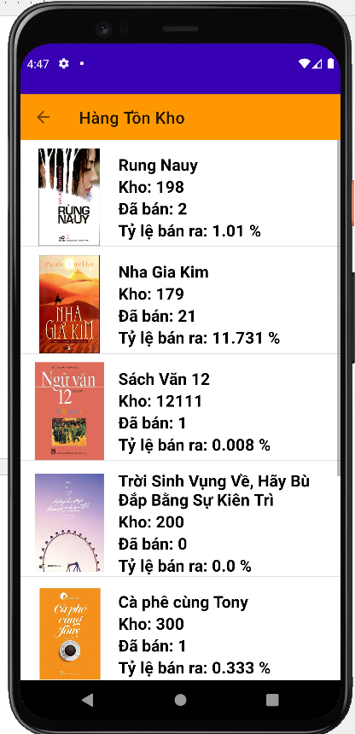

### **Require function**

|  |  |  |  |
| --- | --- | --- | --- |
| **Item** | **Description** | **Behavior** | **Response** |
| **Screen** | Show list of products and sales rate | N/A | N/A |

## **Features / Ingredients: Category Management Screen**

### **User interface**

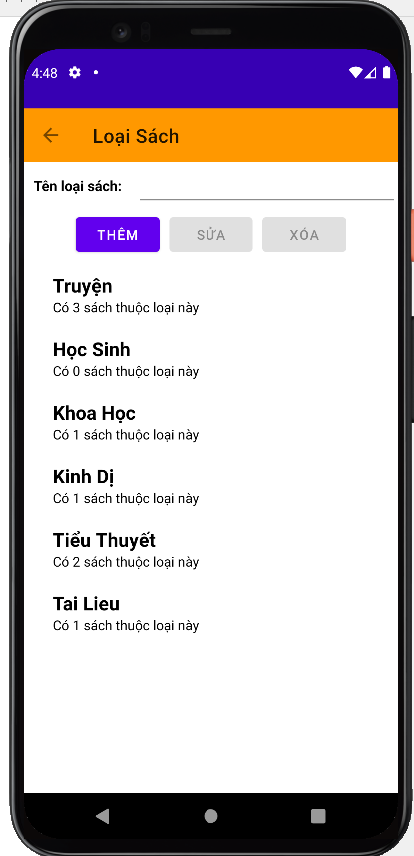

### **Require function**

|  |  |  |  |
| --- | --- | --- | --- |
| **Item** | **Description** | **Behavior** | **Response** |
| Category management Screen | Category management Screen has:   * Button “back” * EditText “Name Category” * Button ”Add” * Button “Delete” * Button ”Edit” * ListView | N/A | N/A |
| Button “back” | Back to main screen | Tab on Button “back” | Back to main screen |
| EditText “category” | Used to enter the type of book | Input | The entered the type of book will be displayed in the edittext |
| Button “Add” | Used to add the type of book | Tab on Button “Add” | Show on the listview |
| Button “Delete” | Used to delete the type of book | Tab on Button “Delete” | Delete from listview |
| Button “Edit” | Used to update the type of book | Tab on Button “Edit” | Update category |
| ListView | Display the category | Display | Display the category |

## **Features / Ingredients: Export Screen**

### **User interface**

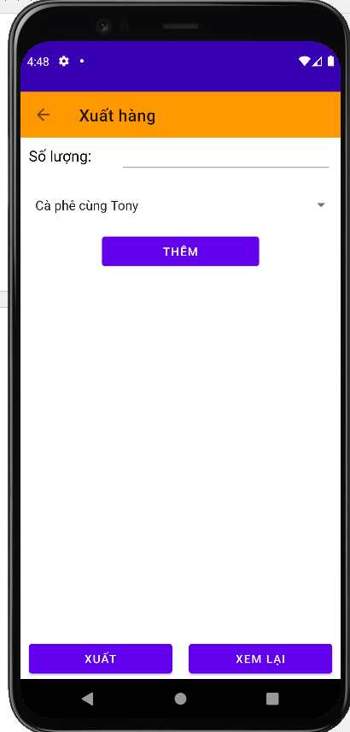

### **Require function**

|  |  |  |  |
| --- | --- | --- | --- |
| Item | Description | Behavior | Response |
| Export Screen | Export Screen Has:   * Button “back” * Edittext “quantity” * Combobox “name of the book” * Button “Add” * Listview * Button “export” * Button “View again” | N/A | N/A |
| Button “back” | Back to main screen | Tab on Button “back” | Back to main screen |
| Edittext “quantity” | Used to enter the quantity to be exported | Input | The quantity entered will be displayed on the edittext |
| Combobox “name of the book” | Used to select the name of the book to be exported | Select | The name of the book selected will be displayed on the combobox |
| Button “Add” | Used to add the book to be exported on the listview | Tab on Button “Add” | Show on the listview |
| Listview | Used to contain the added books | N/A | Contain the added books |
| Button “Export” | Used to |  |  |
| Button “View again” | Used to view again the books exported | Tab on Button “View again” | Go to the View the exported books screen, view again the books exported |

## **Features / Ingredients: Import Goods Screen**

### **User interface**

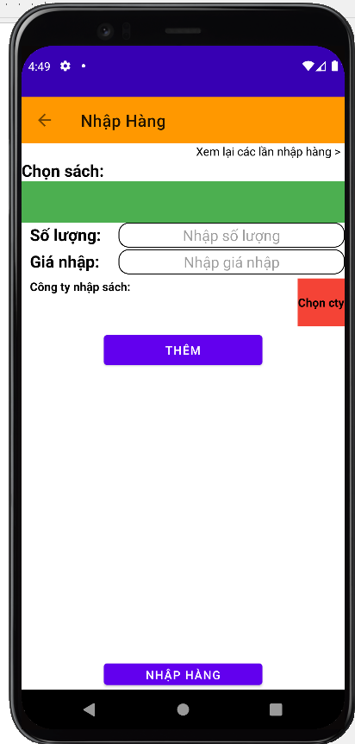

### **Require function**

|  |  |  |  |
| --- | --- | --- | --- |
| Item | Description | Behavior | Response |
| Import Goods screen | Import Goods screen has:   * Button “back” * Link “Import history” * Combobox “name of the book” * Edittext “Quantity” * Edittext “price” * Button “Company” * Button “Add” * Button “Import” | N/A | N/A |
| Button “back” | Back to main screen | Tab on Button “back” | Back to main screen |
| Combobox “name of book” | Used for importers to choose the name of the book they need to import | Tab on Combobox “name of book” and select | The screen will display the titles of the corresponding book type combobox above |
| Link “Import history” | Used to view imported orders | Tab on the Link “Import history” | Go to the Import history screen, view imported orders |
| Edittext “Quantity” | Used to enter the quantity to be entered | Tab on Edittext “Quantity” | Will display on the numeric keypad for users to input |
| Edittext “price” | Used to enter the price to be entered | Tab on Edittext “price” | Will display on the numeric keypad for users to input |
| Button “Company” | Go to select company screen, to select company | Tab on Button “Company” | Go to select company screen, to select company |
| Button “Add” | Used to add books to import to listview | Tab on Button “Add” | Add books to import to listview |
| Listview | Show recently added books | Show | Show recently added books |
| Button “Import” | Used to import books from listview to stock | Tab on Button “Import” | import books from listview to stock |

## **Features / Ingredients: Company Management Screen**

### **User interface**

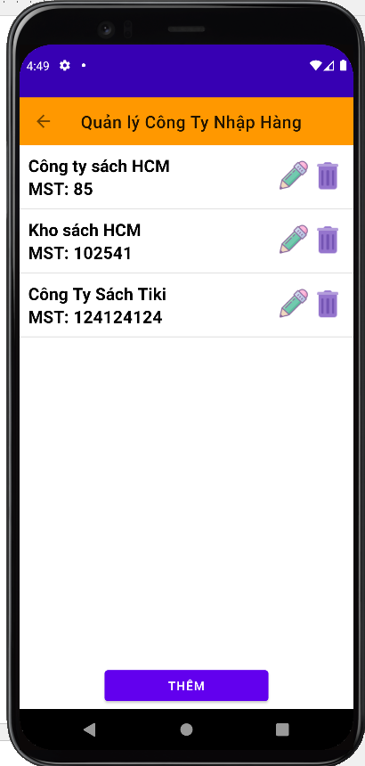

### **Require function**

|  |  |  |  |
| --- | --- | --- | --- |
| Item | Description | Behavior | Response |
| Company management Screen | Company management Screen has:   * Button “back” * Listview * Items * Icon “edit” * Icon “delete” * Button “Add” | N/A | N/A |
| Button “back” | Back to main screen | Tab on Button “back” | Back to main screen |
| ListView | Show list of companies | Show | N/A |
| Items | Name of company | N/A | N/A |
| Company code |
| Icon “edit”: Update company | Tab on Icon “edit” | Go to the update company |
| Icon “delete”: delete company from list | Tab on Icon “delete” | Delete company from list |
| Button “Add” | Used to add company | Tab on Button “Add” | Go to the add company screen to add company |

## **Features / Ingredients: Import history screen**

### **User interface**

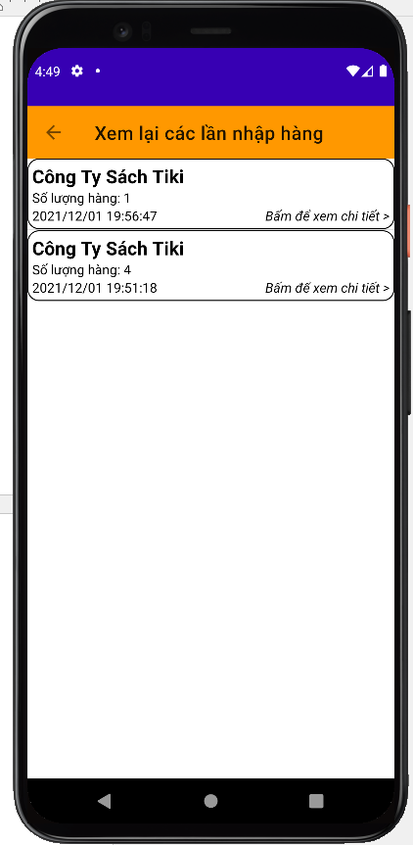

### **Require function**

|  |  |  |  |
| --- | --- | --- | --- |
| Item | Description | Behavior | Response |
| Import history screen | Import history screen has:   * Button “back” * Listview * Items | N/A | N/A |
| Button “back” | Back to Import screen | Tab on Button “back” | Back to Import screen |
| Listview | Show imported orders | N/A | N/A |
| Items | Company: Show company | N/A | N/A |
| Quantity: Show quantity | N/A | N/A |
| Time: Show time import goods | N/A | N/A |
| Link “view detail”:Used to view detail orders | Tab on the link “View detail” | Go to the detail import sceen, view detail. |

## **Features / Ingredients: View the exported goods Screen**

### **User interface**

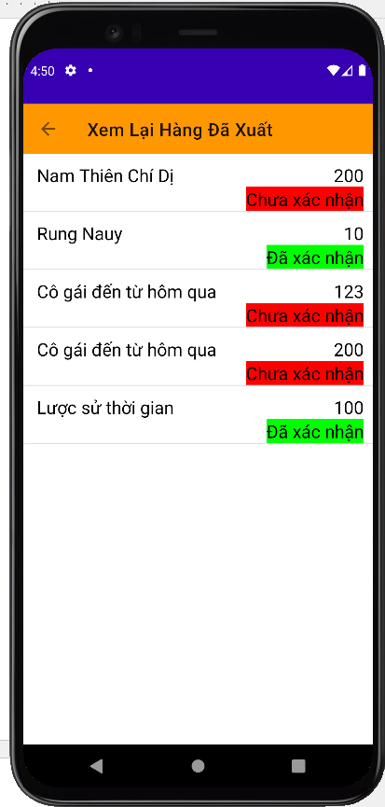

### **Require function**

|  |  |  |  |
| --- | --- | --- | --- |
| Item | Description | Behavior | Response |
| Playback screen | Used to let the storekeeper review the goods that have been shipped | N/A | N/A |
| Listview | View information about that day's delivery | N/A | Display information about each date and each type of book published |
| Unconfimred | The person who prepares the application has not yet entered the form and has received the goods from the exporter | N/A | Show the storekeeper that he or she has not confirmed receipt of goods from you |
| Confirmed | The order maker has ticked the button received goods from the storekeeper. | N/A | Show the storekeeper that the order maker has confirmed receipt of the goods from the storekeeper |

## **Features / Ingredients: Detail Import Screen**

### **User interface**

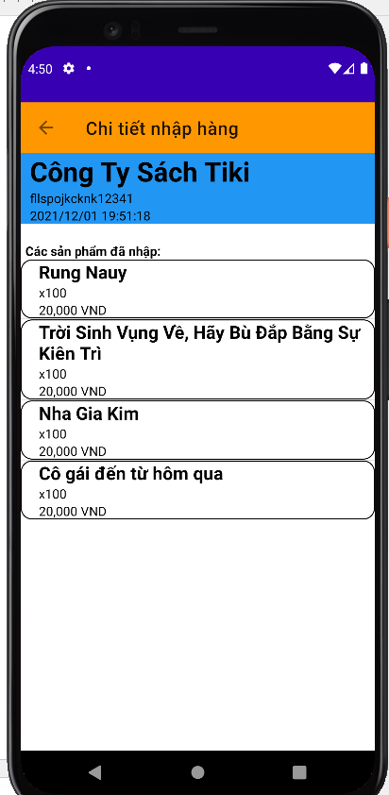

### **Require function**

|  |  |  |  |
| --- | --- | --- | --- |
| Item | Description | Behavior | Response |
| Detail import Screen | Detail import Screen has:   * Button “back” * Item 1 * Item 2 | N/A | N/A |
| Button “back” | Back to Import history screen | Tab on Button “back” | Back to Import history screen |
| Item 1 | Show name of the company | N/A | N/A |
| Show address of the company |
| Show time |
| Item 2 | Show name of the book | N/A | N/A |
| Show quantity imported |
| Show price of the book |

## **Features / Ingredients: Add company Screen**

### **User interface**

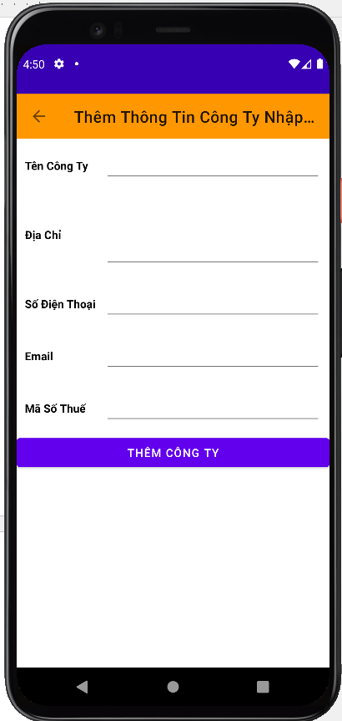

### **Require function**

|  |  |  |  |
| --- | --- | --- | --- |
| Item | Description | Behavior | Response |
| Add company Screen | Add company Screen has:   * Button “back” * Edittext “name company” * Edittext “address” * Edittext “number phone” * Edittext “email” * Edittext “tax id” * Button “Add” | N/A | N/A |
| Button “back” | Back to Company Management screen | Tab on Button “back” | Back to Company Management screen |
| Edittext “name company” | Used to enter the name of the company | Input | Display company name just entered in edittext |
| Edittext “address” | Used to enter the address of the company | Input | Display company address just entered in edittext |
| Edittext “number phone” | Used to enter the number phone of the company | Input | Display company number phone just entered in edittext |
| Edittext “email” | Used to enter the email of the company | Input | Display company email just entered in edittext |
| Edittext “tax id” | Used to enter the tax id of the company | Input | Display company number tax id just entered in edittext |
| Button “Add” | Used to add company | Tab on Button “Add” | Add company to list company management |

## **Features / Components: Store Home Screen**

### **User interface**

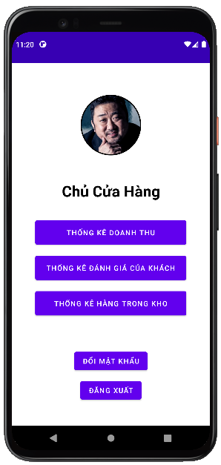

### **Require function**

|  |  |  |  |
| --- | --- | --- | --- |
| **Item** | **Description** | **Behavior** | **Response** |
| **Screen** | Inside the screen include the Administrator's Photo, the administrator's title, the Sales Statistics Button, the Customer Rating Statistics Button, the Inventory Statistics Button and the Log Out Button, Change Password Button. | N/A | N/A |
| **Sales Statistics Button** | Click this Button to go to the App's revenue statistics interface. | Tap on Sales Statistics Button | Go to the revenue statistics interface |
| **Review Statistics Button** | Click this Button to go to the App's evaluation statistics interface. | Tap on Review Statistics Button | Go to the evaluation statistics interface |
| **In-stock Statistics Button** | Click this Button to go to the App's inventory statistics interface. | Tap on In-stock Statistics Button | Go to the stock statistics interface |
| **Log Out Button** | Click this Button to log out of the account and switch to the App's login interface. | Tap on Log Out Button | Log out of your account and return to the login interface |
| **Change Password Button** | Click this Button to change password of the account and switch to the App's change password interface. | Tap on Change Password Button | Change password of your account, a pop up change password screen. |

## **Features / Components: Sales Statistics Screen**

### **User interface**

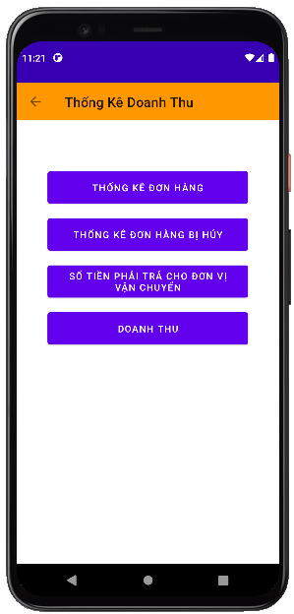

### **Require function**

|  |  |  |  |
| --- | --- | --- | --- |
| **Item** | **Description** | **Behavior** | **Response** |
| **Screen** | Inside the screen include Button Back ,Button Order Statistics, Button Statistics Canceled Orders, Button Amount To Pay For Shipping Units And Button Turnover | Click the Buttons in the screen | N/A |
| **Order Statistics Button** | Click this Button to go to the App's order statistics interface. | Tap On | Go to the order statistics interface |
| **Canceled Order Statistics Button** | Click this Button to go to the App's canceled order statistics interface. | Tap On | Go to canceled order statistics interface |
| **Button Amount To Pay For Shipping Unit** | Click this Button to go to the App's billing statistics interface. | Tap On | Go to the payment statistics interface for the shipping unit |
| **Revenue Button** | Click this Button to switch to App revenue interface. | Tap On | Go to the revenue interface |
| **Button Back** | Click to return to the Revenue Statistics interface | Tap On | Go to the store owner interface |

## **Features / Components: Order Statistics Screen**

### **User interface**

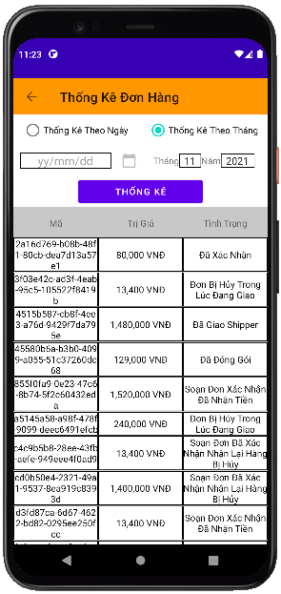

### **Require function**

|  |  |  |  |
| --- | --- | --- | --- |
| **Item** | **Description** | **Behavior** | **Response** |
| **Screen** | Inside the screen include Button Back , TextView Order Statistics, RadioButton Statistics By Date, RadioButton Statistics By Month, DateTime Date May, ComboBox Month, ComboBox Year, Button Statistics,  TextView Date May, TextView Month, TextView Year, Table Statistical Data. Objects such as DateTime Date May, ComboBox Month, ComboBox Year will be locked if one of the two Radio Buttons is not selected for daily statistics and monthly statistics. | Click the Buttons, RadioButtons, ComboBoxes in the screen | N/A |
| **TextView Order Statistics** | Show the title of the interface | Display | Show the title |
| **Text View Date May** | Display title for DateTime object Date May | Display | Show the title |
| **Text View Month** | Display title for ComboBox object Month | Display | Show the title |
| **Text View Year** | Display title for ComboBox object Year | Display | Show the title |
| **RadioButton Statistics By Day** | Tick ​​it to tell the application to list orders by date and to allow the DateTime object to be unlocked. | Check | Set a date-based statistical requirement and unlock the ability to interact with the DateTime object May Day. |
| **RadioButton Monthly Statistics** | Tick ​​to ask the application to list orders by month and allow to unlock the ComboBox Month and ComboBox Year objects . | Check | Set a monthly statistical requirement and unlock the ability to interact with the ComboBox Month and ComboBox Year objects .. |
| **DateTime Date May** | Click on select a specific date to ask the application to order statistics for the selected day. | Tap On | Displays the date the user has just selected to request order statistics by date |
| **ComboBox Monthly** | Click to select the month in which the user wants to record orders according to the previously selected month | Tap On | Display the month the user has just selected to request order statistics for the previously selected month |
| **ComboBox Five** | Click to select the Year in which the user wants order statistics according to the previously selected month | Tap On | Displays the location that the user has just selected to request order statistics for the previously selected month |
| **Stats Button** | Click to start sending the request that the user has set to get the data and fill in the statistical data table | Tap On | The data is compiled according to the previously set requirements |
| **Statistical Data Table** | This table is used to display the statistical data requested by the user. The table includes columns of information such as, Order ID, Orderer, Address, Value, Status | Display | The data will be displayed inside the table in rows and columns |
| **Button Back** | Click to return to the Revenue Statistics interface | Tap On | Go to the revenue statistics interface |

## **Features / Components: Canceled Order Statistics Screen**

### **User interface**

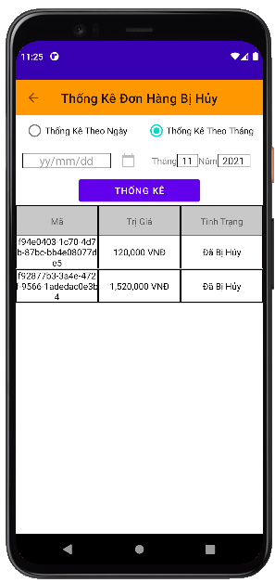

### **Require function**

|  |  |  |  |
| --- | --- | --- | --- |
| **Item** | **Description** | **Behavior** | **Response** |
| **Screen** | Inside the screen include Button Back , TextView Canceled Order Statistics, RadioButton Statistics By Date, RadioButton Statistics By Month, DateTime Date May, ComboBox Month, ComboBox Year, Button Statistics,  TextView Date May, TextView Month, TextView Year, Table Statistical Data. Objects such as DateTime Date May, ComboBox Month, ComboBox Year will be locked if one of the two Radio Buttons is not selected for daily statistics and monthly statistics. | N/A | N/A |
| **TextView Canceled Order Statistics** | Show the title of the interface | Display | Show the title |
| **Text View Date May** | Display title for DateTime object Date May | Display | Show the title |
| **Text View Month** | Display title for ComboBox object Month | Display | Show the title |
| **Text View Year** | Display title for ComboBox object Year | Display | Show the title |
| **RadioButton Statistics By Day** | Tick ​​it to tell the application to count canceled orders by date and allow the DateTime object to be unlocked. | Check | Set a date-based statistical requirement and unlock the ability to interact with the DateTime object May Day. |
| **RadioButton Monthly Statistics** | Tick ​​to request the application to list canceled orders by month and allow to unlock the ComboBox Month and ComboBox objects . | Check | Set a monthly statistical requirement and unlock the ability to interact with the ComboBox Month and ComboBox Year objects.. |
| **DateTime Date May** | Click on select a specific date to request the application to list the canceled orders on the selected date. | Tap On | Displays the date the user has just selected to request statistics of canceled orders by date |
| **ComboBox Monthly** | Click to select the month in which the user wants to record canceled orders according to the previously selected month | Tap On | Display the month that the user has just selected to request statistics of canceled orders according to the previously selected month |
| **ComboBox Five** | Click to select the Year in which the user wants to record canceled orders according to the previously selected month | Tap On | Displays the location that the user has just selected to request the statistics of canceled orders according to the previously selected month |
| **Stats Button** | Click to start sending the request that the user has set to get the data and fill in the statistical data table | Tap On | The data is compiled according to the previously set requirements |
| **Statistical Data Table** | This table is used to display the statistical data requested by the user. The table includes columns of information such as, Order ID, Orderer, Address, Value, Status | Display | The data will be displayed inside the table in rows and columns |
| **Button Back** | Click to return to the Revenue Statistics interface | Tap On | Go to the revenue statistics interface |

## **Features / Components: Statistical screen of the amount payable to the shipping unit**

### **User interface**

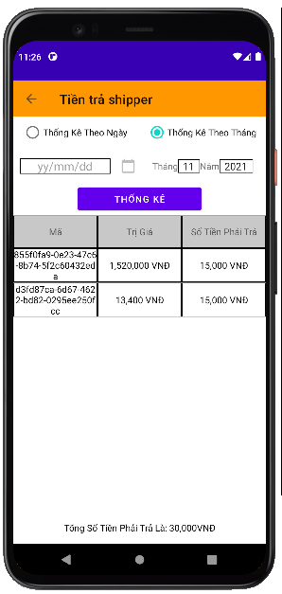

### **Require function**

|  |  |  |  |
| --- | --- | --- | --- |
| **Item** | **Description** | **Behavior** | **Response** |
| **Screen** | Inside the screen include Button Back , TextView Statistics Payable for Shipping Units, RadioButton Statistics By Day, RadioButton Statistics By Month, DateTime May Day, ComboBox Month, ComboBox Year, Button Statistics,  TextView Date May, TextView Month, TextView Year,  TextView Amount To Pay For Shipping, Table Of Statistical Data. Objects such as DateTime Date May, ComboBox Month, ComboBox Year will be locked if one of the two Radio Buttons is not selected for daily statistics and monthly statistics. | N/A | N/A |
| **TextView Statistics Payable for Shipping Units** | Show the title of the interface | Display | Show the title |
| **Text View Date May** | Display title for DateTime object Date May | Display | Show the title |
| **Text View Month** | Display title for ComboBox object Month | Display | Show the title |
| **Text View Year** | Display title for ComboBox object Year | Display | Show the title |
| **RadioButton Statistics By Day** | Tick ​​to ask the application to calculate the amount to be transferred to the carrier by date and to allow the DateTime object to be unlocked. | Check | Set a date-based statistical requirement and unlock the ability to interact with the DateTime object May Day. |
| **RadioButton Monthly Statistics** | Tick ​​to ask the application to calculate the amount to be transferred to the shipping unit by month and allows unlocking the ComboBox Month and ComboBox Year objects . | Check | Set a monthly statistical requirement and unlock the ability to interact with the ComboBox Month and ComboBox Year objects.. |
| **DateTime Date May** | Click on select a specific date to ask the application to calculate the amount to be transferred to the shipping unit on the selected date. | Tap On | Displays the date the user has just selected to request statistics of the amount to be transferred to the carrier according to the selected date |
| **ComboBox Monthly** | Click to select the month in which the user wants to calculate the amount to be transferred to the shipping unit according to the previously selected month | Tap On | Displays the month that the user has just selected to request statistics of the amount to be transferred to the shipping unit according to the previously selected month |
| **ComboBox Five** | Click to select the Year in which the user wants to calculate the amount to be transferred to the shipping unit according to the previously selected month | Tap On | Displays the location that the user has just selected to request the statistics of the amount to be transferred to the shipping unit according to the previously selected month |
| **Stats Button** | Click to start sending the request that the user has set to get the data and fill in the statistical data table | Tap On | The data is compiled according to the previously set requirements |
| **Statistical Data Table** | This table is used to display the statistical data requested by the user. The table includes columns of information such as, Order ID, Value, Amount Payable | Display | The data will be displayed inside the table in rows and columns |
| **Button Back** | Click to return to the Revenue Statistics interface | Tap On | Go to the revenue statistics interface |
| **TextView Amount To Pay For Shipping** | Display the total payable by day or by month | Display | Show total payable |

## **Features / Components: Sales Statistics Screen**

### **User interface**

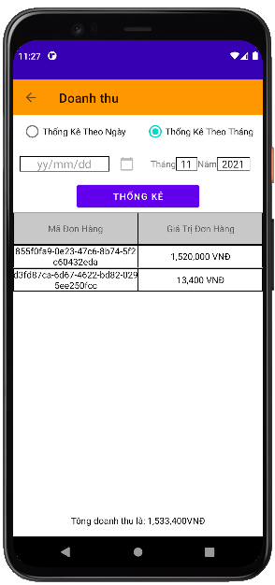

### **Require function**

|  |  |  |  |
| --- | --- | --- | --- |
| **Item** | **Description** | **Behavior** | **Response** |
| **Screen** | Inside the screen include Button Back , TextView Sales Statistics, RadioButton Statistics By Date, RadioButton Statistics By Month, DateTime Date May, ComboBox Month, ComboBox Year, Button Statistics,  TextView Date May, TextView Month, TextView Year,  TextView Total Revenue, Table of Statistical Data. Objects such as DateTime Date May, ComboBox Month, ComboBox Year will be locked if one of the two Radio Buttons is not selected for daily statistics and monthly statistics. | N/A | N/A |
| **TextView Revenue** | Show the title of the interface | Display | Show the title |
| **Text View Date May** | Display title for DateTime object Date May | Display | Show the title |
| **Text View Month** | Display title for ComboBox object Month | Display | Show the title |
| **Text View Year** | Display title for ComboBox object Year | Display | Show the title |
| **RadioButton Statistics By Day** | Tick ​​it to ask the application to calculate the revenue by date and allow the DateTime object to be unlocked. | Check | Set a date-based statistical requirement and unlock the ability to interact with the DateTime object May Day. |
| **RadioButton Monthly Statistics** | Tick ​​to request the application to calculate the monthly revenue and allow the ComboBox Month and ComboBox Year objects to be unlocked . | Check | Set a monthly statistical requirement and unlock the ability to interact with the ComboBox Month and ComboBox Year objects.. |
| **DateTime Date May** | Click on select a specific date to ask the application for revenue statistics for the selected day. | Tap On | Display the date selected by the user to request sales statistics for the selected date |
| **ComboBox Monthly** | Click to select the month in which the user wants the revenue statistics for the previously selected month | Tap On | Displays the month the user has just selected to request revenue statistics for the previously selected month |
| **ComboBox Five** | Click to select the Year in which the user wants the revenue statistics for the previously selected month | Tap On | Displays the location that the user has just selected to request revenue statistics for the previously selected month |
| **Stats Button** | Click to start sending the request that the user has set to get the data and fill in the statistical data table | Tap On | The data is compiled according to the previously set requirements |
| **Statistical Data Table** | This table is used to display the statistical data requested by the user. The table includes columns of information such as, Order ID, Value, Amount Payable | Display | The data will be displayed inside the table in rows and columns |
| **Button Back** | Click to return to the Revenue Statistics interface | Tap On | Go to the revenue statistics interface |
| **TextView Total Revenue** | Display total sales by day or by month | Display | Show total revenue |

## **Features / Components: Customer Rating Statistics Screen**

### **User interface**

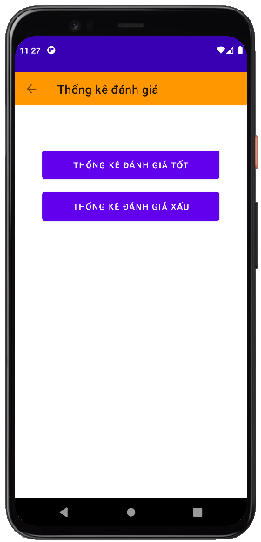

### **Require function**

|  |  |  |  |
| --- | --- | --- | --- |
| **Item** | **Description** | **Behavior** | **Response** |
| **Screen** | Inside the screen include Button Back , TextView Customer Review Statistics, Button, Good Review Button, Bad Review Button | N/A | N/A |
| **Good Review Button** | Click this Button to go to the statistics interface of good customer reviews. | Tap On | Go to the good reviews statistics interface |
| **Bad Rating Statistics Button** | Click this Button to go to the statistics interface of bad customer reviews. | Tap On | Go to the bad reviews statistics interface |
| **Text View Customer Rating Statistics** | Show the title of the interface | Tap On | Show interface title |
| **Button Back** | Click to return to the main interface of the store owner authorization | Tap On | Go to the main interface of the store owner decentralization |

## **Features / Components: Good Rating Stats Monitor**

### **User interface**

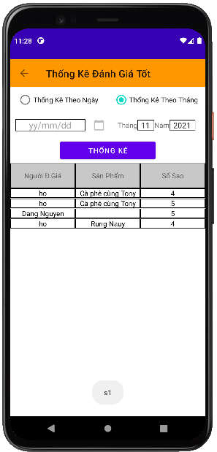

### **Require function**

|  |  |  |  |
| --- | --- | --- | --- |
| **Item** | **Description** | **Behavior** | **Response** |
| **Screen** | Inside the screen include Button Back , TextView Stats Good Rating, RadioButton Statistics By Date, RadioButton Statistics By Month, DateTime Date May, ComboBox Month, ComboBox Year, Button Statistics,  TextView Date May, TextView Month, TextView Year,  TextView Total Revenue, Table of Statistical Data. Objects such as DateTime Date May, ComboBox Month, ComboBox Year will be locked if one of the two Radio Buttons is not selected for daily statistics and monthly statistics. | N/A | N/A |
| **TextView Statistics Good Review** | Show the title of the interface | Display | Show the title |
| **Text View Date May** | Display title for DateTime object Date May | Display | Show the title |
| **Text View Month** | Display title for ComboBox object Month | Display | Show the title |
| **Text View Year** | Display title for ComboBox object Year | Display | Show the title |
| **RadioButton Statistics By Day** | Tick ​​it to tell the statistical application to rate well by date and to allow the DateTime object to be unlocked. | Check | Set a date-based statistical requirement and unlock the ability to interact with the DateTime object May Day. |
| **RadioButton Monthly Statistics** | Tick ​​to ask the application to calculate the good rating by month and allow to unlock the ComboBox Month and ComboBox Year objects . | Check | Set a monthly statistical requirement and unlock the ability to interact with the ComboBox Month and ComboBox Year objects.. |
| **DateTime Date May** | Click to select a specific date to ask the application for good evaluation statistics according to the selected date. | Tap On | Display the date the user has just selected to request good rating statistics according to the selected date |
| **ComboBox Monthly** | Click to select the month in which the user wants good statistics according to the previously selected month | Tap On | Display the month that the user has just selected to request good review statistics according to the previously selected month |
| **ComboBox Five** | Click to select the Year in which the user wants good review statistics according to the previously selected month | Tap On | Displays the location that the user has just selected to ask for good rating statistics according to the previously selected month |
| **Stats Button** | Click to start sending the request that the user has set to get the data and fill in the statistical data table | Tap On | The data is compiled according to the previously set requirements |
| **Statistical Data Table** | This table is used to display the statistical data requested by the user. The table includes columns of information such as, Reviewer, Product Name, Number of Stars, Review Content | Display | The data will be displayed inside the table in rows and columns |
| **Button Back** | Click to return to the Customer Rating Statistics interface | Tap On | Go to the customer rating statistics interface |

## **Features / Components: Bad Rating Stats Monitor**

### **User interface**

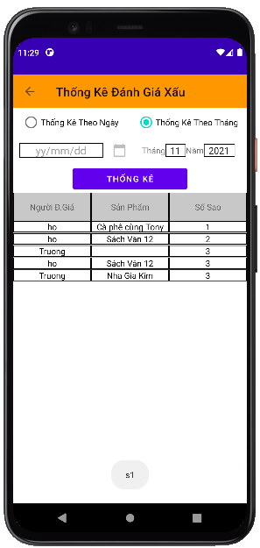

### **Require function**

|  |  |  |  |
| --- | --- | --- | --- |
| **Item** | **Description** | **Behavior** | **Response** |
| **Screen** | Inside the screen include Button Back , TextView Bad Rating Statistics, RadioButton Statistics By Date, RadioButton Statistics By Month, DateTime Date May, ComboBox Month, ComboBox Year, Button Statistics,  TextView Date May, TextView Month, TextView Year,  TextView Total Revenue, Table of Statistical Data. Objects such as DateTime Date May, ComboBox Month, ComboBox Year will be locked if one of the two Radio Buttons is not selected for daily statistics and monthly statistics. | N/A | N/A |
| **TextView Bad Rating Stats** | Show the title of the interface | Display | Show the title |
| **Text View Date May** | Display title for DateTime object Date May | Display | Show the title |
| **Text View Month** | Display title for ComboBox object Month | Display | Show the title |
| **Text View Year** | Display title for ComboBox object Year | Display | Show the title |
| **RadioButton Statistics By Day** | Tick ​​it to tell the application to report bad rating by date and to allow the DateTime object to be unlocked. | Check | Set a date-based statistical requirement and unlock the ability to interact with the DateTime object May Day. |
| **RadioButton Monthly Statistics** | Tick ​​to ask the application to calculate the bad rating by month and allow to unlock the ComboBox Month and ComboBox Year objects . | Check | Set a monthly statistical requirement and unlock the ability to interact with the ComboBox Month and ComboBox Year objects.. |
| **DateTime Date May** | Click to select a specific date to ask the application to report bad reviews according to the selected date. | Tap On | Displays the date the user has just selected to request bad review statistics according to the selected date |
| **ComboBox Monthly** | Click to select the month in which the user wants the bad rating statistics according to the previously selected month | Tap On | Displays the month the user has just selected to request bad review statistics according to the previously selected month |
| **ComboBox Five** | Click to select the Year in which the user wants bad rating statistics according to the previously selected month | Tap On | Display the location that the user has just selected to ask for bad review statistics according to the previously selected month |
| **Stats Button** | Click to start sending the request that the user has set to get the data and fill in the statistical data table | Tap On | The data is compiled according to the previously set requirements |
| **Statistical Data Table** | This table is used to display the statistical data requested by the user. The table includes columns of information such as, Reviewer, Product Name, Number of Stars, Review Content | Display | The data will be displayed inside the table in rows and columns |
| **Button Back** | Click to return to the Customer Rating Statistics interface | Tap On | Go to the customer rating statistics interface |

## **Features / Components: Inventory Monitor**

### **User interface**

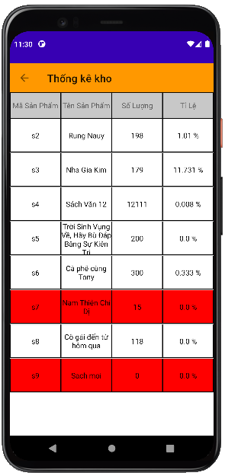

### **Require function**

|  |  |  |  |
| --- | --- | --- | --- |
| **Item** | **Description** | **Behavior** | **Response** |
| **Screen** | Inside the screen include Button Back , TextView Inventory Statistics, Table of Statistical Data | Click the Buttons in the screen | N/A |
| **Statistical Data Table** | This table is used to display statistical data as soon as you enter the interface. The table includes columns of information such as Product Code, Product Name, Remaining Quantity | Display | The data will be displayed inside the table in rows and columns |
| **Text View Statistics** | Show the title of the interface | Tap On | Show interface title |
| **Button Back** | Click to return to the Shop Owner interface | Tap On | Go to inventory statistics interface |

## **Features / Components: Handler Monitor**

### **User interface**

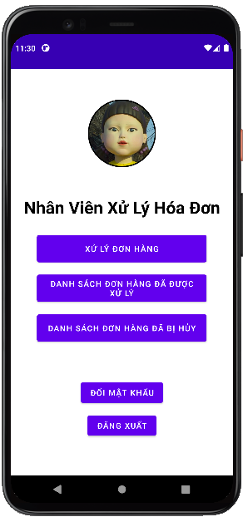

### **Require function**

|  |  |  |  |
| --- | --- | --- | --- |
| **Item** | **Description** | **Behavior** | **Response** |
| **Screen** | Inside the screen include the Administrator's Photo, the administrator's title, the Order Processing Button, the Processed Order List Button, the Canceled Order List Button and the Log Out Button. | N/A | N/A |
| **Order Processing Button** | Click this Button to go to the App's order processing interface. | Tap On | Go to the order processing interface |
| **Processed Order List Button** | Click this Button to go to the App's processed orders interface. | Tap On | Go to the processed orders interface |
| **Canceled Order List Button** | Click this Button to go to the App's canceled order list interface. | Tap On | Go to the canceled order list interface |
| **Log Out Button** | Click this Button to log out of the account and switch to the App's login interface. | Tap On | Log out of your account and return to the login interface |
| **Change Password Button** | Click this Button to change password of the account and switch to the App's change password interface. | Tap on Change Password Button | Change password of your account, a pop up change password screen. |

## **Features / Components: Order Processing Screen**

### **User interface**

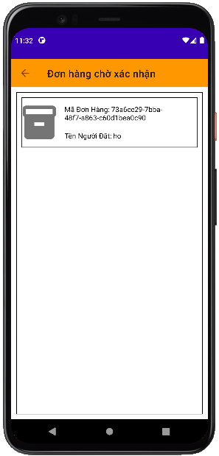

### **Require function**

|  |  |  |  |
| --- | --- | --- | --- |
| **Item** | **Description** | **Behavior** | **Response** |
| **Screen** | Inside the screen includes Button Back, TextView Order Processing, TextView List of Pending Orders and ViewGroups with information of pending orders. | Click the Buttons in the screen | N/A |
| **TextView Order Processing** | Show title for interface | Display | Show interface title |
| **TextView List of Pending Orders** | Display title for pending order ViewGroup objects | Display | Show title for list of pending orders |
| **Log Out Button** | Click this Button to log out of the account and switch to the App's login interface. | Tap On | Log out of your account and return to the login interface |
| **ViewGroup Pending Orders** | Inside View Group includes order icon, Order ID TextView, Orderer TextView. With each ViewGroup representing a pending order, clicking on one of the ViewGroups will take you to the order details page that the ViewGroup displays. | Tap On | Go to order details page |
| **Button Back** | Click to return to the handler interface | Tap On | Go to handler interface |

## **Features / Components: Order Detail Screen**

### **User interface**

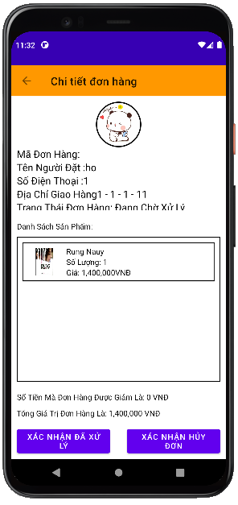

### **Require function**

|  |  |  |  |
| --- | --- | --- | --- |
| **Item** | **Description** | **Behavior** | **Response** |
| **Screen** | Inside the screen include the Back Button, Order Detail TextView, Order Details ViewGroup, Order Product Information ViewGroups, Product List TextView, Order Total Value TextView, Processed Confirmation Button Reason, Confirm Order Cancellation | Click the Buttons in the screen | N/A |
| **TextView Order Details** | Show title for interface | Display | Show interface title |
| **TextView Product List** | Display the title for the product ViewGroup objects of the order | Display | Display title for ViewGroup objects |
| **Text View Total Order Value** | Display the total value of the order | Display | Display the total value of the order |
| **ViewGroup Booking Information** | Inside the View Group includes the person's account avatar, Order ID TextView, Orderer Name TextView, Phone Number TextView, Address TextView, Order Status TextView. This ViewGroup is used to display information of the person placing the order. | Display | Display information of the person placing the order |
| **ViewGroup product information of the order** | Inside the View Group include the product's photo, TextView Product Name, TextView Number of User Sets, TextView Price Of Product. This ViewGroup is used to display detailed information of each product inside the order | Display | Display product information inside the order |
| **Confirmation Processed Button** | Click to send confirmation that this order has been processed | Tap On | Show processing confirmation message, this message allows to choose yes or no. If you select yes, a confirmation message of successful order processing will be displayed and a Close Button will close the message. If you choose not, it will close the notification and do nothing |
| **Cancellation Confirmation Button** | Click to send confirmation that this order will be cancelled | Tap On | Show a confirmation message to cancel the order, this message allows you to choose yes or no. If you choose yes, a confirmation message will be displayed to confirm the successful order cancellation and a Close Button to close the notification. If you choose not, it will close the notification and do nothing |
| **Button Back** | Click to return to the order processing interface | Tap On | Go to the order processing interface |

## **Features / Components: Canceled Order List Screen**

### **User interface**

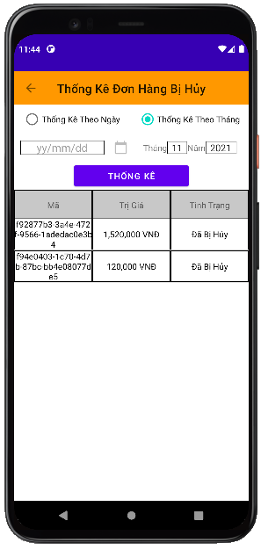

### **Require function**

|  |  |  |  |
| --- | --- | --- | --- |
| **Item** | **Description** | **Behavior** | **Response** |
| **Screen** | Inside the screen include Button Back , TextView Statistics Canceled Order List, RadioButton Statistics By Date, RadioButton Statistics By Month, DateTime Date May, ComboBox Month, ComboBox Year, Button Statistics,  TextView Date May, TextView Month, TextView Year, Table Statistical Data. Objects such as DateTime Date May, ComboBox Month, ComboBox Year will be locked if one of the two Radio Buttons is not selected for daily statistics and monthly statistics. | N/A | N/A |
| **TextView List of Canceled Orders** | Show the title of the interface | Display | Show the title |
| **Text View Date May** | Display title for DateTime object Date May | Display | Show the title |
| **Text View Month** | Display title for ComboBox object Month | Display | Show the title |
| **Text View Year** | Display title for ComboBox object Year | Display | Show the title |
| **RadioButton Statistics By Day** | Tick ​​it to tell the application to count canceled orders by date and allow the DateTime object to be unlocked. | Check | Set a date-based statistical requirement and unlock the ability to interact with the DateTime object May Day. |
| **RadioButton Monthly Statistics** | Tick ​​to request the application to list canceled orders by month and allow to unlock the ComboBox Month and ComboBox objects . | Check | Set a monthly statistical requirement and unlock the ability to interact with the ComboBox Month and ComboBox Year objects.. |
| **DateTime Date May** | Click on select a specific date to request the application to list the canceled orders on the selected date. | Tap On | Displays the date the user has just selected to request statistics of canceled orders by date |
| **ComboBox Monthly** | Click to select the month in which the user wants to record canceled orders according to the previously selected month | Tap On | Display the month that the user has just selected to request statistics of canceled orders according to the previously selected month |
| **ComboBox Five** | Click to select the Year in which the user wants to record canceled orders according to the previously selected month | Tap On | Displays the location that the user has just selected to request the statistics of canceled orders according to the previously selected month |
| **Stats Button** | Click to start sending the request that the user has set to get the data and fill in the statistical data table | Tap On | The data is compiled according to the previously set requirements |
| **Statistical Data Table** | This table is used to display the statistical data requested by the user. The table includes columns of information such as, Order ID, Orderer, Address, Value, Status | Display | The data will be displayed inside the table in rows and columns |
| **Button Back** | Click to return to the handler interface | Tap On | Go to handler interface |

## **Features / Components: Processed Order List Screen**

### **User interface**

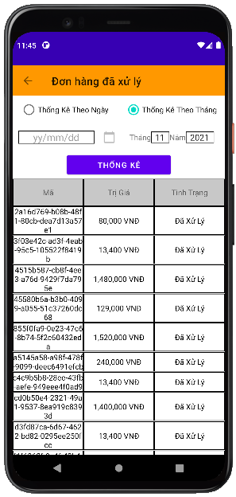

### **Require function**

|  |  |  |  |
| --- | --- | --- | --- |
| **Item** | **Description** | **Behavior** | **Response** |
| **Screen** | Inside the screen include Button Back , TextView List of Processed Orders, RadioButton Statistics By Date, RadioButton Statistics By Month, DateTime Date May, ComboBox Month, ComboBox Year, Button Statistics,  TextView Date May, TextView Month, TextView Year, Table Statistical Data. Objects such as DateTime Date May, ComboBox Month, ComboBox Year will be locked if one of the two Radio Buttons is not selected for daily statistics and monthly statistics. | N/A | N/A |
| **TextView List of Processed Orders** | Show the title of the interface | Display | Show the title |
| **Text View Date May** | Display title for DateTime object Date May | Display | Show the title |
| **Text View Month** | Display title for ComboBox object Month | Display | Show the title |
| **Text View Year** | Display title for ComboBox object Year | Display | Show the title |
| **RadioButton Statistics By Day** | Tick ​​it to ask the application to list processed orders by date and to allow the DateTime object to be unlocked. | Check | Set a date-based statistical requirement and unlock the ability to interact with the DateTime object May Day. |
| **RadioButton Monthly Statistics** | Tick ​​to ask the application to list the processed orders by month and allow the ComboBox Month and ComboBox Year objects to be unlocked . | Check | Set a monthly statistical requirement and unlock the ability to interact with the ComboBox Month and ComboBox Year objects.. |
| **DateTime Date May** | Click on select a specific date to ask the application to list the orders processed in the selected day. | Tap On | Display the date the user has just selected to request the processed order statistics by date |
| **ComboBox Monthly** | Click to select the month in which the user wants the processed order statistics according to the previously selected month | Tap On | Displays the month the user has just selected to request the processed order statistics according to the previously selected month |
| **ComboBox Five** | Click to select the Year in which the user wants to record the processed orders according to the previously selected month | Tap On | Displays the location that the user has just selected to ask for the processed order statistics according to the previously selected month |
| **Stats Button** | Click to start sending the request that the user has set to get the data and fill in the statistical data table | Tap On | The data is compiled according to the previously set requirements |
| **Statistical Data Table** | This table is used to display the statistical data requested by the user. The table includes columns of information such as, Order ID, Orderer, Address, Value, Status | Display | The data will be displayed inside the table in rows and columns |
| **Button Back** | Click to return to the handler interface | Tap On | Go to handler interface |

## **Features/Components: Management Screen**

### **User interface**

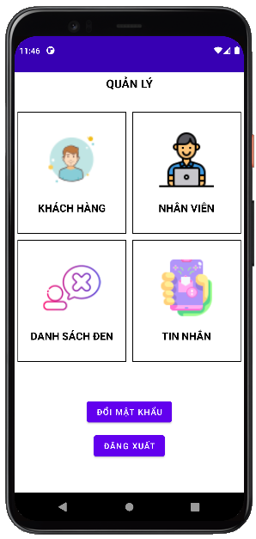

### **Require function**

|  |  |  |  |
| --- | --- | --- | --- |
| **Item** | **Description** | **Action** | **Response** |
| **Management screen** | Management screen with 6 buttons, 1 TextView:  ●          User  ●          Employee  ●          Blacklist  ●          Message  ●         Manage  ●         Change password  ●         Logout | N/A | N/A |
| **User button** | Go to the user account management screen | Tap on User button | The user management screen appears |
| **Block button** | Go to the user account management screen | Tap on Block button | The user blocking management screen appears |
| **Employee button** | Go to employee account management screen | Tap on Employee button | Employee management screen appears |
| **Blacklist button** | Go to the blacklist account management screen | Tap on Blacklist button | Blacklist management screen appears |
| **Message button** | Go to the message management screen | Tap on Message button | The message management screen appears |
| **Manage TextView** | Display the name of the screen | N/A | N/A |
| **Change Password button** | Go to the change password screen | Tap on Change Password button | The change password screen appears |
| **Logout button** | Sign out account | Tap on Logout button | The login screen appears |

## **Features/Components: User Management Screen**

### **User interface**

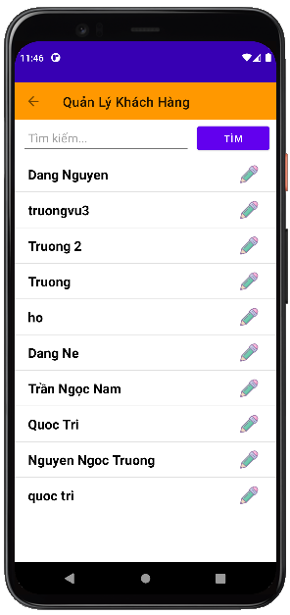

### **Require function**

|  |  |  |  |
| --- | --- | --- | --- |
| **Item** | **description** | **Action** | **Response** |
| **User management screen** | The user management screen has 2 buttons, 1 search box:  ●          Update  ●          Back  ●          Search Box | N/A | N/A |
| **Update button** | Update user information | Tap on Update button | Go to user account update screen |
| **Back button** | Back to screen | Tap on Back button | Back to Management screen |
| **Search Box** | Search for users | Tap on Search Box | Search for users |

## **Features/Components: User Update Screen**

### **User interface**

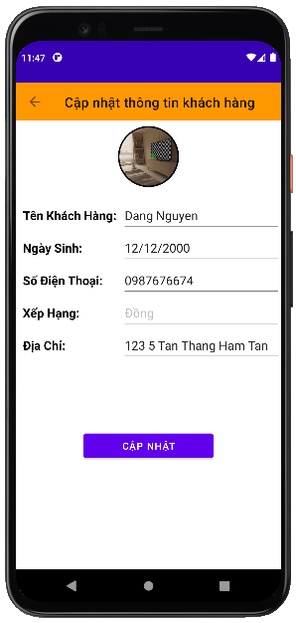

### **Require function**

|  |  |  |  |
| --- | --- | --- | --- |
| **Item** | **Description** | **Action** | **Response** |
| **User Update Screen** | Update user screen has 1 buttons ,5 Edit Text:  ●         Update  ●          Back  ●          Name  ●        Birthday  ●        Phone  ●         Rank  ●         Address | N/A | N/A |
| **Update button** | Update customer information | Tap on Update button | Save the information customer, return to the user management screen |
| **Name edittext** | Enter user account | Tap on Name edittext | Enter the fullname for customer |
| **Birthday edittext** | Enter user password | Tap on Birthday edittext | Enter the birthday for customer |
| **Phone edittext** | Enter the number phone | Tap on Phone edittext | Enter the number phone for customer |
| **Rank edittext** | Display rank | Tap on Rank edittext | Display rank for customer |
| **Address edittext** | Enter the password | Tap on Address edittext | Enter the addres for customer |

## **Features/Components: Blacklist Screen**

### **User interface**

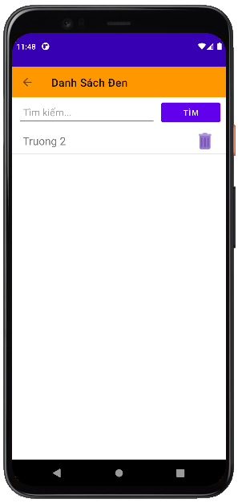

### **Require function**

|  |  |  |  |
| --- | --- | --- | --- |
| **Item** | **Description** | **Action** | **Response** |
| **Blacklist screen** | The  blacklist screen has 2 buttons, 1 search box:  ●          Delete  ●          Back  ●          Search Box | N/A | N/A |
| **Delete button** | Delete user account | Tap on Delete button | Remove user account from blacklist |
| **Back button** | Back to screen | Tap on Back button | Back to Management screen |
| **Search Box** | Search for users | Tap on Search Box | Search for users |

## **Features/Components:Add Blacklist Screen**

### **User interface**

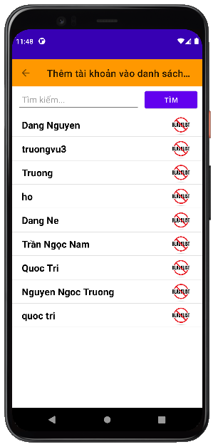

### **Require function**

|  |  |  |  |
| --- | --- | --- | --- |
| **Item** | **description** | **Action** | **Response** |
| **Add Blacklist screen** | Add blacklist has 2 buttons ,1 search box:  ●          Check  ●          Back  ●          Search Box | N/A | N/A |
| **Block button** | Add a user account to the blacklist | Tap on Block button | Add a user account to the blacklist |
| **Back button** | Back to screen | Tap on Back button | Back to Blacklist screen |
| **Search Box** | Search for users | Tap on Search Box | Search for users |

## **Features/Components: Main Blacklist Screen**

### **User interface**

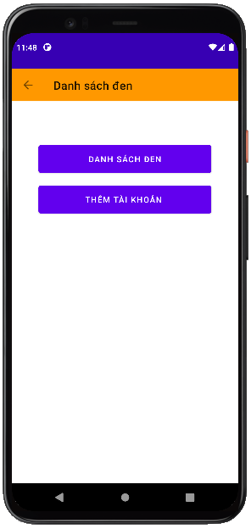

### **Require function**

|  |  |  |  |
| --- | --- | --- | --- |
| **Item** | **description** | **Action** | **Response** |
| **Block screen** | Block screen has 3 buttons :  ●          Blacklist  ●          Back  ●          Add blacklist | N/A | N/A |
| **Blacklist button** | Switch interface blacklist screen | Tap on Blacklist button | A popup Blacklist screen |
| **Back button** | Back to screen | Tap on Back button | Back to Management screen |
| **Add blacklist button** | Switch interface add blacklist screens | Tap on Add blacklist button | A popup Add Blacklist screen |

## **Features/Components: Massage Screen**

### **User interface**

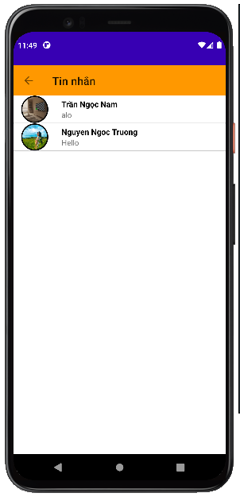

### **Require function**

|  |  |  |  |
| --- | --- | --- | --- |
| **Item** | **description** | **Action** | **Response** |
| **Massage screen** | Message screen has 2 buttons ,1 search box,1 Listview:  ●          Message Listview  ●          Back  ●          Search Box | N/A | N/A |
| **Message listview** | Show list of chats | Tap on Add button | Tap on the chat to go to the chat screen |
| **Back button** | Back to screen | Tap on Back button | Back to Management screen |
| **Search Box** | Search for users | Tap on Search Box | Search chat |

## **Features/Components: Chat Screen**

### **User interface**

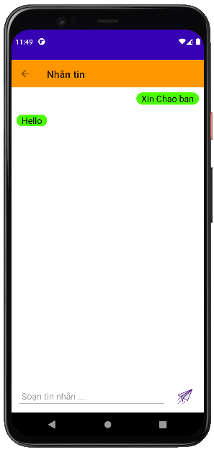

### **Require function**

|  |  |  |  |
| --- | --- | --- | --- |
| **Item** | **description** | **Action** | **Response** |
| **Employee screen** | Employee screen has 2 buttons ,1 Edit text:  ●          Back  ●          Edit Text  ●          Send | N/A | N/A |
| **Chat EditText** | Enter the message you want to send in the chat | Tap on Update button | Go to employee information update screen |
| **Send button** | Send a message you're composing | Tap on Delete button | Delete employee information |
| **Back button** | Back to screen | Tap on Back button | Back to Massage screen |

## **Features/Components: Employee Screen**

### **User interface**

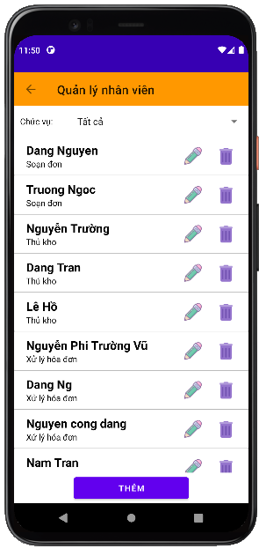

### **Require function**

|  |  |  |  |
| --- | --- | --- | --- |
| **Item** | **description** | **Action** | **Response** |
| **Employee screen** | Employee screen has 4 buttons ,1 Search Box,1 Combo Box,1 TextView:  ●          Add  ●          Delete  ●          Update  ●          Back  ●          Search Box  ●          Position  ●          Position Combo Box | N/A | N/A |
| **Add button** | Add to employee | Tap on Add button | Add a new employee |
| **Update button** | Update employee information | Tap on Update button | Go to employee information update screen |
| **Delete button** | Delete employee | Tap on Delete button | Delete employee information |
| **Back button** | Back to screen | Tap on Back button | Back to Management screen |
| **Search Box** | Looking for employees | Tap on Search Box | Looking for employees |
| **Roles TextView** | Show name of combo box | N/A | N/A |
| **Roles Combo Box** | Filter the list of employees by role | Select roles All | Show All roles on the Combo Box |
| Select roles Management | Show Management roles on the Combo Box |
| Select roles Shipper | Show Shipper roles on the Combo Box |
| Select roles Order handled | Show Order handle roles on the Combo Box |
| Select roles Packer | Show Packer roles on the Combo Box |
| Select roles Shop Owner | Show Shop Owner roles on the Combo Box |

## **Features/Components:Add Employee Screen**

### **User interface**

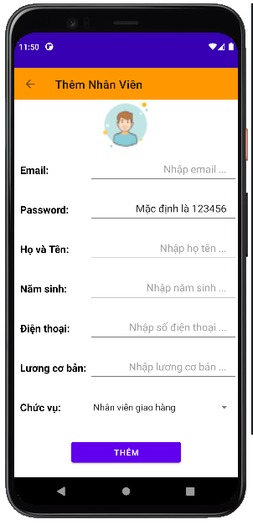

### **Require function**

|  |  |  |  |
| --- | --- | --- | --- |
| **Item** | **description** | **Action** | **Response** |
| **Add Employee screen** | Add Employee screen has 2 Button,2 Radio Button ,8 Edit Text,1 Date Chooser,1 Combo Box:  ●          Add  ●          Username  ●          Password  ●          Back  ●          Name  ●          Birth of day  ●          Gender  ●          Phone  ●          Address  ●          Email  ●          Basic salary  ●          Coefficient  ●          Roles | N/A | N/A |
| **Name edittext** | Enter employee name | Tap on Name edittext | Save information |
| **Birth of day edittext** | Enter date of birth | Tap on Birth of day date chooser | Back to Employee screen |
| **Gender radio button** | Choose your gender | Tap on Male radio button or Female radio button | Gender selection |
| **Phone edittext** | Enter your phone number | Tap on Phone edittext | Enter your phone number |
| **Address edittext** | Enter address | Tap on Address edittext | Enter address |
| **Email edittext** | Enter your email address | Tap on Email edittext | Enter your email address |
| **Basic salary edittext** | Enter basic salary | Tap on Basic salary edittext | Enter basic salary |
| **Coefficient edittext** | Enter salary coefficient | Tap on Coefficient edittext | Enter salary coefficient |
| **Roles edittext** | Enter the position for the employee | Tap on Position **e**text | Enter the position for the employee |
| **Username Edit Text** | Enter account | Tap on Username EditText | Enter the employee's account name |
| **Password Edit Text** | Enter password | Tap on Password EditText | Enter the employee's password |
| **Add Button** | Save the newly created account | Tap on Save Button | Save the newly created account and return to the staff management screen |

## **Features/Components:Update Employee Screen**

### **User interface**

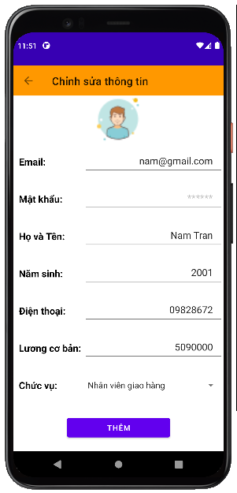

### **Require function**

|  |  |  |  |
| --- | --- | --- | --- |
| **Item** | **description** | **Action** | **Response** |
| **Update Employee screen** | Update Employee screen has 2 Button,2 Radio Button ,8 Edit Text,1 Date Chooser, 1 Combo Box:  ●          Update  ●          Back  ●          Username  ●          Password  ●          Name  ●          Birth of day  ●          Gender  ●          Phone  ●          Address  ●          Email  ●          Basic salary  ●          Coefficient  ●          Roles | N/A | N/A |
| **Name edittext** | Enter employee name | Tap on Name edittext | Save information |
| **Birth of day edittext** | Enter date of birth | Tap on Birth of day date chooser | Back to Employee screen |
| **Gender radio button** | Choose your gender | Tap on Male radio button or Female radio button | Gender selection |
| **Phone edittext** | Enter your phone number | Tap on Phone edittext | Enter your phone number |
| **Address edittext** | Enter address | Tap on Address edittext | Enter address |
| **Email edittext** | Enter your email address | Tap on Email edittext | Enter your email address |
| **Basic salary edittext** | Enter basic salary | Tap on Basic salary edittext | Enter basic salary |
| **Coefficient edittext** | Enter salary coefficient | Tap on Coefficient edittext | Enter salary coefficient |
| **Roles Combo Box** | Choose a role for an employee | Select roles on the Combo Box | Choose a role for an employee |
| **Username Edit Text** | Enter account | Tap on Username EditText | Enter the employee's account name |
| **Password Edit Text** | Enter password | Tap on Password EditText | Enter the employee's password |
| **Update Button** | Save the updated information | Tap on Save Button | Save the updated information and return to the employee management screen |

# CHƯƠNG 3: CÀI ĐẶT VÀ KIỂM THỬ

1. **Cài Đặt**

* Download source từ trang Github của dự án:

<https://github.com/truongth2904/Selling-book-customer.git>

<https://github.com/truongth2904/Selling-book-store.git>

<https://github.com/truongth2904/Selling-book-shipper.git>

* Cài đặt file apk
* Mở Androis Studio và chạy chương trình.

1. **Kiểm Thử**

* Testcase

# CHƯƠNG 4: KẾT QUẢ ĐẠT ĐƯỢC

1. **Kết Quả Đạt Được**
   1. **Ứng dụng dành cho khách hàng**
      * 1. **Đăng nhập**

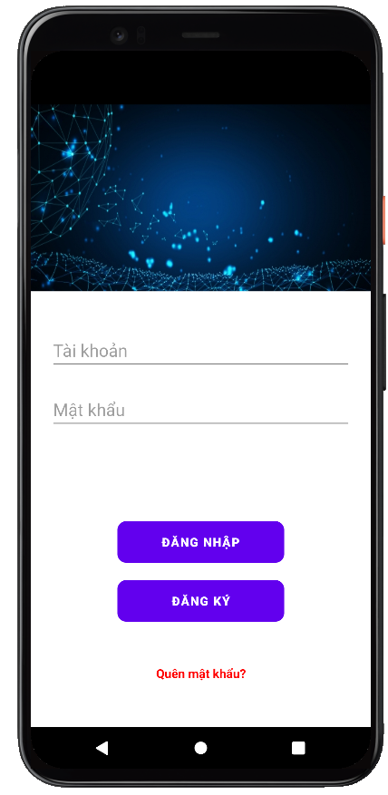

**Ở chức năng đăng nhập, người dùng cần điền đầy đủ thông tin vào hai trường tài khoản và mật khẩu để vào được giao diện bên trong.**

* + - 1. **Đăng kí**

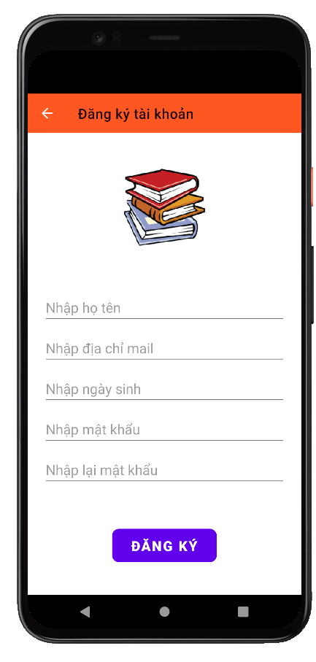

**Ở chức năng đăng ký, người dung cần điền các thông tin để có thể tiến hành tạo tài khoản.**

* + - 1. **Trang chủ**

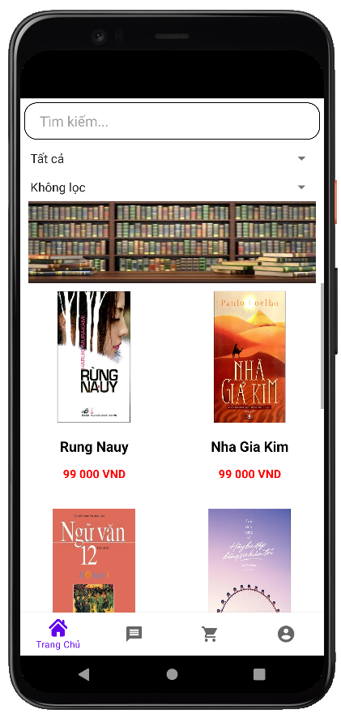

**Sau khi đăng nhập người dùng tiến vào trang giao diện chính. Ở đây sẽ hiển thị các sản phẩm hiện đang bán.**

* + - 1. **Giỏ hàng**

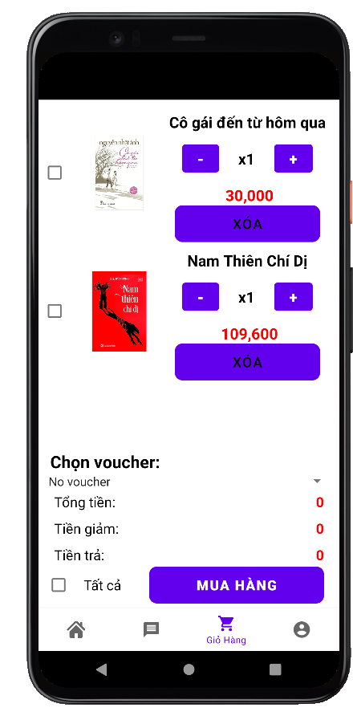

**Chức năng giỏ hàng hiển thị sản phẩm mà người dùng đã thêm vào giỏ hàng đồng thời hiển thị tổng giá trị của các sản phẩm nằm trong giỏ hàng.**

* + - 1. **Hồ sơ**

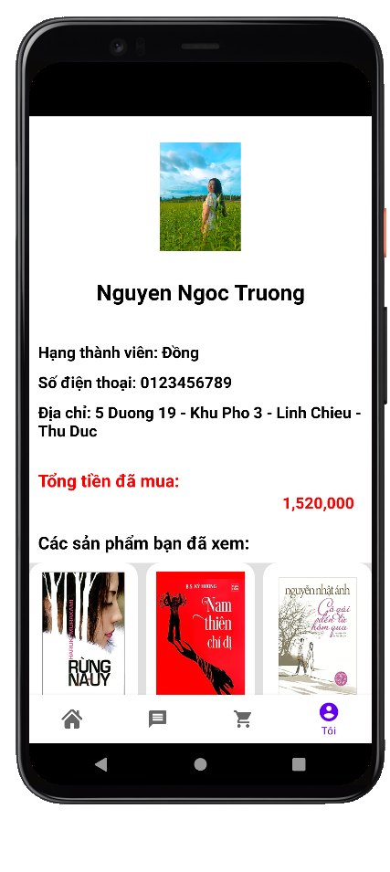

**Giao diện chức năng hồ sơ người dùng bao gồm thông tin của người dùng và các chức năng các như xem đơn hàng, thông tin người dùng, thay đổi mật khẩu, đăng xuất.**

* + - 1. **Đơn hàng**

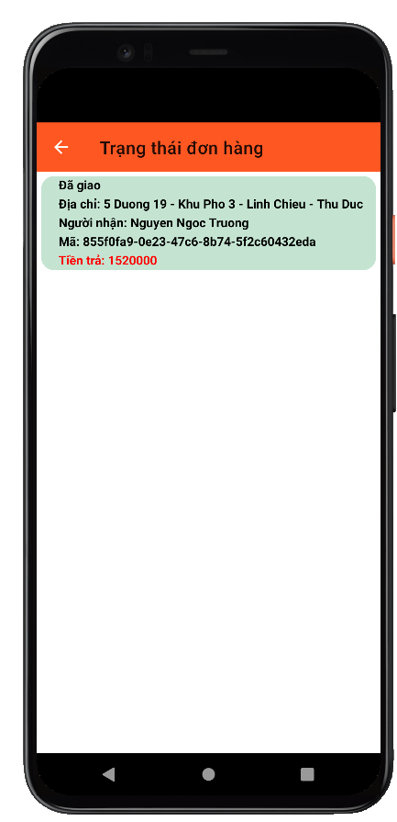

**Chức năng Xem Đơn Hàng dung dể hiển thị các đơn hàng mà người dùng đã đặt.**

* + - 1. **Thông tin tài khoản**

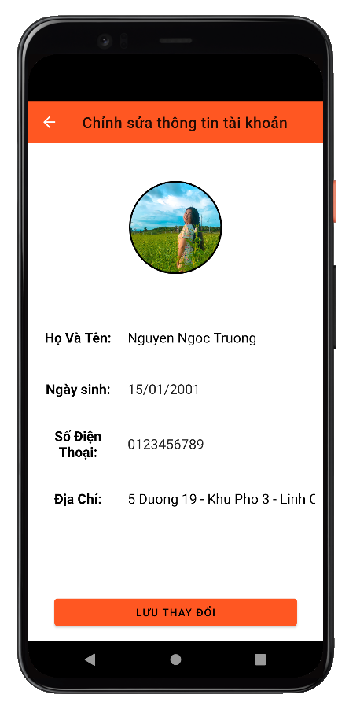

**Chức năng thông tin người dùng được dùng để hiển thị và chỉnh sửa một số thông tin như Số Điện Thoại, Địa Chỉ, vv**

* + - 1. **Đổi mật khẩu**

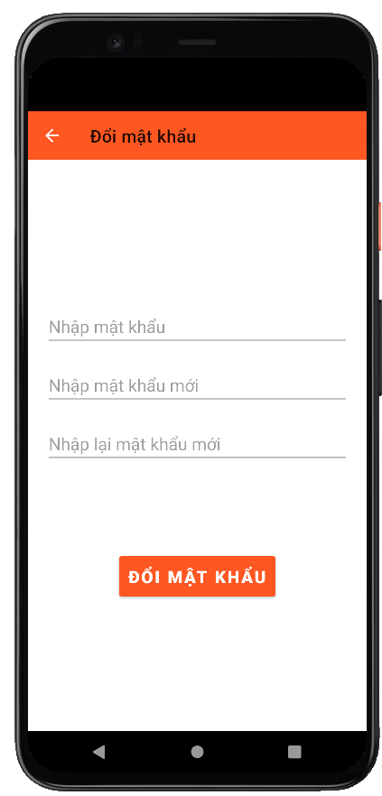

**Ở chức năng đổi mật khẩu người dùng có thể đặt lại mật khẩu tài khoản của mình**

* + - 1. **Quên mật khẩu**

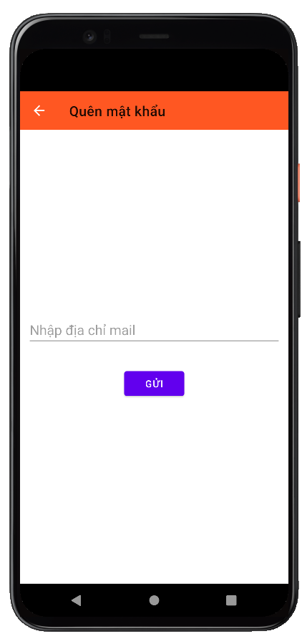

**Ở chức năng quên mật khẩu người dùng có thể gửi mật khẩu về email của mình.**

* + - 1. **Chi tiết sản phẩm**

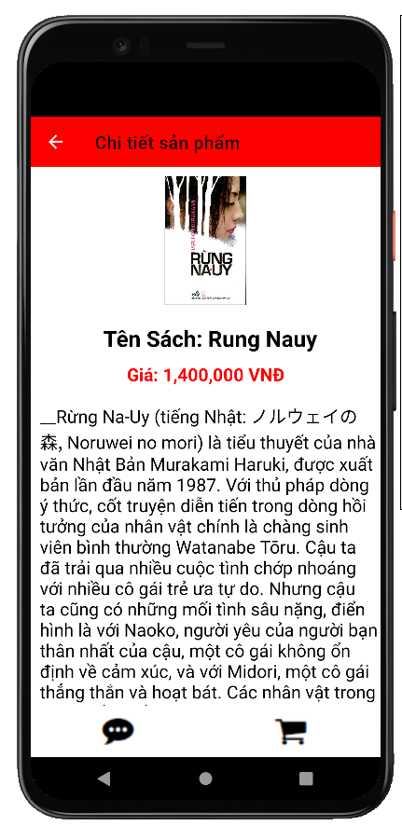

**Chức năng chi tiết sản phẩm dùng để hiển thị thông tin chi tiết của sản phẩm.**

* + - 1. **Nhắn tin**

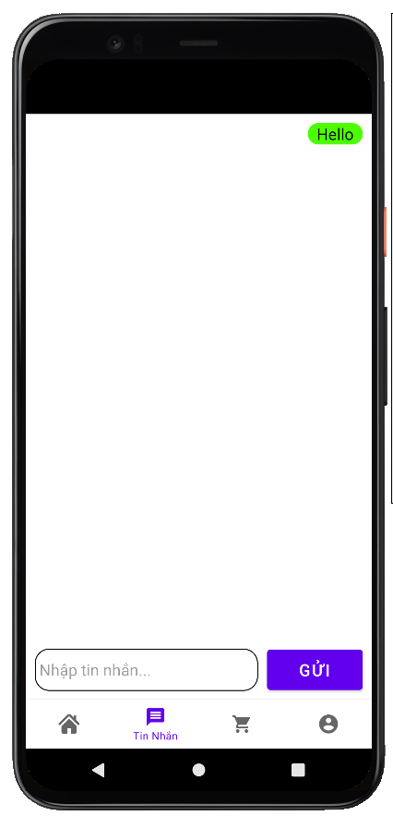

**Ở chức năng này người dùng có thể nhắn tin với nhân viên quản lí.**

* 1. **Chủ cửa hàng**
     + 1. **Đăng nhập**

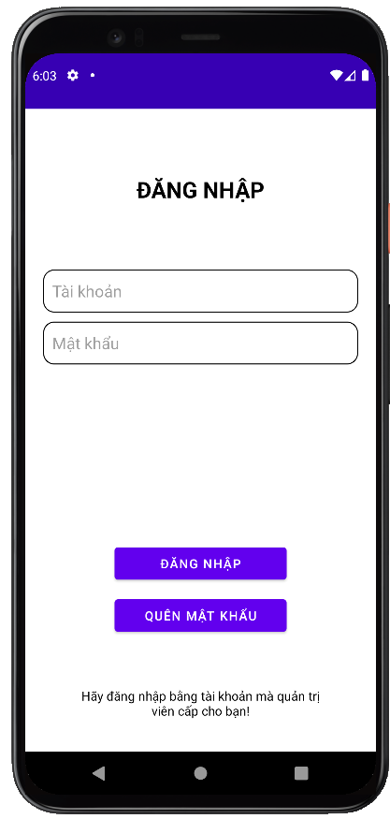

**Ở chức năng này người dùng cần điền đầy đủ thông tin vào hai trường tài khoản và mật khẩu để có thể vào được giao diện chính của Chủ Cửa Hàng.**

* + - 1. **Trang chủ**

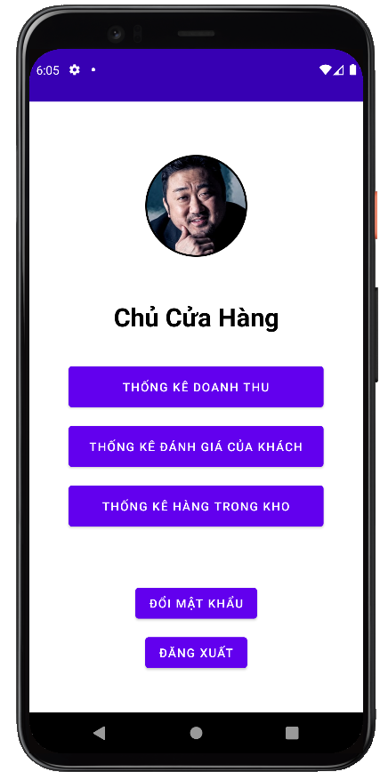

**Đây là giao diện chính của phân quyền Chủ Cửa Hàng, giao diện chứa các chức năng của chủ cửa hàng như Thống Kê Doanh Thu, Thống Kê Đánh Giá,…**

* + - 1. **Thống kê đơn hàng**

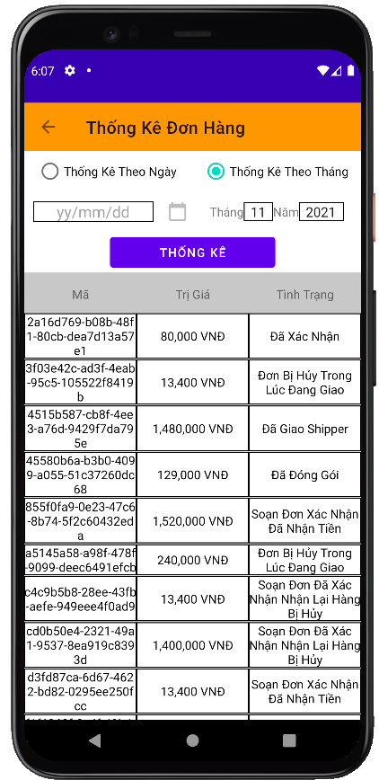

**Ở chức năng này người dùng có thể lọc tất cả các đơn hàng theo ngày hoặc theo tháng.**

* + - 1. **Thống kê đơn hàng bị huỷ**

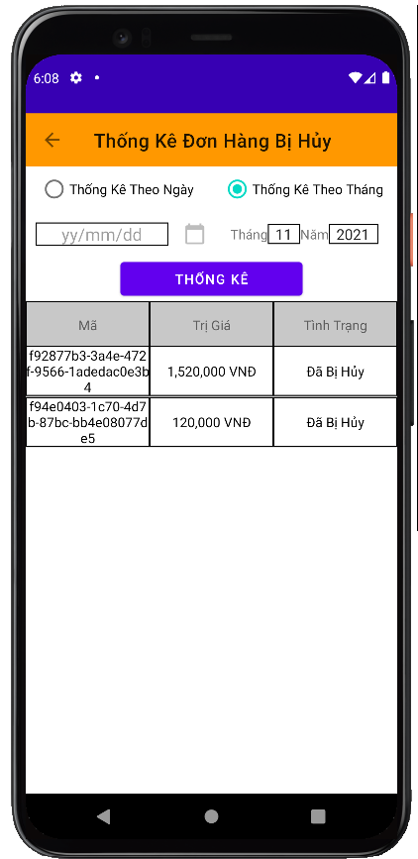

**Ở chức năng này người dùng có thể lọc tất cả các đơn hàng bị hủy theo ngày hoặc theo tháng.**

* + - 1. **Thống kê tiền trả dịch vụ vận chuyển**

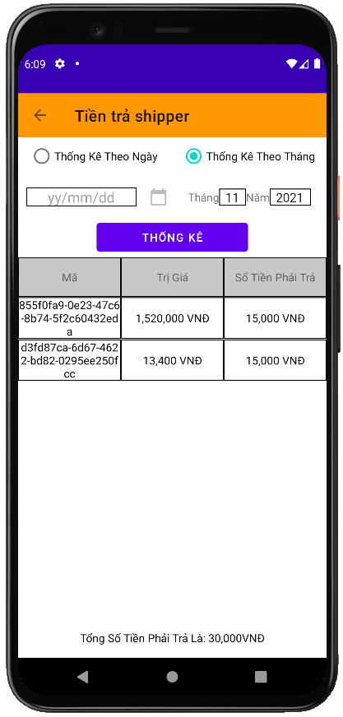

**Ở chức năng này người dùng có thể lọc tất cả các đơn hàng đã được giao và tính thống kê tiền phải trả cho đơn vị vận chuyển theo ngày hoặc theo tháng.**

* + - 1. **Doanh thu**

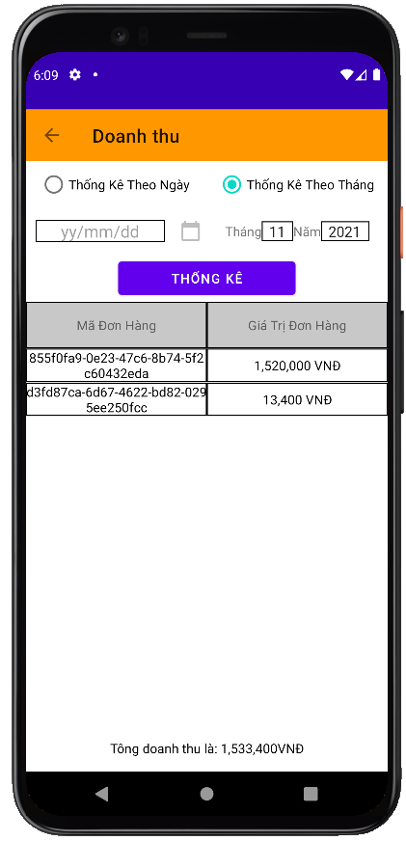

**Ở chức năng này người dùng có thể lọc doanh thu tất cả các đơn hàng đã giao hàng thành công theo ngày hoặc theo tháng.**

* + - 1. **Thống kê đánh giá tốt**

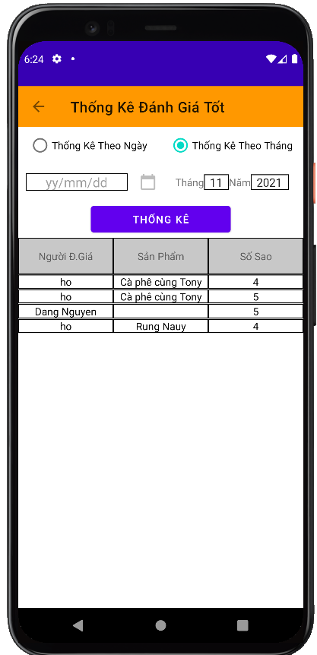

**Ở chức năng này người dùng có thể lọc tất cả các đánh giá tốt theo ngày hoặc theo tháng.**

* + - 1. **Thống kê đánh giá xấu**

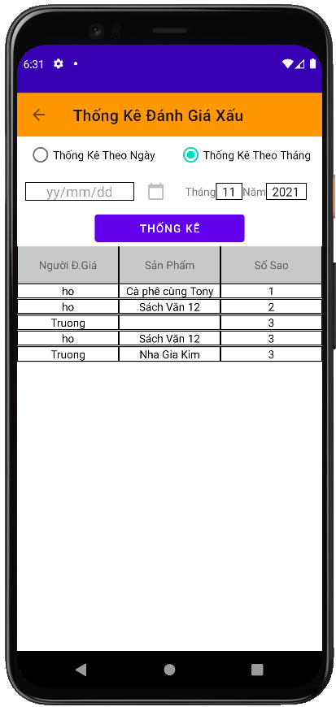

**Ở chức năng này người dùng có thể lọc tất cả các đánh giá xấu theo ngày hoặc theo tháng.**

* + - 1. **Thống kê kho**

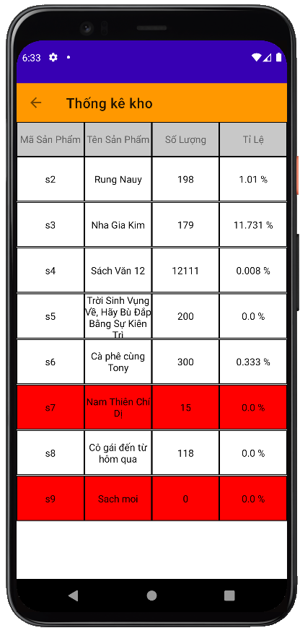

**Ở chức năng này người dùng có thể thống kê số lượng và tỉ lệ bán ra tất cả hàng các hang hóa trong kho theo ngày hoặc theo tháng.**

* + - 1. **Đổi mật khẩu**

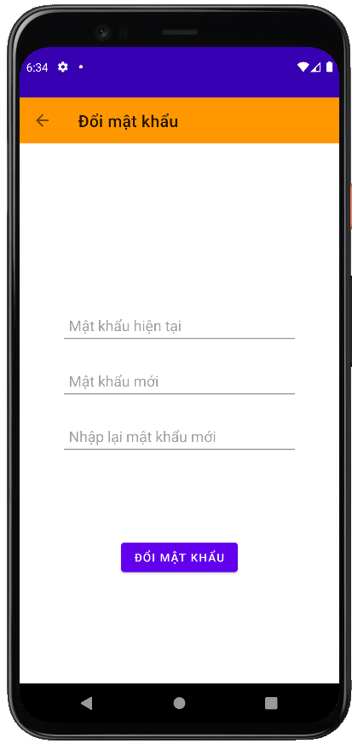

**Ở chức năng này người dùng có thể đổi mật khẩu.**

* 1. **Quản lý**
     + 1. **Trang chủ**

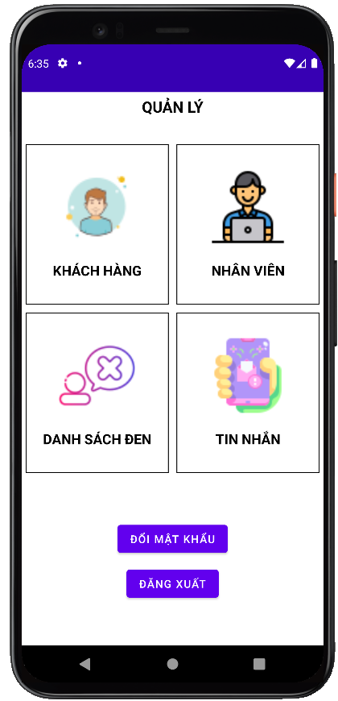

**Đây là giao diện chính của phân quyền Quản Lý, giao diện chứa các chức năng của người quản lý như quản lí khách hàng, nhân viên,…**

* + - 1. **Dánh sách khách hàng**

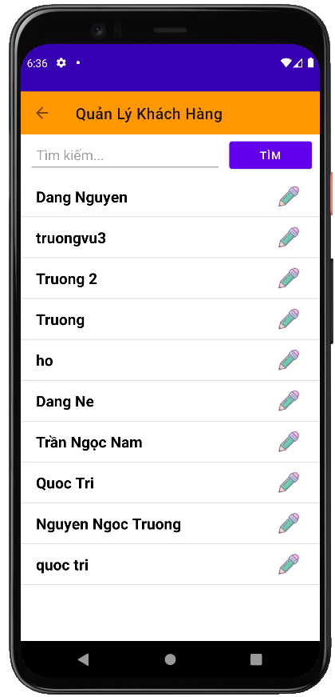

**Ở chức năng này hiển thị danh sách người dùng hiện có.**

* + - 1. **Chỉnh sửa thông tin khách hàng**

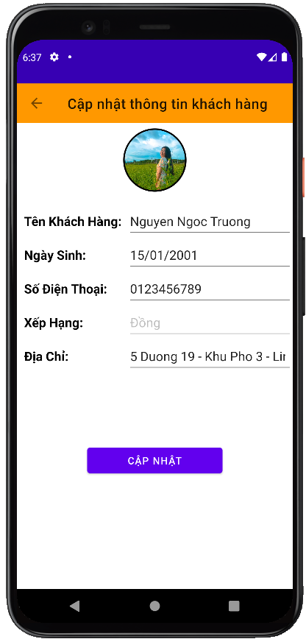

**Ở chức năng này người dùng có thể chỉnh sửa thông tin khách hàng**

* + - 1. **Danh sách nhân viên**

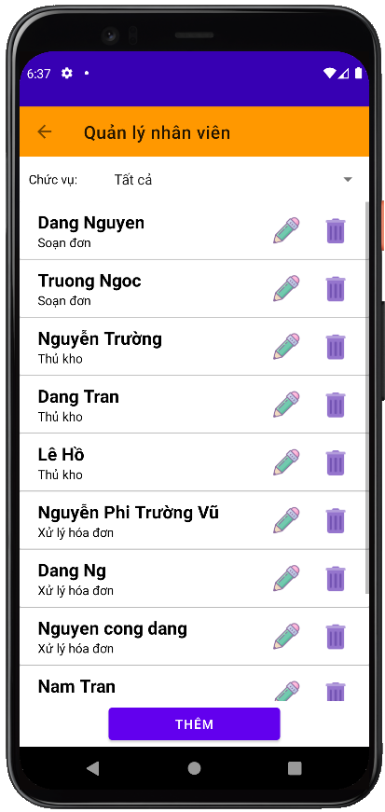

**Ở chức năng này hiển thị danh sách nhân viên hiện có.**

* + - 1. **Chỉnh sửa thông tin nhân viên**

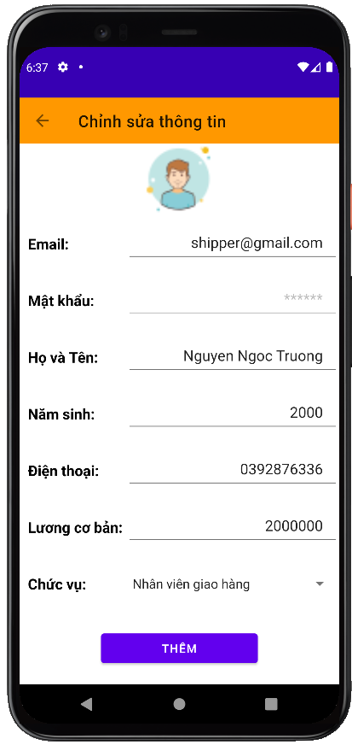

**Ở chức năng này người dùng có thể chỉnh sửa thông tin nhân viên.**

* + - 1. **Xoá thông tin nhân viên**

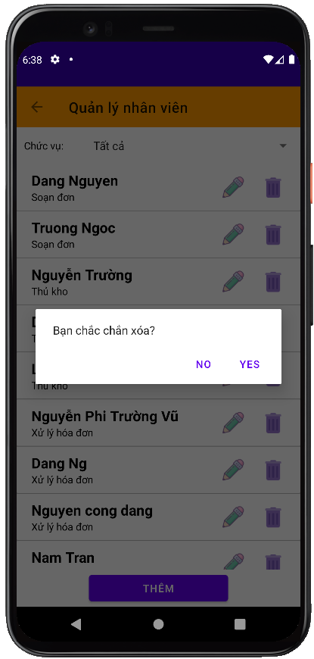

**Ở chức năng này người dùng có thể xóa thông tin nhân viên.**

* + - 1. **Thêm nhân viên**

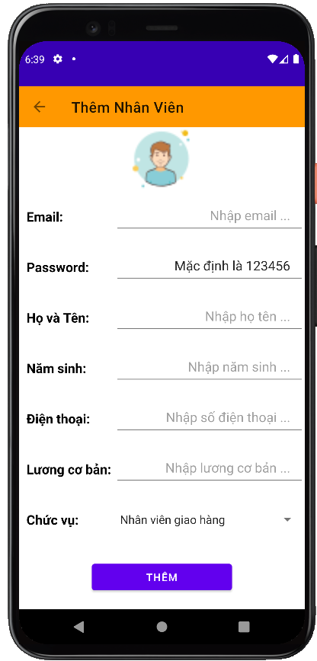

**Ở chức năng này người dùng có thể thêm tài khoản cũng như thông tin của một nhân viên mới.**

* + - 1. **Danh sách đen**

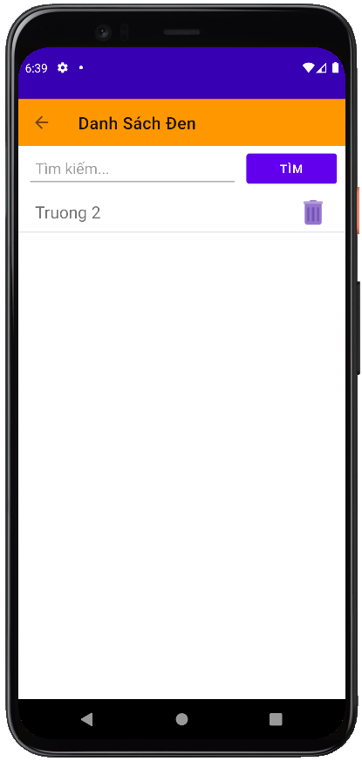

**Ở chức năng này hiển thị danh sách người dùng nằm trong danh sách đen.**

* + - 1. **Thêm tài khoản vào danh sách đen**

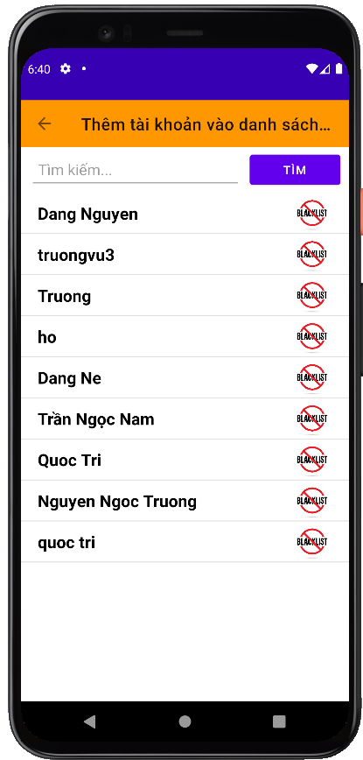

**Ở chức năng này người dùng có thể thêm tài khoản vào danh sách đen.**

* + - 1. **Đổi mật khẩu**

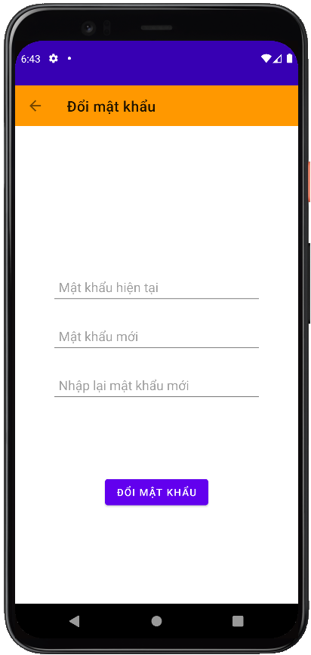

**Ở chức năng này người dùng có thể đổi mật khẩu**

* 1. **Thủ kho**
     + 1. **Trang chủ**

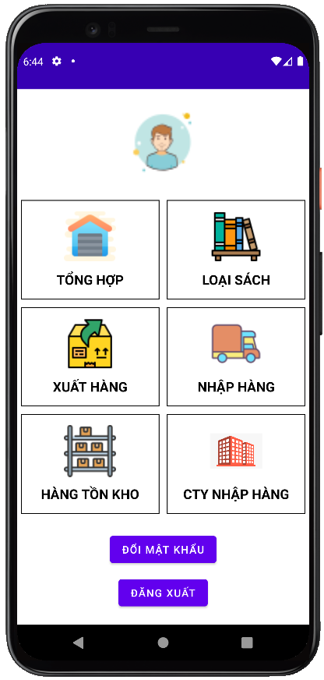

**Đây là giao diện chính của phân quyền Thủ Kho, bao gồm các chức năng như thêm, xóa, sửa sản phẩm, …**

* + - 1. **Tổng hợp**

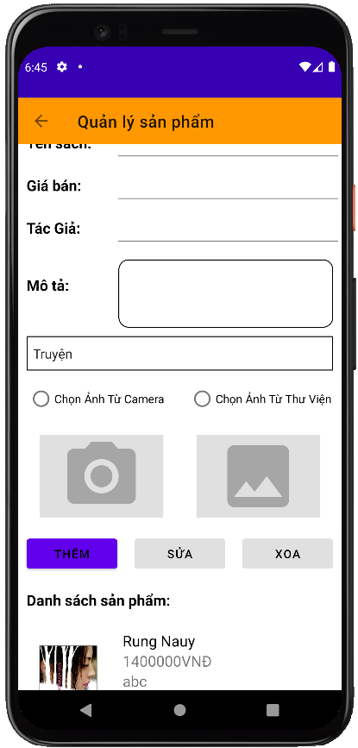

**Ở chức năng này người dùng có thể thêm, xóa, sửa sản phẩm.**

* + - 1. **Quản lý loại sách**

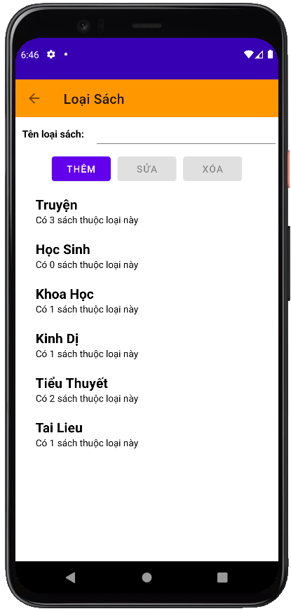

**Ở chức năng này người dùng có thể thêm, xóa, sửa loại sách.**

* + - 1. **Xuất hàng**

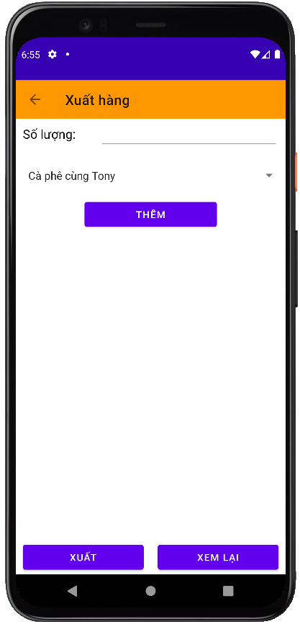

**Ở chức năng này người dùng có thể xuất hàng cho soạn đơn.**

* + - 1. **Nhập hàng**

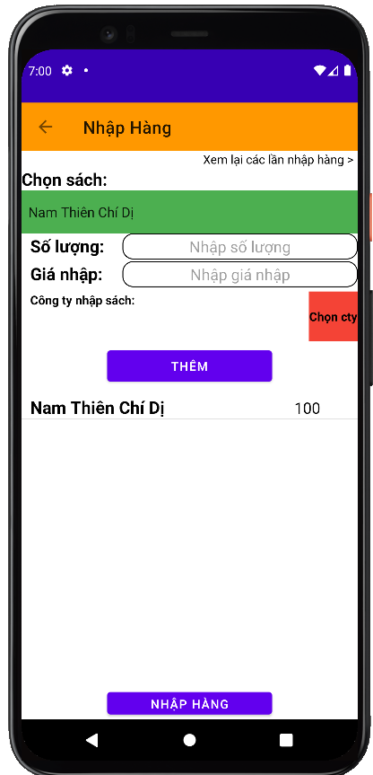

**Ở chức năng này người dùng có thể nhập hàng và cập nhật thông tin số lượng cho sản phẩm.**

* + - 1. **Lịch sử nhập hàng**

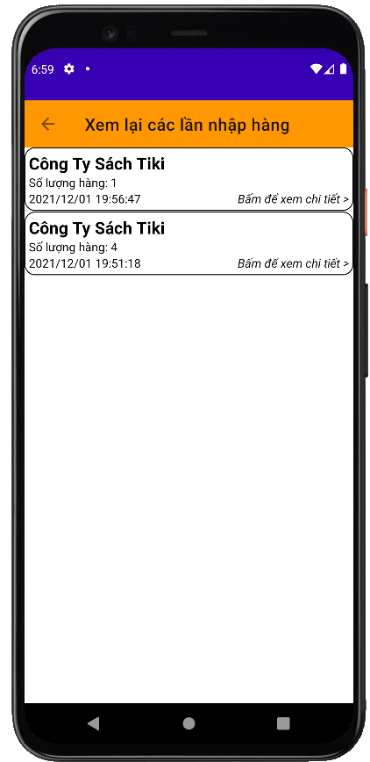

**Ở chức năng này người dùng có thể xem lại lịch sử nhập hàng.**

* + - 1. **Quản lý công ty nhập hàng**

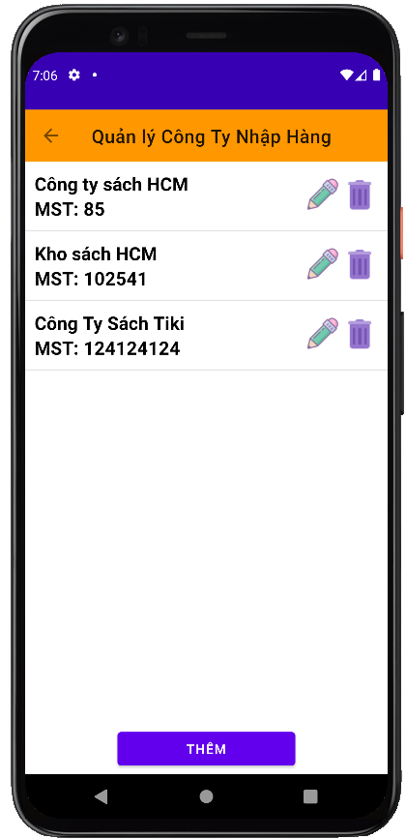

**Ở chức năng này người dùng có thể thêm, xóa hoặc sửa thông tin công ty nhập hàng.**

* 1. **Người xử lý**
     + 1. **Trang chủ**

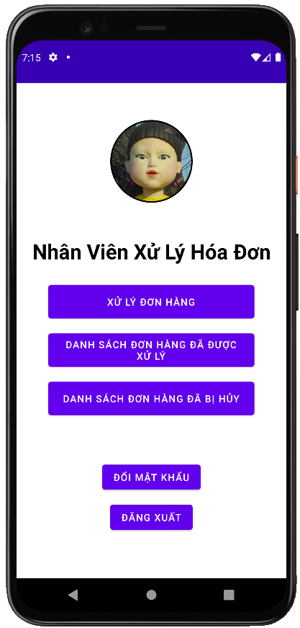

**Đây là giao diện chính của phân quyền Xử Lý Đơn Hàng, bao gồm các chức năng như xử lý đơn hàng, chi tiết đơn hàng …**

* + - 1. **Danh sách đơn hàng chờ xử lý**

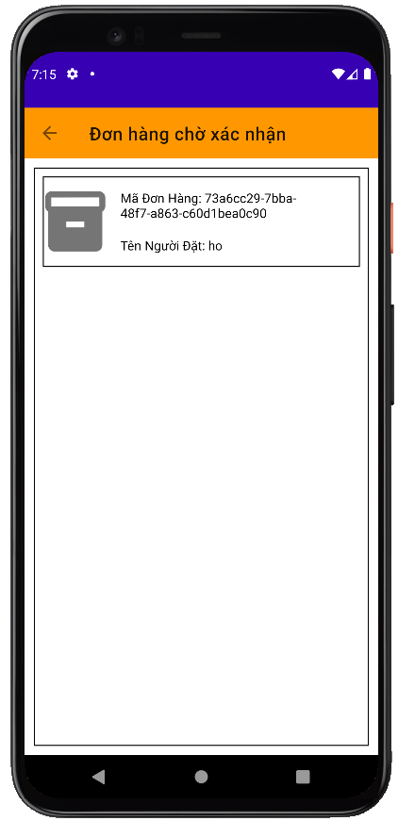

**Ở chức năng này hiển thị danh sách các đơn hàng đang chờ xử lý.**

* + - 1. **Chi tiết đơn hàng**

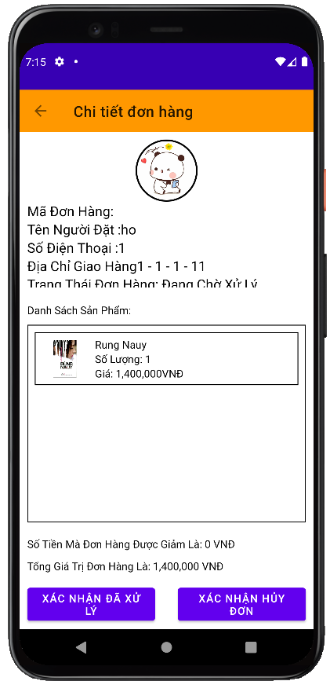

**Ở chức năng này hiển thị thông tin chi tiết của một đơn hàng người dùng có thể xác nhận hoặc hủy đơn hàng.**

* + - 1. **Danh sách đơn hàng đã được xử lý**

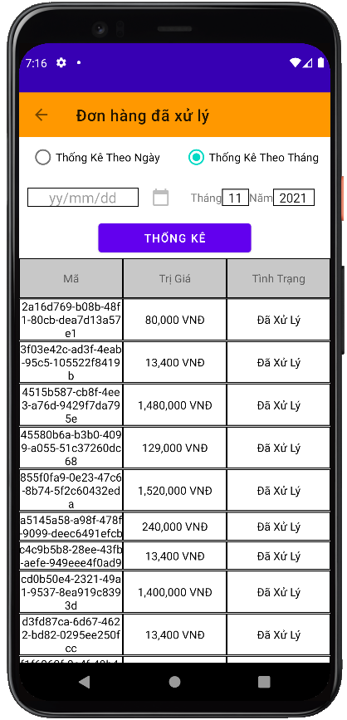

**Ở chức năng này lọc các đơn hàng đã được xử lý theo ngày hoặc theo tháng.**

* + - 1. **Dánh sách đơn hàng đã bị huỷ**

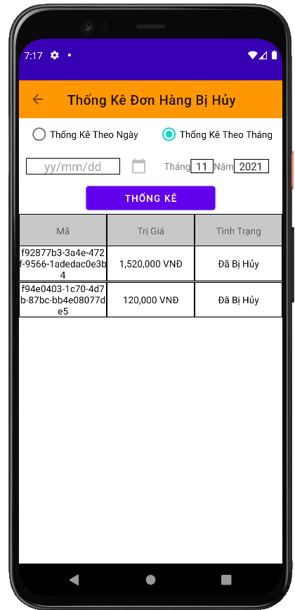

**Ở chức năng này lọc các đơn hàng đã bị hủy theo ngày hoặc theo tháng.**

* 1. **Người soạn đơn**
     + 1. **Trang chủ**

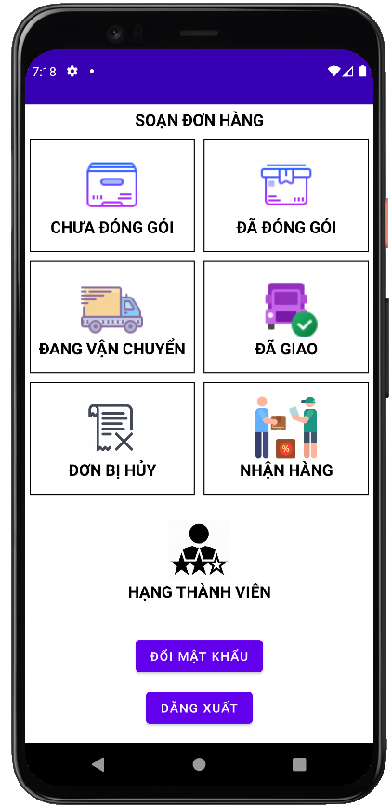

**Đây là giao diện chính của phân quyền người soạn đơn, bao gồm các chức năng như danh sách đơn hàng chưa đóng gói, đã đóng gói, …**

* + - 1. **Danh sách đơn hàng chưa đóng gói**

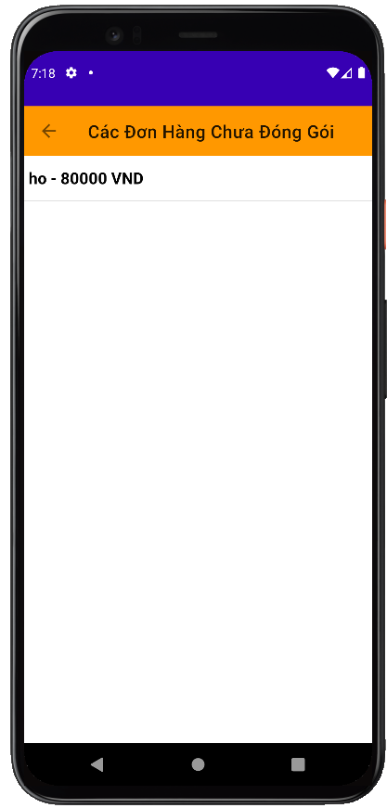

**Ở chức năng này hiển thị danh sách các đơn hàng chưa được đóng gói.**

* + - 1. **Danh sách đơn hàng đã đóng gói**

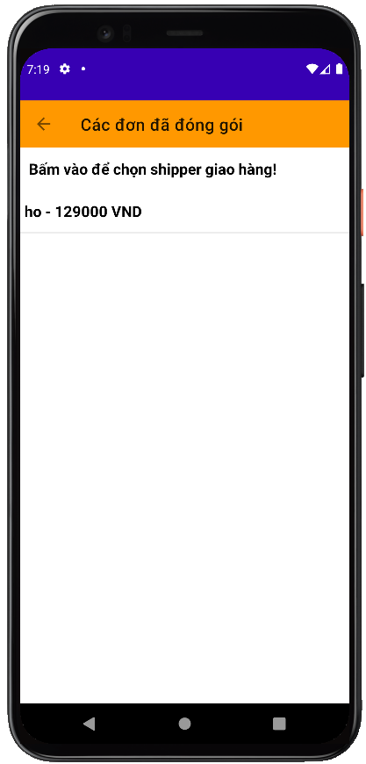

**Ở chức năng này hiển thị danh sách các đơn hàng đã được đóng gói.**

* + - 1. **Chọn shiper cho đơn hàng đã đóng gói**

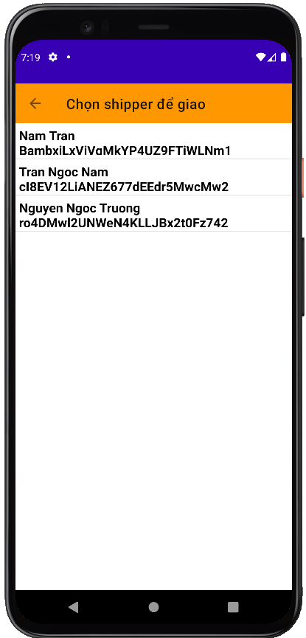

**Ở chức năng này hiển thị danh sách shipper và người dùng có thể chọn shipper cho đơn hàng chưa giao.**

* + - 1. **Danh sách đơn hàng đang vận chuyển**

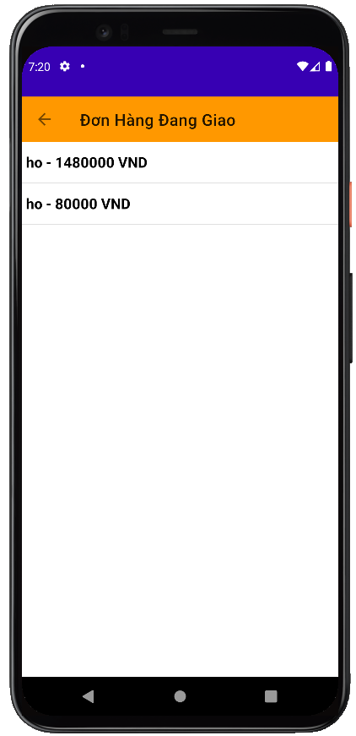

**Ở chức năng này hiển thị danh sách các đơn hang đang vận chuyển.**

* + - 1. **Danh sách đơn hàng đã giao**

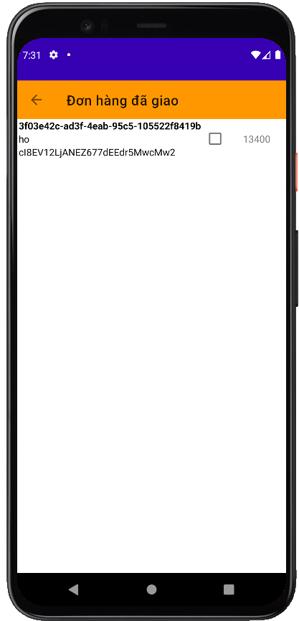

**Ở chức năng này hiển thị danh sách các đơn hàng đang vận chuyển.**

* + - 1. **Danh sách đơn hàng bị huỷ**

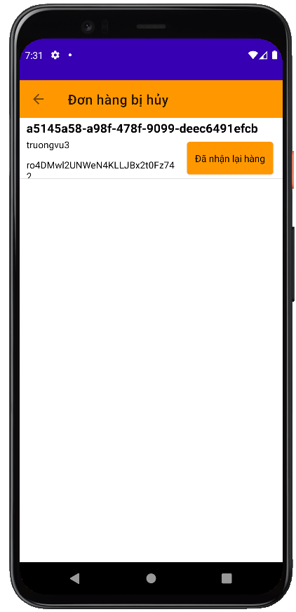

**Ở chức năng này hiển thị danh sách đơn hàng bị hủy nhưng người soạn đơn đã nhận lại hàng.**

* + - 1. **Nhận hàng**

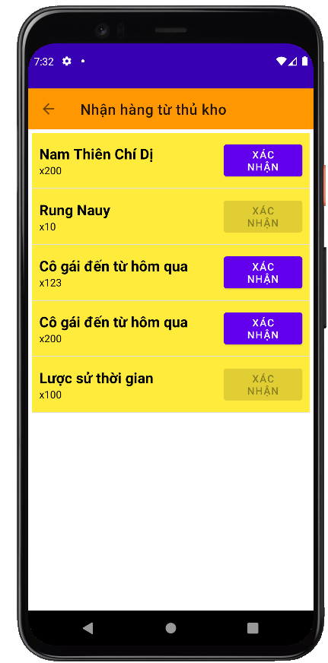

**Ở chức năng này người dùng xác nhận để nhận hàng từ thủ kho.**

* + - 1. **Hạng thành viên**

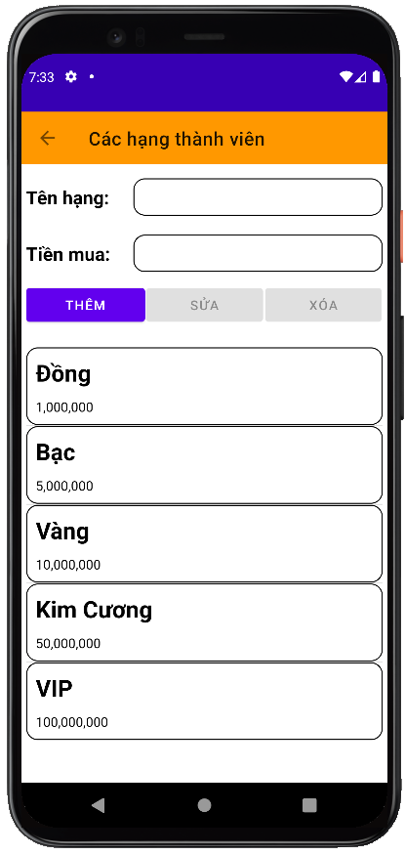

**Ở chức năng này người dùng có thể thêm xóa sửa hạng thành viên.**

* 1. **Shipper**
     + 1. **Đăng nhập**

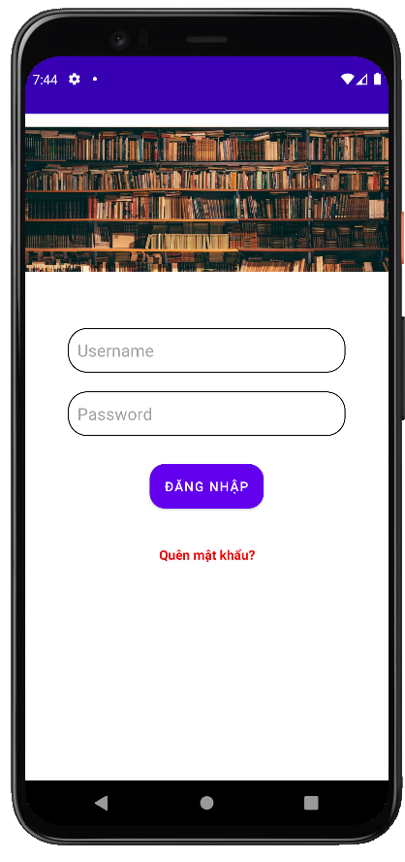

**Ở chức năng này người dùng cần điền đầy đủ thông tin vào hai trường tài khoản và mật khẩu để có thể vào được giao diện chính của ứng dụng.**

* + - 1. **Trang chủ**

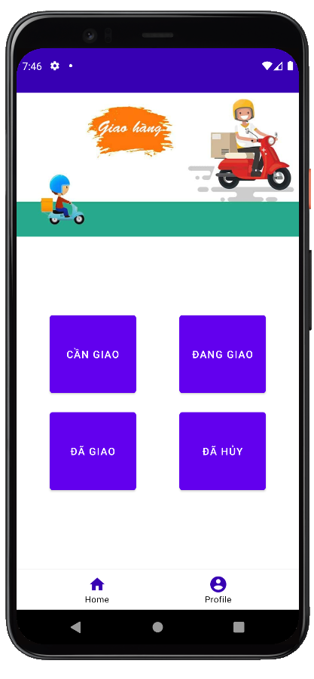

* + - 1. **Đơn hàng cần giao**

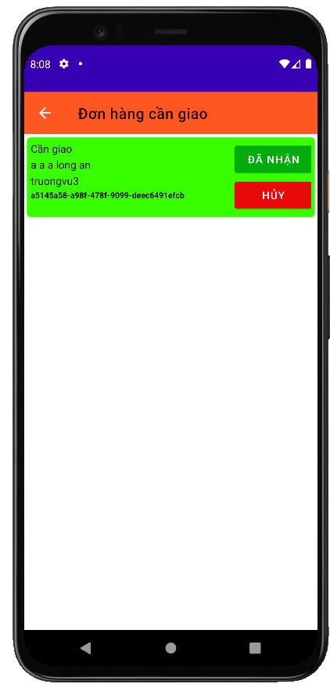

**Ở chức năng này hiển thị các đơn cần giao và chưa có shipper nhận giao hàng.**

* + - 1. **Đơn hàng đang giao**

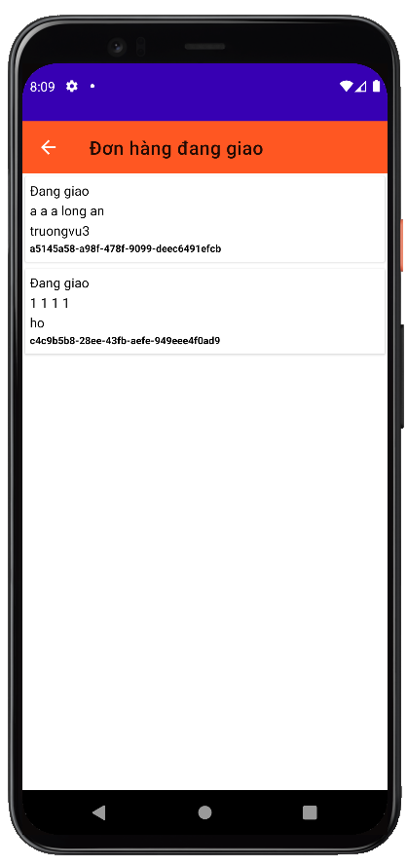

**Chức năng này hiển thị các đơn hàng đang giao.**

* + - 1. **Chi tiết đơn hàng**

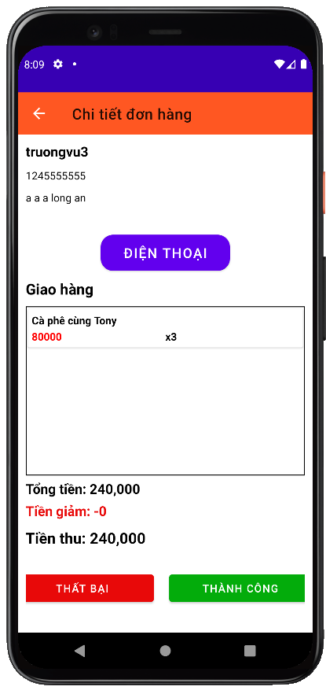

**Ở chức năng này hiển thị thông tin chi tiết của đơn hàng đang giao.**

* + - 1. **Đơn hàng đã giao**

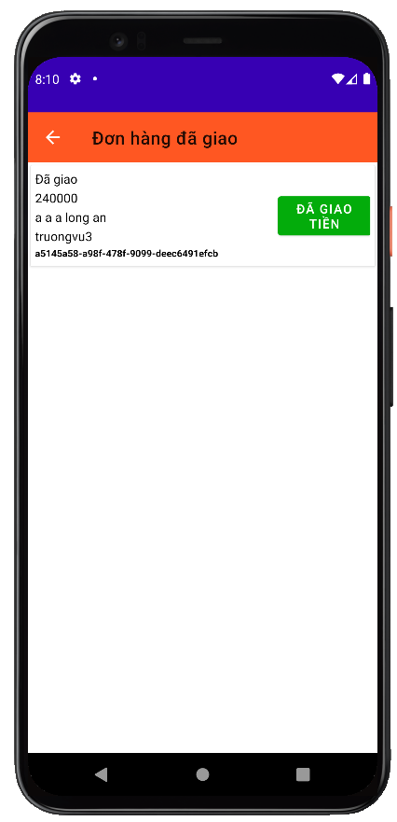

**Ở chức năng này hiển thị tất cả các đơn hàng đã giao hàng thành công.**

* + - 1. **Đơn hàng đã huỷ**

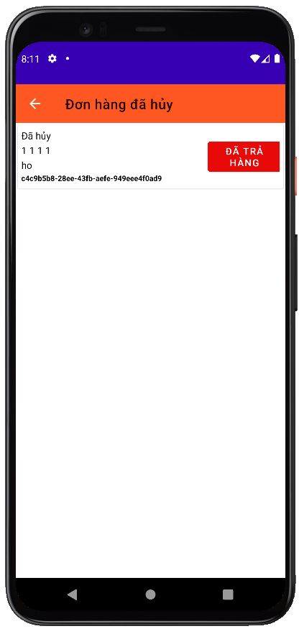

**Ở chức năng này hiển thị tất cả các đơn hàng của người dùng đã bị shipper hủy.**

* + - 1. **Chỉnh sửa thông tin shipper**

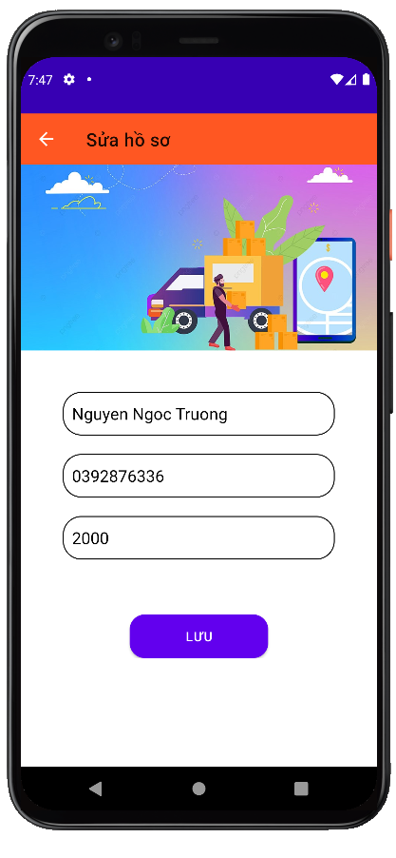

**Ở chức năng này người dùng có thể chỉnh sửa thông tin của shipper.**

* + - 1. **Thông tin shipper**

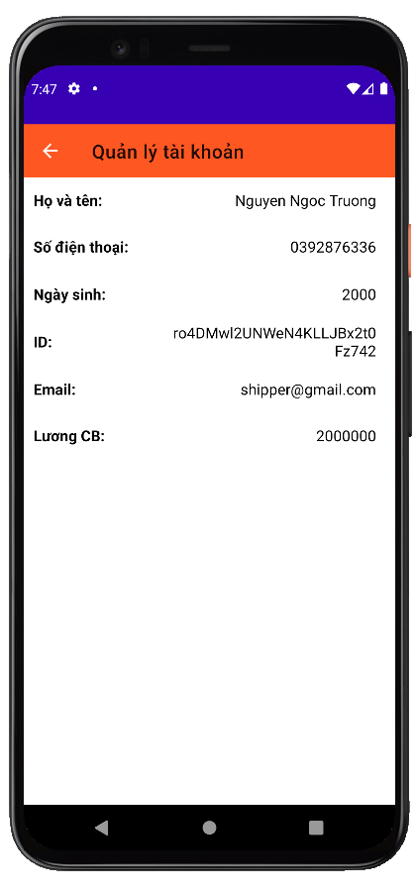

**Ở chức năng này hiển thị tất cả thông tin của shipper.**

* + - 1. **Quên mật khẩu**

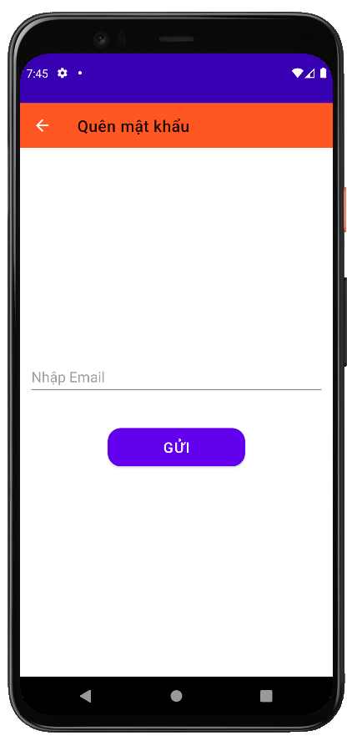

**Ở chức năng này người dùng có thể lấy lại mật khẩu từ email.**

* + - 1. **Đăng xuất**

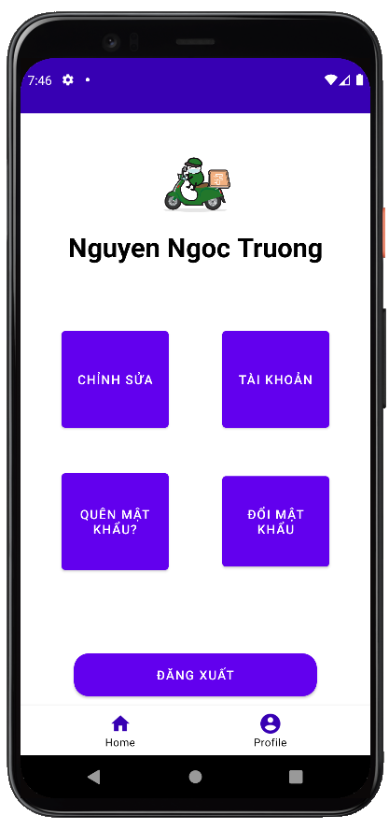

**Chức năng này người dùng có thể đăng xuất tài khoản hiện tại khỏi ứng dụng.**

1. **Các Kết Luận Và Kiến Nghị**
   1. **Những điểm đã làm được:**
      * Hoàn thành ứng dụng.
      * Hoàn thành báo cáo.
      * Test
   2. **Những điểm chưa làm được:**
      * Tối ưu hoá các chức năng của ứng dụng.
      * Một số chức năng vẫn còn hashcode.
      * Chưa phát triển thêm các tính năng nhiều cho ứng dụng.
   3. **Các chức năng bổ sung nếu có thêm thời gian:**
      * Voucher.
      * Capcha

# PHỤ LỤC

# TÀI LIỆU THAM KHẢO

1. [Tài liệu  |  Firebase Documentation (google.com)](https://firebase.google.com/docs?authuser=0&fbclid=IwAR1NMLgkjjA-pVEdguU0Uh1P8pemofm2QY1iPGv8QzQ-3zBhZohQJ6usMR8)